HOLPA guidelines for implementation and analysis of results

HOLPA Key Performance Indicator Protocols

Indicator protocol format
Each indicator has a protocol for use, which describes the indicator purpose, how to collect data for it, and references for further information. The protocol format is as follows:
Indicator | Name of indicator
Theme | Performance framework theme
Purpose of indicator | Rationale for monitoring this indicator
Data source | Proposed data source, e.g. farmer recall, farm records, household survey or interview, focus group, transect, plot measurements, local expert, satellite data.
Measurement | Recommended measurement
Measurement units | Recommended measurement units
Guidance on measurement | Guidance on how to correctly collect data for and calculate the recommended measurement, including tips on where common measurement errors occur and how to avoid them.
Guidance on data entry and reporting | Guidance on how to report data in a transparent and consistent way to facilitate understanding and comparability. This includes any data conversion steps (e.g. to code qualitative data, or convert tree height and diameter measurements to estimated carbon stocks).
Indicator interpretation and threshold setting | How to interpret the measurements used for this indicator and thresholds or reference points to use for defining sustainable and unsustainable values ideally justified with scientific literature. Thresholds can be set in two ways: 1. Using absolute values, e.g. setting minimum and maximum limits based on scientific literature or expert opinion, 2. Using relative values, e.g. compared to the best and worst values in the dataset.
Limitations | Limitations of the measurement method and ideas for alternative measurements to consider in future research and projects.
References | Key references on the indicator

Environmental KPIs

Crop, livestock and fish diversity
Indicator | Crop, livestock and fish diversity
Theme | Agrobiodiversity
Purpose of indicator | Relevant for the post-2020 Global Biodiversity Framework Target 10 on ‘Proportion of agricultural area under productive and sustainable agriculture’, where the Agrobiodiversity Index is a complementary indicator (CBD/COP/15/L.26). The Agrobiodiversity Index includes various measures of agrobiodiversity, including crop and livestock diversity.
Data source | Household survey
Measurement | Diversity of crop varieties (or species) and fish and livestock breeds (or species) on the farm, measured using data on richness and area coverage.
Measurement units | Count with associated production area recorded in hectares, disaggregated by crop and animal species and ideally also variety/breed
Guidance on measurement | This indicator can be calculated by collecting data on the:  - Count of crop varieties and species, and the relative area occupied.  - Count of livestock breeds and species.  - Count of fish breeds and species.  These data can be collected as part of a household survey. To verify the data, and if time allows, the researcher and farmer could conduct a transect of the farm and discuss and record where different crops are planted.
Guidance on data entry and reporting | Be sure to use the same area units for all species/varieties/breeds, so that diversity indices can be calculated. Crop and livestock varieties/breeds and species names should be stored in the local language and also using their scientific and English names to enable comparisons across sites. A local agronomist may need to help identify the scientific and English names.
Indicator interpretation and threshold setting
Limitations
References | FAO (2019), Jones et al. (2021) ^{1,2}

Insect, mammal and tree diversity
Indicator | Insect, mammal and tree diversity
Theme | Biodiversity
Purpose of indicator | Relevant for global climate mitigation targets (the Paris Agreement) and the post-2020 Global Biodiversity Framework Target 10 on ‘Proportion of agricultural area under productive and sustainable agriculture’. Biodiversity indicators selected to be easy to use and scalable, in line with Essential Biodiversity Variables 2020 initiative recommendations.
Data source | Household survey, field survey
Measurement | Diversity of insect, mammal and tree species per hectare of farmland, measured using data on richness, abundance, and density, and standardised to a scale of 0 to 100 to enable data aggregation.
Measurement units | Count with associated production area recorded in hectares, disaggregated by insect/mammal/tree species, tree maturity, and local/exotic origin.
Guidance on measurement | This indicator can be calculated by collecting data on the:  - Richness and abundance of mammals, insects and trees  These data can be collected as part of household and field surveys.  To enable more indepth tree data analysis, e.g. to support efforts to monitor native species, ancient specimens, and carbon sequestration on-farm, additional data can be collected on:  - Proportion of native tree species  - Proportion of mature trees (>50cm diameter at breast height, or height >10m)
Guidance on data entry and reporting | Species names (if available) should be stored in the local language and also using their scientific and English names to enable comparisons across sites.
Indicator interpretation and threshold setting
Limitations
References | Landmann et al. (2023)³, Navarro et al. (2017)⁴, GEO-BON⁵

Landscape complexity
Indicator | Landscape complexity
Theme | Biodiversity
Purpose of indicator | Relevant for the post-2020 Global Biodiversity Framework Goal B on conserving services provided by ecosystems and Target 10 on ‘Proportion of agricultural area under productive and sustainable agriculture’ (CBD/COP/15/L.26). Aligns with SDG indicators 2.4.1 and 15.3.1 on proportion of agricultural area under productive and sustainable agriculture. Maintaining at least 20% natural and semi-natural habitat in agricultural landscapes is important for safeguarding food security, biodiversity, and ecosystem services (Garibaldi et al. 2020).
Data source | Satellite data, or direct measurement by walking around natural or semi-natural features on-farm with a GPS. In both cases, the field or farm boundary needs delineating.
Measurement | Percentage of farmland area that is covered with natural or semi-natural vegetation.
Measurement units | Percentage cover, disaggregated by type of feature
Guidance on measurement | We discuss three options for measurement, i) farmer estimates validated through field surveys (default option in HOLPA), ii) using satellite imagery, iii) direct measurement.  Farmer estimates  A simplistic and rapid way to assess this indicator is to ask respondents to estimate the proportion of their farmland covered by natural or semi-natural vegetation (e.g. bushland, fallow land, hedgerows, natural grassland, ponds, lakes, forest patches). This can be validated by assessing the proportion of natural vegetation contained within three 10x10m plots sampled on the farm, taking a GPS point to allow for satellite-based analysis of the proportion of natural vegetation at larger spatial scales.  Satellite imagery  Natural or semi-natural features on farmland (see Definitions) are often visible on high resolution (<50m and ideally <10m) satellite imagery, such as Google Earth imagery. In a GIS, import the boundary of the field or farm of interest (see Definitions). If no boundary is available, generate a 1km diameter circular plot around each fieldwork plot, using a GPS point collected at the centre of the plot on the ground. In Google Earth Engine, digitise all visible natural or semi-natural features within the area of interest. Calculate the area of land with natural or semi-natural features to obtain an estimate of the share of land covered with natural or semi-natural features. Where possible this should be verified on the ground.  Examples:  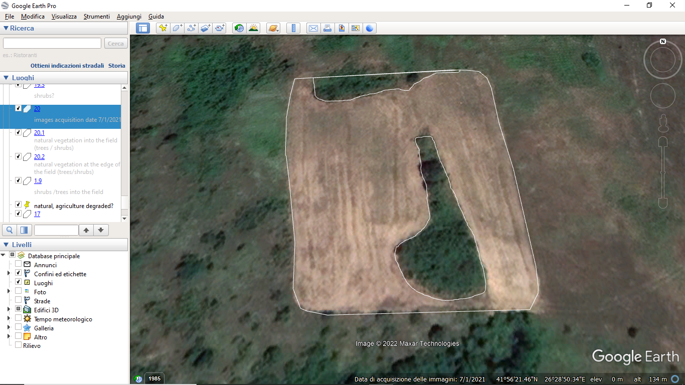  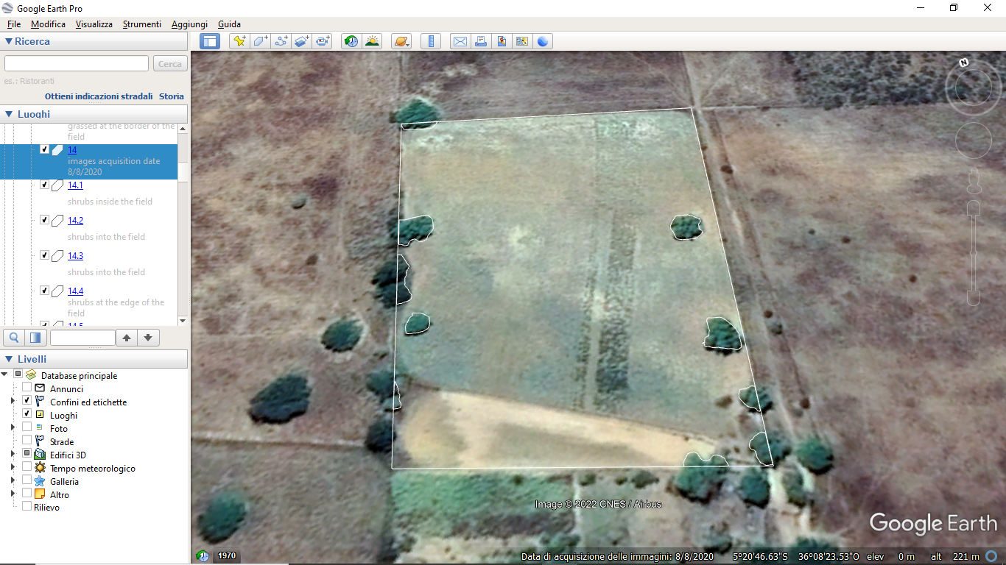  Known problems:  - Distinguishing between tree canopies and shade can be difficult.  - Determining what is farmland and what is natural land can be difficult.  - Distinguishing between grass and shrubs is not always easy.  - The condition of the vegetation is an unknown but important variable.  Direct measurement  Natural or semi-natural features coverage can be determined by walking around the field or farm of interest including all natural or semi-natural features, recording the boundaries with a handheld GPS. These areas can be imported into a GIS and used to obtain an estimate of the percentage of farmland covered with natural or semi-natural features.  Definitions:  Farmland includes areas delineated with generally linear boundaries and inside which there are one of the following:  - Regular rows of woody or herbaceous crops  - Visible tractor tracks  - Visible rows of tilled soil  - Evidence of irrigation, e.g. area is much greener than surrounding land, or visible sprinkler system  - Hay bales in field  Natural or semi-natural features on farmland includes linear or areal features on farmland comprising:  - Single or small groups of trees or shrubs not regularly arranged within the field. These include woodlots, forest remnants.  - Narrow strips of trees, shrubs or other vegetation along field edge that have no visible management, e.g., are not arranged in rows, no signs of tractor or tillage activity, irregular shape. These include hedgerows, flower strips, grass borders.  - Other natural or semi-natural features, including long-term (>6 month) fallow land, rivers, ponds.  This list of natural or semi-natural features should be discussed and adjusted with local communities and/or based on expert knowledge of the context
Guidance on data entry and reporting | Record which natural or semi-natural features were detected, e.g. hedgerows, flower strip. For fallow land, record how long the land has been in fallow.
Indicator interpretation and threshold setting
Limitations
References | Garibaldi et al. (2020), Mohamed et al. (2024)^{5,6}

Water stress
Indicator | Water stress
Theme | Water
Purpose of indicator | Aligns to SDG 6.4.2 on level of water stress, and SDG 6.6.1 on extent of water-related ecosystems.
Data source | Household survey
Measurement | Proportion of months with agricultural water shortages per year, for all agriculturally active months
Measurement units | %
Guidance on measurement | This indicator can be calculated by collecting data on the:  - Number of months for which a household experienced water shortages in the last 12 months, in relation to crop, livestock, fish or other agricultural activities (ideally disaggregated).  The indicator is calculated by summing the number of months of water stress and dividing this by 12, and then taking the inverse (1/x) so that higher values indicate less water stress.  Additional data can be collected on water sources (disaggregated by rainwater, water storage on-farm, water storage off-farm, flood water, piped water, other) to distinguish rainfed water stress versus irrigated water stress, and whether water harvesting measures are used.  These data can be collected as part of a household survey.
Guidance on data entry and reporting | Collect data by asking which months (Jan, Feb, Mar, etc) water is needed per activity, and then which months there are water shortages per activity, to ensure alignment between the two responses.
Indicator interpretation and threshold setting | This indicator presents the percentage of months in a year with water stress. Lower values indicate less stress, while high values indicate more stress. Therefore the indicator values should be inversed
Limitations | Key limitations of the measurement approach for this indicator include:  - Water quality is not accounted for.  - Water storage and delivery infrastructure are not considered.  Alternatives to consider for future surveys include the ''Agricultural Water Scarcity Index'' which is a dimensionless index; or ''Water Productivity'' (kg produced/m3 water consumed); or Quantify freshwater (rainfall, groundwater and surface water) supplied to different agricultural enterprises on the farm during the month or year. For the latter, users should:  - Estimate amount of water (m3/year) required by crop, livestock, fish or other agricultural enterprises (disaggregated) on the farm.  - Estimate the amount of water (m3/year) supplied to each agricultural enterprise on the farm.  - Calculate: Water Stress (%) = (Total freshwater supplied / Available freshwater resources) × 100.  - Classify water stress (%) into the following categories:  - No stress = <10. Low water demand relative to water supply.  - Low stress = 10-20. Moderate demand – sustainable status.  - Medium stress = 20-40. Significant pressure on water resources.  - High stress = 40-80. Strong competition for water – management is critical.  - Critical stress = >80. Unsustainable water extraction for agriculture.
References | - Biancalani, R., & Marinelli, M. (2021). Assessing SDG indicator 6.4.2 "level of water stress" at major basins level. UCL Open Environment.  - Food and Agriculture Organization (FAO). (2021). SDG Indicator 6.4.2 – Level of water stress: Methodology. United Nations FAO. (http://www.fao.org/aquastat).  - van Vliet, M. T. H., Jones, E. R., et al. (2021). Global water scarcity including surface water quality and expansions of clean water technologies. Environmental Research Letters, 16(2), 024020. https://doi.org/10.1088/1748-9326/ABBFC3

Energy use
Indicator | Sustainable energy use
Theme | Energy use
Purpose of indicator | Fossil fuels and other non-renewable energy sources contribute to global greenhouse gas emissions, exacerbating global warming. Increasing the share of renewable energy sources while reducing overall energy consumption contributes to net zero emissions targets (Paris Agreement, SDG 13), while self- and locally produced energy helps ensure an affordable and reliable energy supply (SDG 7).
Data source | Household survey
Measurement | - Proportion of energy sources that are from renewable sources (energy produced from solar panels, wind turbines, hydropower or other renewable sources).  - Proportion of consumed energy that is produced on-farm or by local suppliers.
Measurement units | %
Guidance on measurement | This indicator can be calculated by collecting data on:  - Sources of energy , disaggregated by renewable and non-renewable, per activity (cooking, irrigation, tillage, and other food-related/agricultural activities). Used to provide a Likert scale measure of clean energy:  - Totally clean: 100% renewable energy sources  - Partially clean: 1-99%  - Not clean: 0%  - Proportion of energy used that is produced on-farm, by the community, or purchased from other sources  Data on the proportion of renewable and locally produced energy sources can be combined to provide a Likert-scale measure of the sustainability of energy use.
Guidance on data entry and reporting | Record the energy sources in the system assessed.
Indicator interpretation and threshold setting
Limitations
References | https://energy.sustainability-directory.com/question/what-are-key-indicators-of-energy-security/

Climate mitigation
Indicator | Net greenhouse gas emissions
Theme | Climate mitigation
Purpose of indicator | Globally, the agriculture and land use sector contributes approximately 18% of total greenhouse gas emissions, rising to nearly 60% of GHG emissions in parts of the developing world where agriculture dominates the economy. With the world set to exceed the emissions threshold for keeping warming below 1.5ºC in less than 10 years⁷, mitigation from all sectors is a top global priority.  This indicator is relevant for global climate mitigation goals (Paris Agreement) and nationally determined contributions (NDCs). It is also relevant for the post-2020 Global Biodiversity Framework Target 10 on ‘Proportion of agricultural area under productive and sustainable agriculture’, where changes in soil organic carbon stocks is a complementary indicator (CBD/COP/15/L.26).
Data source | Farmer survey, literature review, and/or field measurements
Measurement | Qualitative score of net greenhouse gas emissions  (alternative: carbon storage in soil and above-ground biomass)
Measurement units | 5-point Likert scale (alternative: t C ha⁻¹ yr⁻¹)
Guidance on measurement | We discuss two options for measurement of net greenhouse gas emissions: i) qualitative assessment of climate mitigation potential of on-farm practices, ii) quantitative assessment of carbon storage and sequestration only, based on soil organic carbon (SOC) and estimates of carbon stored in live woody biomass.  Qualitative assessment  Given the importance of climate change mitigation and the relative difficulty of accurately quantifying net GHG emissions from smallholder agriculture across diverse country contexts, we propose a qualitative approach for integration of mitigation into all performance assessments.  Measurement involves:  - Classifying farming practices according to their net emissions: 1,2,3,4,5, where 1 represents high emitting and low sequestrating practices, and 5 represents low emitting and high sequestrating practices.  - Collecting household survey data on the share of cropland under each practice.  - Calculating a weighted average score for all practices found on the farm, using the share of cropland as weights.  Note that the final score could instead be weighted by productivity for an emissions intensity estimate, if practice data are collected for each main crop/livestock/fish.  Locally relevant farming practices need to be identified and classified into a net emissions category. The classification can be done through literature review and local experts.  Some qualitative assessments/reviews of mitigation potential of agricultural practices already exist. We use one such review by Bell et al. (2018) to provide an example scoring of practices by emission category. The overall score is an average of the component score. In the overall score, 1 represents high emitting and low sequestrating practices, and 5 represents low emitting and high sequestrating practices.  Practices Carbon sequestration in soils Carbon sequestration in biomass Avoided GHG emissions Overall score References  Cropping systems  Agroforestry 5 5 4 4.66 Bell et al. (2018)  Biochar 3 3 2 2.66 Bell et al. (2018)  Crop rotation 3 3 3 3 Bell et al. (2018)  Drip irrigation 3 3 2 2.66 Bell et al. (2018)  Embedded natural (hedgerows) 4 5 4 4.33 Bell et al. (2018)  Green manure 4 3 2 3 Bell et al. (2018)  Intercropping 5 3 5 4.33 Bell et al. (2018)  Microdosing 3 3 2 2.66 Bell et al. (2018)  Mulching 4 3 3 3.33 Bell et al. (2018)  Reduced tillage 4 3 4 3.66 Bell et al. (2018)  Lowland rice systems  Biochar 4 4 2 3.33 Bell et al. (2018)  Green manure 4 4 4 4 Bell et al. (2018)  Microdosing 4 4 2 3.33 Bell et al. (2018)  Rice-fish integration 3 3 4 3.33 Bell et al. (2018)  Alternate wetting and drying 3 3 4 3.33 Bell et al. (2018)  Livestock systems  Improved feed quality 4 4 4 4 Bell et al. (2018)  Planting N-fixing legumes 4 3 3 3.33 Bell et al. (2018)  Rotational grazing 4 3 3 3.33 Bell et al. (2018)  Fish systems  Improved feed quality 3 3 3 3 Bell et al. (2018)  Quantitative assessment  Measurement involves collecting data on tree diameter at breast height (dbh), tree height, number of trees, and collecting data on soil organic carbon through laboratory analysis of soil samples.  Carbon storage and sequestration in woody biomass:  - Get on-farm tree count for trees with dbh > 50cm or >10m in height  - Convert above and below-ground biomass to t/ha using IPCC conversion factors.  Soil carbon storage:  - Use the median SOC in the 0-20cm zone from across the three plots per farm (see Soil Health indicator).  Additional GHG measurement options (beyond the scope of the standard HOLPA tool, see Complementary Indicators)  The most precise, quantitative measurements of GHG emissions are obtained through field measurements of GHG fluxes, either through collection of gas samples and later analysis in a gas chromatography lab (e.g. for ruminant methane emission), or through real-time measurement of gas fluxes using an infrared gas analyzer (e.g. leaf photosynthesis and respiration, soil respiration, or landscape eddy covariance). These methods require costly equipment and/or laboratory analysis, as well as expert technicians to collect and analyze the samples. Further details on the procedures are provided in the section on Complementary Indicators.  In lieu of direct measurement, all other approaches to quantifying GHG emissions from agriculture rely on collecting activity data and using emissions factors to convert activities into emissions levels (e.g. from IPCC). Activity data is a description of the farm practices and areas (or number of livestock) over which they are practiced. Activity data can be collected via household surveys, potentially supplemented with measurement of farm sizes. Higher levels of detail in the activity data (amounts of inputs used, crops and crop varieties, soil types, feed formulations, tree species in agroforestry systems, etc.) generally allow for more precise estimation of emissions. However, conversion of activity data into quantitative emissions relies on the use of emissions factors. Most widely available emissions factors (e.g. Tier 1 Approach) are based on data from temperate countries (Ogle et al. 2013; Albanito et al. 2017) and may not be appropriate for estimating GHG emissions from agricultural activities in tropical countries.  Models of GHG emissions also rely on collection of activity data and emissions factors, but many can account for local conditions, such as soil types, livestock breeds, climate, etc to produce more appropriate emissions estimates for tropical or developing countries not well represented in the Tier 1 approach. Several models are available for calculating emissions, including the Ex-Ante Carbon Balance Tool (EXACT) and the Cool Farm Tool, however use of these models requires a degree of technical expertise.
Guidance on data entry and reporting
Indicator interpretation and threshold setting
Limitations
References | - Thornton et al. 2018. A qualitative evaluation of CSA options in mixed crop-livestock systems in developing countries.⁸  - Bell et al. 2018. A Practical Guide to Climate Smart Agricultural Technologies in Africa. CCAFS Working Paper No. 224.⁹  - Anuga et al. 2020. Towards low carbon agriculture: Systematic narratives of climate-smart agriculture mitigation potential in Africa. Current Research in Environmental Sustainability.¹⁰  - MacLeod et al. 2020. Quantifying greenhouse gas emissions from global aquaculture. Scientific Reports.¹¹

Agricultural KPIs

Crop health
Indicator | Crop health
Theme | Crop health
Purpose of indicator | Crop and pasture health can influence agricultural productivity and resilience of plants to stress, pests and competition. Crop health can be affected by any biological, chemical, or physical factors that may affect plant physiology and crop performance, impacting food production (SDG2) and the spread of food-borne diseases with consequences for human health (SDG3).
Data source | Household survey, field measurements
Measurement | % crop losses, and SOCLA indicators of crop health
Measurement units | Score from 1 to 10, representing the mean indicator value across 10 indicators
Guidance on measurement | We propose two complementary measures of crop health: i) Qualitative based on household survey responses, ii) Qualitative based on field observations.  Household survey based  A simple measure of crop health can be provided by collecting responses on: What percentage of the total crop production was lost or damaged in the last 12 months?  Field based  More detailed data on crop health can be determined through field measurements interpreted jointly by farmers and researchers. Field measurements to collect data on each crop health indicator should be conducted every 50m along a transect of approximately 150m (this may vary depending on the farm size), to collect data on all 10 crop health indicators at three sampling sites per farm. Crop health should be assessed for only the main crop(s) grown on the farm to keep the task manageable.  At three 10x10m square plots per farm, observe the crops and/or pasture present in the plot and jointly with the respondent record the responses to the indicators with the respondent. Refer to the example images provided in the field survey (Appendix 7.1.3.3 Crop and pasture health) to determine the most appropriate responses crop health related questions.  The proposed indicators were developed by the Latin American Society for Agroecology (SOCLA) and described in Nicholls et al. (2004)¹². The SOCLA 10 indicators of crop health are:  - Appearance  - Crop growth  - Disease incidence  - Insect pest incidence  - Natural enemy abundance and diversity  - Weed competition and pressure  - Actual or potential yield  - Vegetational diversity  - Natural surrounding vegetation  - Management system  Each indicator is scored from 1 to 10 based on the following guidelines (from Nicholls et al. 2004, Table 1):  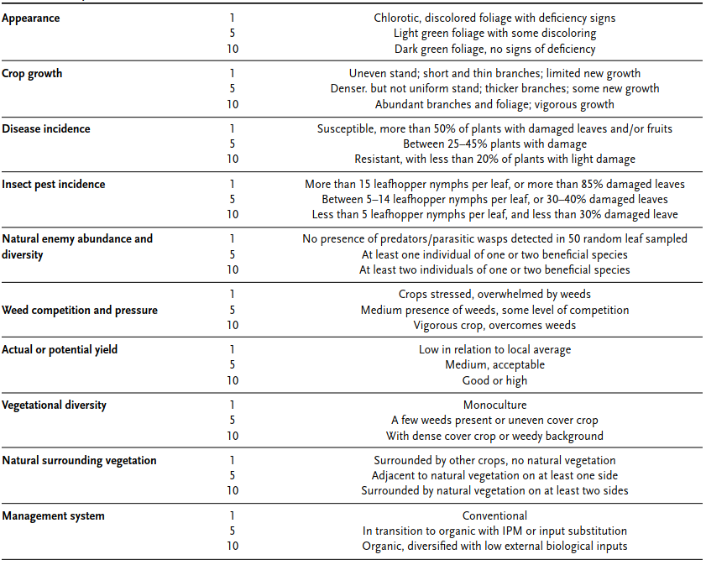
Guidance on data entry and reporting | Record the crop species and variety in the system assessed. Be sure to take a GPS point and keep a record of the geographic coordinates where crop health was assessed to allow follow-up surveys in the same locations.
Indicator interpretation and threshold setting
Limitations
References | Nicholls et al. (2004), FAO (2019) ¹³, ¹

Animal health
Indicator | Animal health
Theme | Animal health
Purpose of indicator | Maintaining healthy and diverse stocks of animals on-farm contributes to overall agroecosystem functioning for more sustainable farming systems (SDG2, GBF Target 10). Keeping animals in poor health increases the spread of zoonoses, food-borne disease, and livestock mortalities, with associated negative consequences on human health (SDG2 and 3) and livelihoods (SDG1). Healthier animals have a smaller environmental footprint (SDG12 and 13).
Data source | Household survey with farm transect
Measurement | Qualitative measure of livestock disease and losses. Alternative: Health and welfare of farm animals, measured using the welfare outcome assessment tool as applied to each livestock species.
Measurement units | Various (e.g. number of animals in each welfare category, number of mortalities per 100 animals)
Guidance on measurement | We discuss two measures of animal health: i) qualitative welfare assessment, ii) (optional) full welfare assessment.  Qualitative asessment  Likert score (1 to 4) based on the following questions:  What was the extent of injury, illness, or death of livestock due to diseases in the last 12 months?  - None  - Low  - Medium  - High  What was the extent of injury, illness or death of fish due to diseases in the last 12 months?  - None  - Low  - Medium  - High  Full welfare assessment (optional)  The welfare outcome assessment tool is a practical and scientifically informed way of assessing and measuring animal welfare. It aims to provide an objective, accurate and direct picture of animal welfare.  The assessment measures the impact of farm inputs (e.g. housing, space, feed, veterinary care, management) on the health, physical condition and behaviour of the animals themselves. There are different assessment approaches for each livestock species: laying hens, dairy cows, pigs, broiler hens, beef cattle, sheep. The method was developed by Assurewel and is implemented by the UK Soil Association and RSPCA: http://www.assurewel.org/aboutassurewel/aboutwelfareoutcomeassessment.html.  The assessment of one livestock species takes around 30 mins per farm. The researcher will need to complete, with the farmer, the AssureWel simple scoresheet for each livestock produced on the farm. For example, for dairy cattle, this includes documenting:  - Mobility (good, impaired, severely impaired)  - Body condition (thin, moderate, fat)  - Cleanliness (clean to very dirty)  - Hair loss, lesions and swellings  - Number of cows with broken tails  - Number of cows needing further care  - Farmer records of mobility, mastitis, calf and heifer survivability, cull and casualty cows.
Guidance on data entry and reporting
Indicator interpretation and threshold setting
Limitations
References | - ¹⁴ – assessment protocol for dairy cattle  - ¹⁵ – scoresheet for dairy cattle  - ¹⁶ – explanation of measures for dairy cattle  - See http://www.assurewel.org for protocols, scoresheets and explanations for laying hens, pigs, broiler hens, beef cattle, and sheep.

Soil health
Indicator | Soil organic carbon (alternative: qualitative measure of soil health)
Theme | Soil health
Purpose of indicator | Soil organic carbon or organic matter (SOC or SOM) is a key indicator of soil health, supporting vegetation growth, soil stability, soil fertility and other vital ecosystem services. SOC/SOM assessment is relevant for assessing carbon emission and sequestration, and soil health, under local and international commitments. This indicator is relevant to global climate mitigation goals (Paris Agreement) and the post-2020 Global Biodiversity Framework Target 10 on ‘Proportion of agricultural area under productive and sustainable agriculture’, where changes in soil organic carbon stocks is a complementary indicator (CBD/COP/15/L.26). In resource-constrained projects, it can be challenging to collect soil samples and run laboratory analyses to calculate SOC. We propose using simple qualitative measures of soil erosion and fertility o provide an alternative, rapid assessment of soil health in cases where SOC is unattainable.
Data source | Soil samples collected on-site (alternative: household survey)
Measurement | Laboratory measurement of % soil organic carbon, or % soil organic matter (alternative: qualitative assessment of erosion and fertility through household survey)
Measurement units | % (alternative: Likert-scale score)
Guidance on measurement | We discuss two options for the measurement of soil health: i) soil organic carbon calculated in a laboratory from soil samples, ii) qualitative measure of soil health.  Soil organic carbon  Soil samples should be taken randomly, in a W-shaped pattern, from 5 points per plot, for three 10x10m plots per farm.  After collecting the soil samples, a standard laboratory procedure should be used to determine the carbon content of the sample. The loss-on-ignition method¹⁷ can be used to estimate the SOC/SOM using the following steps.  - Air-dry the soil samples after collection, and grind fine enough to sieve through a mesh <2 mm or smaller.  - Oven dry each sample at 105°C for 24 hours.  - Weigh 5.000g ±0.001g of each oven-dried sample and place each into a crucible. This will be the pre-ignition weight of the sample.  - Heat the sample in a muffle furnace at 375°C for 16 hours or overnight  - Weigh the sample after the ignition and this will be the post-ignition weight  - Calculate percentage SOC/SOM using the following equation:  $$SOC \left(SOM\right)\left(\%\right)=\frac{pre ignition weight \left(g\right)-post ignition weight \left(g\right)}{pre ignition weight (g)}$$  Alternatively, a Carbon Nitrogen (CN) Elemental Analyser can be used to estimate soil organic carbon content. The C-N elemental analyser provides a quantitative measurement of SOC and N content based on the amount of C and N produced after combustion of products in a sample.  Alternatively, the Walkey Black method can be used to estimate soil organic matter content. Walkey Black provides a qualitative measurement of SOM after oxidising the soil with potassium dichromate and H2SO4 and measuring the color change; which is proportionate to the organic matter available in the soil. A conversion factor can be used to convert either SOC to SOM or vice versa.  Qualitative measure of soil health  To complement SOC data, and to allow for a basic assessment of soil health in cases where neither soil organic carbon data or SOCLA (see Complementary indicators) can be collected (e.g. to due to resource constraints), HOLPA includes two standard questions on farmer perceptions of soil health. Farmer perceptions of soil fertility and erosion are gathered using a simple Likert scale, based on the following two questions:  How would you describe the fertility of your soil on your farmland?  - Highly fertile (score 5)  - Moderately fertile (score 3.66)  - Low fertility (score 2.33)  - Infertile (score 1).  How would you describe the level of soil erosion problems on your farmland?  - Soil erosion is not a problem on my farm (score 5)  - Soil erosion is a minor problem on my farm (score 3)  - Soil erosion is a major problem on my farm (score 1).  These perception questions can be used to assign a soil health score from 1 (infertile and major soil erosion) to 3 (highly fertile with no soil erosion), by taking the median across the fertility and erosion responses.
Guidance on data entry and reporting | Report the SOC content as a volume-based concentration (i.e. %)
Indicator interpretation and threshold setting
Limitations
References | Bahadori, M., & Tofighi, H. (2016). A modified Walkley-Black method based on spectrophotometric procedure. Communications in Soil Science and Plant Analysis, 47(2), 213-220. ¹⁸  Gelman, F., Binstock, R., & Halicz, L. (2012). Application of the Walkley–Black titration for the organic carbon quantification in organic rich sedimentary rocks. Fuel, 96, 608-610.¹⁹  Nelson, D.W., and Sommers, L.E. (1996). Total Carbon, Organic Carbon, and Organic Matter. In Methods of Soil Analysis (John Wiley & Sons, Ltd), pp. 961–1010. https://doi.org/10.2136/sssabookser5.3.c34.¹⁷  Walkley, A. and I.A. Black. 1934. An examination of the Degtjareff method for determining soil organic matter and a proposed modification of the chromic acid titration method. Soil Sci. 37:29-38.²⁰

Nutrient use
Indicator | Nutrient use
Theme | Nutrient management
Purpose of indicator | Nutrient use per unit area provides information on the under or over-use of fertilizers, which has implications for crop productivity, economic viability, and environmental sustainability. By monitoring nutrient applications, farmers and agronomists can determine if the current inputs are meeting or exceeding the nutrient needs of the crop and if adjustments are needed to optimize input use and reduce nutrient losses to the environment. This indicator is related to a number of Sustainable Development Goals (SDG) e.g., SDG 2 on zero hunger and SDG 15 life on land.
Data source | Field measurements, household survey
Measurement | Fertilizer applications in the production system
Measurement units | Fertilizer input (kg) per hectare per year, disaggregated by organic and chemical inputs. Can be presented as a ratio of recommended fertilizer input intensity in the landscape obtained from extension services and literature.
Guidance on measurement | Nutrient use can be determined at the three levels i.e. plot level (the level of individual crops), farm level (the level of a whole farm and its cropping system), and landscape level (a larger area e.g. region or watershed).  At all scales, it is important to consider all possible sources of inputs into the system to avoid under or overestimation of nutrient use.  Specific survey questions should address the following:  - What is the amount of nutrient input, such as nitrogen (N), phosphorus (P), or potassium (K), added to the farm system through fertilization or other means per year?  - What proportion of these nutrients come from each source (chemical, organic plant, manure)?
Guidance on data entry and reporting | Uniform data entry and conversion of inputs to kg ha⁻¹ yr⁻¹.
Indicator interpretation and threshold setting
Limitations
References | - Dobermann, (2007)²¹  - European Union Nitrogen Use Efficiency (2016)²²

Social KPIs

Diet quality
Indicator | Diet quality
Theme | Nutrition
Purpose of indicator | Eradicating food insecurity and malnutrition is a sustainable development goal (SDG2). Nutritious diets are a prerequisite to achieving this goal.
Data source | Household and individual survey using the Diet Quality Questionnaire (DQQ), developed by the Global Diet Quality Project
Measurement | Diet quality from 24-hour food consumption recalls, calculated from the number of food groups consumed per individual and household, from 29 food groups.
Measurement units | Raw measurement: Y/N for consumption of each food group together with (optional) food group source (own production, purchased, borrowed, food aid, other).  Final measurement:  - Household Food Group Diversity Score (FGDS) (0-10) (this measurement is the default KPI)  - Minimum Dietary Diversity for Women of Reproductive Age (MDD-W) (0/1)  - All-5 recommended food groups consumed (0/1)  - Non-Communicable Disease (NDC) Protect (0-9), which is an indicator of dietary factors that protect against NDCs according to the World Health Organisation (WHO)  - NDC-Risk (0-9), which is an indicator of dietary factors increasing the risk of NCDs according to WHO  - Global Dietary Recommendations (GDR) Score (0 to 18), which indicates level of adherence to global dietary recommendations for a healthy diet according to WHO  - (Optional) Proportion of food that is produced on-farm
Guidance on measurement | The Diet Quality Questionnaire (DQQ) is a standardized tool to collect indicators of dietary adequacy, including the minimum dietary diversity for women (MDD-W) indicator, and All-5, as well as indicators of protection of health against noncommunicable diseases (NCDs), including NCD-Protect, NCD-Risk, and the global dietary recommendations score (GDR). It is a low-burden tool for collecting valid, comparable food group consumption data in populations.  The DQQ is two-pages long and includes 29 multiple choice questions corresponding to the 29 DQQ food groups. Each question asks the respondent if they consumed a specific DQQ food groups with yes/no responses. The questionnaire takes approximately 5 minutes to complete per individual.  The survey should be completed for the adult household members, including men and women. Researchers can optionally add one column asking, for each food group, the source: own production, purchased, borrowed, food aid, other. This will allow calculation of the proportion of consumed food that is from each source.  Note that the timing of survey affects results. Try to collect data from all farms at a period when food supplies are adequate, rather than when some farms are more likely to suffer shortages (e.g. end of dry season, or after a drought season).  DQQ Food Groups:  1. Foods made from grains  2. Whole grains  3. White roots, tubers, and plantains  4. Pulses  5. Vitamin A-rich orange vegetables  6. Dark green leafy vegetables  7. Other vegetables  8. Vitamin A-rich fruits  9. Citrus  10. Other fruits  11. Baked / grain-based sweets  12. Other sweets  13. Eggs  14. Cheese  15. Yogurt  16. Processed meats  17. Unprocessed red meat (ruminant)  18. Unprocessed red meat (non-ruminant)  19. Poultry  20. Fish and seafood  21. Nuts and seeds  22. Packaged ultra-processed salty snacks  23. Instant noodles  24. Deep fried foods  25. Fluid milk  26. Sweet tea / coffee / cocoa  27. Fruit juice and fruit-flavored drinks  28. Sugar-sweetened beverages (soft drinks, energy drinks, sports drinks)  29. Fast food  Examples of how the final scores are calculated:  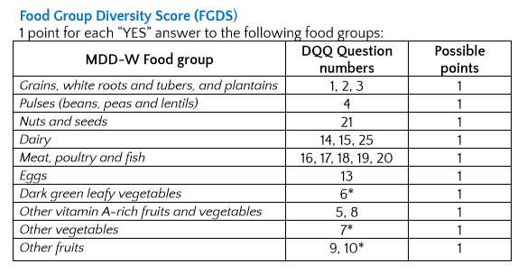  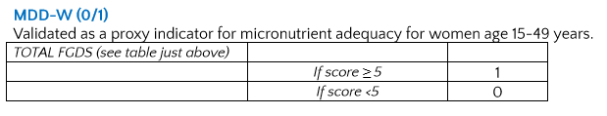
Guidance on data entry and reporting
Indicator interpretation and threshold setting
Limitations
References | Global Diet Quality Project resources²³:  - https://www.globaldietquality.org/dqq  - DQQ Food Group Descriptions  - Diet Quality Questionnaire (DQQ) Indicator Guide  Diet Quality Questionnaires are adapted to each country, downloadable from the Global Diet Quality Project website and translated into many languages.

Land tenure security
Indicator | Land tenure security
Theme | Land tenure
Purpose of indicator | Land access is closely linked to use and control over productive resources. Secure land tenure is therefore a key determinant of individual agency, income and wellbeing. This indicator is aligned with SDG 1.4.2 and 5.a.1.
Data source | Parcels (most preferable) or household/farm (most possible) survey using a simplified version of the harmonized questionnaire proposed by FAO et al. (2019)²⁴. Additionally, GPS delineation of parcels is strongly advised wherever feasible, as evidence points to systematic bias in farmer estimates of land area²⁵.
Measurement | ((Area of agricultural land used by the household for which at least one member of the household has their name on a legally recognized document OR has the right to sell OR has the right to bequeath)/(Total land area used by the household))*100
Measurement units | %
Guidance on measurement | The indicator can be calculated with data collected using FAO’s harmonized questionnaire, which is a standardized and succinct survey instrument designed to collect the essential data for computation of both 1.4.2ª and 5.A.1^{b} Sustainable Development Goals (SDGs) indicators simultaneously.  The methodology proposed 5 versions of the questionnaire (see next figure) depending on: (i) the respondent selection approach, (ii) whether or not the survey collects data at the parcel-level and (iii) whether or not the existing survey includes a parcel roster. Each version of the questionnaire has approximated 10 questions and assumes that a separate household member roster exists and that the sex of each household member is captured in that roster.  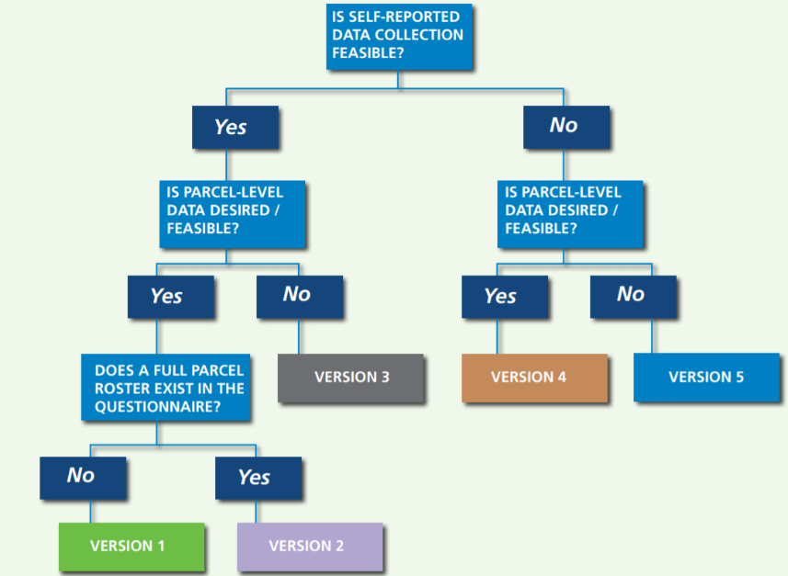  Where possible, it is advised to have parcel level data and implement a self-respondent approach (i.e., where individuals respond for themselves only, not on behalf of others) (version 2 with 7 questions). Where it is not, land tenure data should be collected at the household/farm level, using the version 3 (13 questions) of the questionnaire.  A sub-indicator can be calculated as: ((Number of adult women in agricultural households whose name is on a legally recognized document OR who have the right to sell OR bequeath agricultural land)/(Total adult individuals in agricultural households whose name is on a legally recognized document OR who have the right to sell OR bequeath agricultural land))*100.  Note, for pastoralists, land tenure security may be better measured in terms of mobility, i.e. proportion of grazing lands over which the farmer has unrestricted rights to graze livestock.  Guidance of how to apply the questionnaire:  - The survey should be completed for the adult household member (18 years old or older).  - Because a self-respondent approach is going to be used and only some (or one) randomly selected household members are interviewed about their  tenure rights, only the selected members are part of the reference population (i.e., denominator in the indicator and sub-indicator formulas).  - The country-specific questionnaire should include: i) a comprehensive list of all tenure types applicable to the country; ii) a comprehensive list of land tenure-related documents, specifying which ones the government considers as legally recognized; iii) images of the documents considered legally recognized; iv) a context-specific definition of alienation rights.  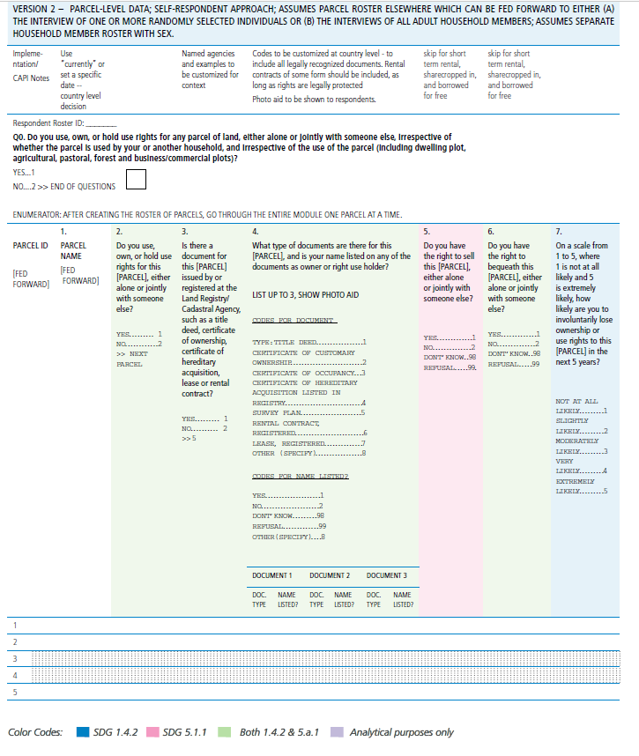  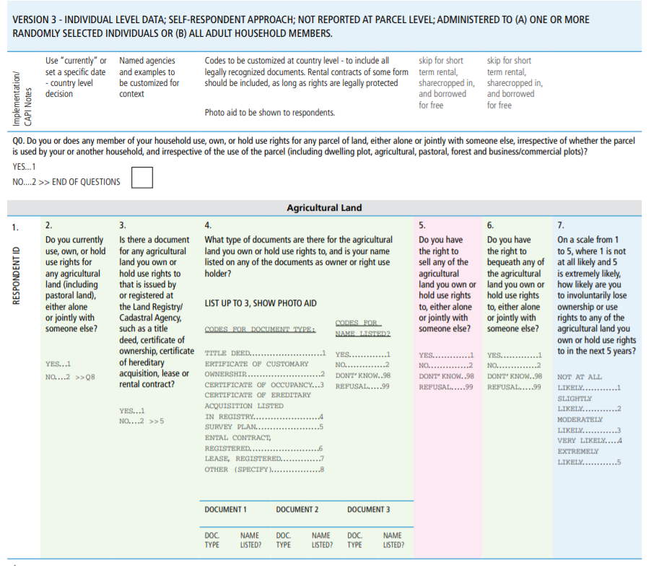  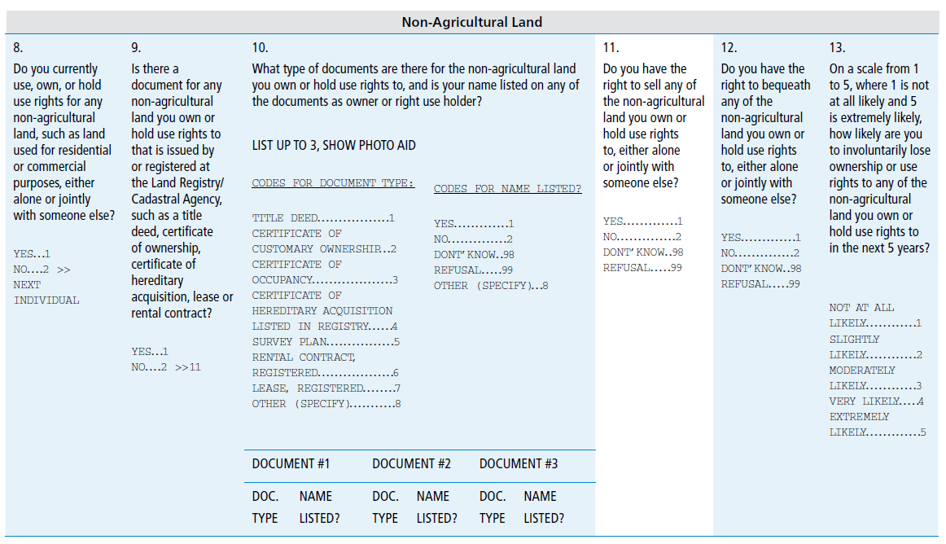  ª Proportion of total adult population with secure tenure rights to land, with (a) legally recognized documentation; and (b) who perceive their rights to land as secure, by sex and by type of tenure.  ^{b} (a) proportion of total agricultural population with ownership or secure rights over agricultural land by sex; and (b) share of women among owners or rights bearers of agricultural land, by type of tenure.
Guidance on data entry and reporting | Check that the total land area accessed by the household matches the sum of the land areas with different access types.
Indicator interpretation and threshold setting
Limitations
References | FAO; The World Bank; UN-Habitat. 2019. Measuring Individuals’ Rights to Land: An Integrated Approach to Data Collection for SDG Indicators 1.4.2 and 5.a.1. Washington, DC. 72p.²⁴

Farmer agency
Indicator | Farmer agency
Theme | Social justice
Purpose of indicator | Individual agency to decide on what to consume, produce, and trade, and how to produce it, is a basic human right for farmers. Monitoring farmer agency provides an indication of the power dynamics influencing major decisions about the farm and food system, and level of social equality (SDG 10, 16).
Data source | Household surveys
Measurement | Ladder of Power and Freedom, from GENNOVATE
Measurement units | Score of 1 to 5, and quotes and insights from analysing qualitative data, for the household and each individual surveyed
Guidance on measurement | The GENNOVATE Ladder of Power and Freedom is a qualitative data collection tool aimed at understanding local men and women farmers’ own perceptions of agency and key factors determining levels of agency. Here, agency refers to ‘the capacity to make important decisions in one’s life and act upon them’ ²⁶.  The Ladder provides comparative qualitative measures of agency that remain contextually grounded, and can be converted to a single quantitative agency score (but see notes on effectively applying the ladder approach). Data are collected through an individual interview using the ladder visual (see inset), which is a scoreboard showing different levels of agency. Data can also be collected at the community level through a focus group.  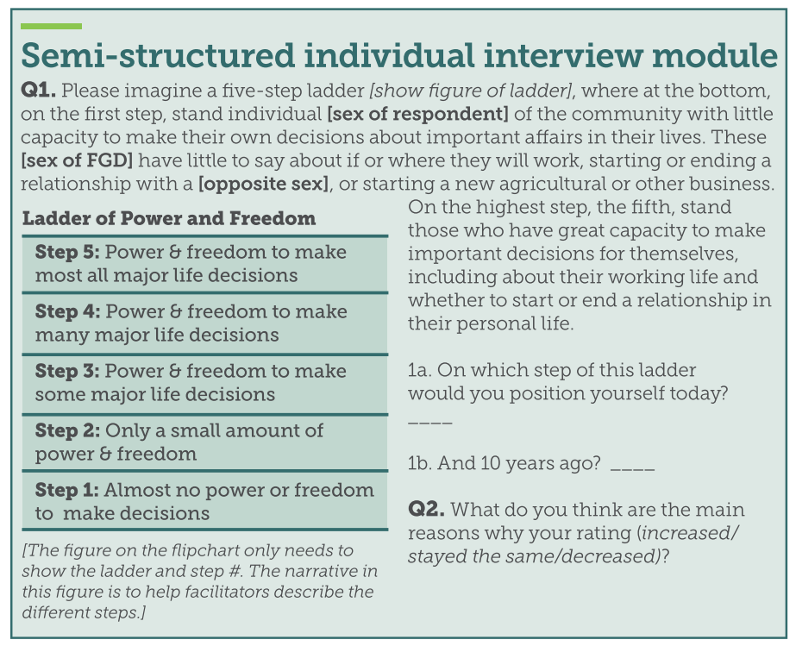  Source: ²⁶  The ladder is applied as follows. The researcher identifies a meaningful historical benchmark, usually 10 years in the past, and provides (or creates) a visual of the five-step ladder on a sheet of paper. The researcher introduces the purpose of the exercise. They will need to explain the five-step ladder, and that step 5 indicates great power and freedom while step 1 indicates very little power and freedom to make important decisions.  For example: Today we want to talk to you about how much power and freedom [wo]men in this household have to control the household food system – that is, how and what kind of food is produced, where it goes, and how and what kind of food people consume. Please imagine a five-step ladder [show figure], where at the bottom, on the first step, stand the individual [wo]men of this community with little capacity to make their own decisions about food production and consumption. These [wo]men have little to say about the types and varieties of crops, animals, trees, and animals they cultivate, the way they manage their water, land, soil, animals, and wildlife, the markets available to them, and the food source and food choices available to them. On the highest step, the fifth, stand those who have great capacity to make important decisions for themselves, including what they grow, how they manage their land, soil, water, animals, and trees, and what food they buy.  Request the individual to mark on the ladder the step they think household members of their gender occupy.  Facilitate the discussion on reasons for the step identified. For example:  Q. Why would you place [wo]men on this step? Would you like to volunteer the reasons for your rating?  Q. Would you position different types of [wo]men in different places on this ladder? Older people, younger people, poorer people, single people, etc.? Do women and men differ?  Repeat the rankings and discussion to capture perceptions of power and freedom a decade ago (or at the pre-defined historical benchmark). These sticky notes / cards can fill in the other side of the ladder. These discussions should also be probed deeply to elicit detailed explanations for the trends in agency identified. The goal of the exercise is to understand the factors that shape women’s or men’s conceptions of power and freedom in their lives, and reasons for changes in these conceptions over time, rather than obtaining exact measurements or absolute values for agency.  Time permitting, facilitate a discussion about the changes the participants would like to see and what would be needed to achieve their vision. For example:  Q. Having talked through this together, are there changes you would like to see to give [wo]men more power and freedom in the future? What would be needed to achieve this? What are the major obstacles?  Record the whole interview and take good notes. During the discussion, listen closely for the reasoning behind votes, root causes of high or low agency, factors that contributed to change, and any differences reported for different groups in the community. Make note of powerful quotes that could be extracted later. Record how many votes are cast for each ladder step for both past and present.  Example responses for data collected at the community level:  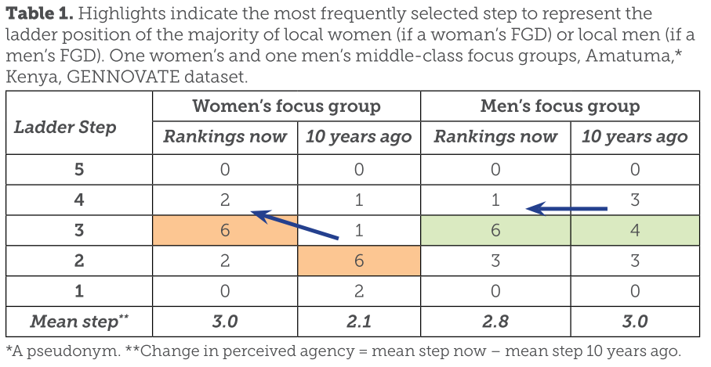  Source: ²⁶  Notes on effectively applying the ladder approach:  - Researchers should ideally be the same sex as participants.  - Individual surveys should be conducted in a private room without the presence of any members of the household or anyone of the opposite sex.  - Since the tool requires respondents to recall circumstances 10 years ago, the minimum recommended respondent age is 25 years old. However the 10-year timeframe could be reduced if younger respondents are present.  - To assist with recall, it is helpful to identify the year corresponding to 10 years ago (e.g. 2014) and an important event at that time.  - Researchers need to have a good level of skill in qualitative data collection to collect meaningful data on agency using this (or any) method. For example, managing group dynamics in household (or focus group) surveys is important to ensure the perspectives of individuals with lower levels of agency are captured.  - The researcher should probe deeply into individual explanations of ladder rankings to understand the reasons for these rankings.  - Reducing agency to a single score (i.e., the mean step change at household level) risks undermining the relevance and quality of the data collected. Focusing on qualitative data collection and analysis is strongly recommended for a more meaningful and accurate understanding of individual and household agency.
Guidance on data entry and reporting | This indicator collects sensitive data on human subjects. Researchers should obtain ethical approval from a verified review board prior to data collection. Study participants should receive assurances that their testimonies will be provided anonymously and no identifying information shared in any future publications.
Indicator interpretation and threshold setting
Limitations
References | - Petesch and Bullock (2018) ²⁶  - Tavenner and Crane (2022) ²⁷

Human well-being
Indicator | Personal Wellbeing Index
Theme | Human well-being
Purpose of indicator | This indicator aligns with SDG 3 “Ensure healthy lives and promote well-being for all at all ages”.
Data source | Household survey
Measurement | OECD Personal Wellbeing Index evaluation questions
Measurement units | Likert scale (0-10)
Guidance on measurement | Human well-being encompasses quality of life and the ability of people and societies to contribute to the world with a sense of meaning and purpose. It encompasses a broad range of factors, including material well-being and emotional, physical, and social health²⁸. While people’s living conditions (e.g., housing, income, employment) are important contributors to well-being, measuring living conditions (i.e. material well-being) alone fails to capture what people think and feel about their lives – i.e., their subjective well-being.  OECD’s Personal Wellbeing Index is computed based on responses to the following questions²⁹:  - Thinking about your own life and personal circumstances, how satisfied are you with your life as a whole? [0-10]  - How satisfied are you with your standard of living? [Standard of Living] [0-10]  - How satisfied are you with your health? [Personal Health] [0-10]  - How satisfied are you with what you are achieving in life? [Achieving in Life] [0-10]  - How satisfied are you with your personal relationships? [Personal Relationships] [0-10]  - How satisfied are you with how safe you feel? [Personal Safety] [0-10]  - How satisfied are you with feeling part of your community? [Community-Connectedness] [0-10]  - How satisfied are you with your future security? [Future Security] [0-10]  - How satisfied are you with the amount of time you have to do the things that you like doing? [0-10]  - How satisfied are you with the quality of your local environment? [0-10]  - For respondents who are employed only: How satisfied are you with your job? [0-10]
Guidance on data entry and reporting | Key issues include the need to be careful with question wording, use consistent scales, and appropriate question ordering.  1. Question wording  “Because question wording matters to how people respond to questions on subjective well-being, the translation of questions is of high importance. Potential issues arising from translation cannot be eliminated, but they can be managed through an effective translation process. A robust translation process, including back translation, is therefore essential” ²⁹.  2. Scale design  “Variation in response formats can affect data quality and comparability. In the case of evaluative measures, there is empirical support for using a 0-10 point numerical scale, anchored by verbal labels which represent conceptual absolutes (such as completely satisfied/completely dissatisfied). On balance, it is preferable to label scale interval points (between the anchors) with numerical, rather than with verbal, labels” ²⁹.  3. Question order  Subjective well-being questions are influenced by context and thus need to be asked in the right place so as not to be influenced by previous questions. Also consider randomizing the order in which the well-being questions are asked to reduce ordering-bias.
Indicator interpretation and threshold setting
Limitations
References | WHO (2024), Promoting well-being, https://www.who.int/activities/promoting-well-being, accessed 1 July 2024²⁸  OECD (2013), OECD Guidelines on Measuring Subjective Well-being, OECD Publishing. http://dx.doi.org/10.1787/9789264191655-en²⁹  International Wellbeing Group (2006), Personal Wellbeing Index, 4th edition, Melbourne, Australian Centre on Quality of Life, Deakin University.³⁰

Economic KPIs

Agricultural productivity
Indicator | Crop and livestock productivity
Theme | Agricultural productivity
Purpose of indicator | Ensuring productivity and closing yield gaps is a primary goal in agricultural systems and vital for achieving global food security (SDG2), and securing livelihoods (SDG1).
Data source | Household survey (farmer recall)
Measurement | For crops: kg/ha (dry weight) of harvestable produce; land equivalent ratio for intercropped and agroforestry systems (0 to infinity)  For livestock: ## animals slaughtered for consumption/sale/gifts, kg meat/animal, litres (milk)/animal eggs/chicken, manure/animal, wool/animal, skin/animal
Measurement units | Kg/ha; kg/animal; l/animal; land equivalent area
Guidance on measurement | Crop productivity through farmer recall  Harvestable production per unit land area (kg/ha) for at least the three main crops, based on farmer recall for all produce harvested over the past 12 months. In the case of intercropped or agroforestry systems, collect data for all crops present in the plot and compute the land equivalent ratio (LER).  Livestock productivity  Production of animal products per unit livestock, for at least the three main livestock species (including fish), based on farmer recall of all products consumed, sold or gifted over the last 12 months.  Desirable additional data:  - Population growth rate: ratio between the production in number of animals and the initial population size  - Total annual livestock production = (stock variation +offtake-Intake)/ Initial size  - Production of milk : av. production per female (/day)* number of reproductive female* milking period  - Skin & hides (from offtake)  - Wool : total production per year  - Manure : total production (can be collected in declarative)  - Productivity indicators: 1) Number of new sub-adults produced per reproductive female per year 2) Number of new adults produced per reproductive female and year  Crop productivity - detailed measurements (beyond the scope of HOLPA)  For crops see FAO (2017): https://www.fao.org/3/ca6514en/ca6514en.pdf.  For livestock see FAO (2018): https://www.fao.org/3/ca6400en/ca6400en.pdf.  Summary for crop yield: Yields of all crops should be measured by randomly demarcating at least three same-size plots in a field, harvesting all produce, then drying the produce and weighing it to determine its dry weight. If possible take into account harvest losses (proportion of diseased, rotten or otherwise unusable produce). Alternatively, yields can be measured based on farmer recall particularly where farmers keep good records, but note that in many cases this method is inaccurate. Alternatively, farmers can be asked to keep crop diaries and record all harvested produce over the cropping season, which produced reliable results for the LSMS but is unsuitable for illiterate farmers. See guide for further details on calculating yields in mixed cropping systems.  Crop and pasture areas should be estimated by walking along the perimeter of the farmed areas with a GPS (preferred method) or using the rope-and-compass method (see https://www.fao.org/3/ca6514en/ca6514en.pdf). Areas of additional plots that are far away or difficult to access can be estimated by farmers, and verified on Google Earth imagery if possible. Asking farmers to estimate the area of their fields can work well for small parcel sizes in some contexts, but is often unreliable e.g. when farmers are not familiar with the units of measurement or if farmers have incentives to misreport crop area (see https://www.fao.org/3/ca6514en/ca6514en.pdf).
Guidance on data entry and reporting
Indicator interpretation and threshold setting
Limitations
References | Dutilly C., Alary V., Bonnet P., Lesnoff M., Fandamu P., De Haan Cees, 2020. Multi-scale assessment of the livestock sector for policy design in Zambia. Journal of Policy Modeling 42 (2): 401-418. https://doi.org/10.1016/j.jpolmod.2019.07.004³¹  Alary, V., Lasseur, J., Frija, A., & Gautier, D. (2022). Assessing the sustainability of livestock socio-ecosystems in the drylands through a set of indicators. Agricultural Systems, 198, 103389.³²

Labour productivity
Indicator | Labour inputs per unit agricultural land area
Theme | Labour productivity
Purpose of indicator | Labour inputs required for agricultural production is one of the primary factors determining which practices are used, how profitable they are, and the social sustainability of the production system. Distinguishing which productive systems promote sustainable employment contributes to SDG 2 and SDG8.
Data source | Farmer recall during household survey
Measurement | Person hours per year, disaggregated by gender, season, and productive activity
Measurement units | Person hours per year per hectare of cultivated land
Guidance on measurement | This indicator can be computed by collecting data on number of labour hours per year per hectare of land actively used for agricultural purposes. Labour hours should be disaggregated by:  - gender  - age  - type of worker: hired or not hired, permanent or seasonal  - type of activity: routine (e.g. manure collection, milking) or seasonal work (e.g. seeding, harvesting, pruning).
Guidance on data entry and reporting
Indicator interpretation and threshold setting
Limitations
References | FAO (2010) ³³

Total income and income stability
Indicator | Total income; Income stability
Theme | Income
Purpose of indicator | Total income and income stability are indicators of household living standards. Ensuring that agricultural livelihoods provide adequate and stable or increasing incomes contributes to rural development and ending poverty (SDG1).
Data source | Household survey
Measurement | Ratio of household income to national income; Likert score
Measurement units | Ratio (unitless); Likert score 1-3 or 1-5
Guidance on measurement | We discuss three measurement approaches used in HOLPA: i) calculating total household income, ii) qualitative measure of income stability, iii) qualitative measure of income-expenditure ratio.  Income level (KPI1)  Total income per household is the total amount of profit or net earning a household makes over a given period. Ideally, income should be computed from data collected on all types of income generating activities agricultural or non-agricultural activities, goods and service based) and all types of household expenses, over the last 12 months. In practice, these data can be challenging to accurately collect in systems without digital records because they rely on farmer recall of all incoming and outcoming funds. Data on income should be compared to the national mean income level and used to calculate the ratio of household to mean national income.  In addition, collecting data on income sources can be used to assess the level of dependency on single income sources or the capacity to withstand a shock through income diversification.  Income based on assets (alternative KPI1)  [Veronique found that 10 questions on assets were a good indicator of total income]  Flows (income) versus stocks (wealth)  - For wealth there is the DHS asset index  - Related issues on interpretation of income - subsistence farmers may have a low income but high food security  Carlo has references that show how to use  Income stability (qualitative) (KPI2)  Respondents are asked ‘How would you rate the stability of household income?’:  5 - Income is increasing over time.  4 – Income is stable over time.  3 - Income varies little from year to year.  2 - Income varies from year to year.  1 - Income is on a decreasing trend.  This information provides a rapid indication of income trends.  Income-expenditure balance (complementary indicator, not a KPI)  HOLPA collects data on whether expenditures are less than, equal to, or more than income received by the household, over the last 12 months. The responses can be used to give a simple measure of whether the household has sufficient income to meet its needs.  Data are collected by asking: In the last 12 months, did the household spend more money on the farm than it earns from the farm?  - Yes  - No  - I don't know
Guidance on data entry and reporting | For KP1, be sure to use the same time unit and currency. Discuss income in terms of the local currency during the survey. When possible (not always easy), it may be more appropriate to ask the question of total income for each source of income to avoid confusion (IDH, 2021). If a crop was grown during multiple seasons within one year, it is preferable to ask the question for each season and then evaluate over the year. For livestock activities, distinguish regular income (e.g., milk, eggs per week) and more occasional income due to the sale of animals.
Indicator interpretation and threshold setting | Income level depends on occupational activity, but this is not the only determining factor. Income level is also a criterion of social differentiation; it partially influences consumption, savings, accumulation, and lifestyle behaviors.
Limitations | Total income assessment faces at least three main difficulties:  1. The attitude of the head of household and her/his family, who will (i) either underestimate their net income to avoid taxes, benefit from potential survey-related assistance, avoid social pressures from neighbors, (ii) or overestimate it to display their social success or assert their social position (Parvathi et al, 2018; Carletto et al, 2022; Angel et al., 2019).  2.The complexity of income in rural areas, with significant seasonal variability in both earnings and production costs, means that respondents may rely on either recent transactions or their primary activity, neglecting all sources of income derived from other activity.  3. the revenues can be earned and manage by the different members of the household who share the same roof or the same meal (household unit). In this case, it is important to make a link between the various activities carried out by all household members.  Alternative income indicators to consider in future surveys include:  - Using the main household assets (type of housing, number of rooms and building materials, means of transport and communication, production tools, livestock) and their owners, it is possible to develop a good proxy for income level ( see for instance: PPI, https://www.povertyindex.org/)  - Monitoring expenditures, since income in rural areas is often composed of the market and non market sales, and self-consumption.
References | PPI, https://www.povertyindex.org/)  IDH Sustainable Trade. (2024). Income measurement survey user guide [PDF]. Retrieved from https://www.idhsustainabletrade.com/uploaded/2024/05/Annex-1_Income-Measurement-Survey_IDH_User-Guide.pdf  Angel, S., Disslbacher, F., Humer, S., & Schnetzer, M. (2019). What did you really earn last year?: explaining measurement error in survey income data. Journal of the Royal Statistical Society Series A: Statistics in Society, 182(4), 1411-1437.  Carletto, G., Covarrubias, K., Davis, B., Krausova, M., & Winters, P. (2007). Rural Income Generating Activities Study: Methodological note on the construction of income aggregates. Agricultural Sector in Economic Development Service, Food and Agriculture Organization.  Gero Carletto, Marco Tiberti, Alberto Zezza, Measure for Measure: Comparing Survey Based Estimates of Income and Consumption for Rural Households, The World Bank Research Observer, Volume 37, Issue 1, February 2022, Pages 1–38, https://doi.org/10.1093/wbro/lkab009  Parvathi, P., & Nguyen, T. T. (2018). Is environmental income reporting evasive in household surveys? Evidence from rural poor in Laos. Ecological Economics, 143, 218-226.  Markowitz, 1952. Portfolio Selection. The Journal of Finance, Vol. 7, No. 1, pp. 77-91.  PPI, https://www.povertyindex.org/)

Climate resilience
Indicator | Resilience score
Theme | Climate resilience
Purpose of indicator | Climate change is affecting food systems around the world, with temperatures and precipitation anomalies and extreme events leading to crop/livestock losses, altering species ranges, creating agricultural water stress, altering working conditions and triggering human migration. Building farm and food system resilience to climate change and other major stressors (e.g. pandemics, war) is fundamental to prevent food and livelihood insecurity (SDG 1, 2), and avoidable loss of life (SDG 3, 15).
Data source | Household survey
Measurement | Resilience score adapted from RIMA
Measurement units | Score 0-20
Guidance on measurement | Resilience is the capacity of socioeconomic systems (e.g., households) to withstand shocks through adaptation and transformation.  FAO’s Resilience Index Measurement and Analysis (RIMA) is one way to measure resilience. FAO computes a Resilience Capacity Index (RCI) based on data collected across four pillars:  - Access to basic services (ABS)  - Assets (AST)  - Social safety nets (SSN)  - Adaptive capacity (AC)  FAO calculates the RCI using structural equation modelling (SEM), combining Confirmatory Factor Analysis and Path Analysis. There are two steps: 1) estimate resilience of each pillar through Factor Analysis (FA), 2) calculate a resilience index from the pillars, using Ordinary Least Squares with the outcome variable being a food security indicator(s) such as dietary diversity score. The benefit of this approach is that is possible to quantify the contribution of each pillar to the overall resilience. The limitation is that the RCI depends heavily on which indicator is used as the outcome variable which does not capture the variation across the four pillars.  For HOLPA, we adapt the FAO approach to directly combine the data from the four pillars into a measure of resilience scaled from 0-20. This can be done by assigning scores of 0-5 to all responses, then taking the mean within each pillar, and summing scores across the four pillars according to the following table:  Pillar Question Score assigned to response  ABS Does your farm/household have the following services: 1) Drinking water piped to the household, 2) Toilet with piped sewer or septic tank, 3) Electrical energy, 4) Waste (rubbish) collection service, 5) Mobile phone reception, 6) Internet. [Count services] 5: 3 or more 2.5: 1-2 0: None  ABS How far (one way) is the household from the closest accessible and functioning service in minutes (walking): 1) Freshwater source, 2) primary school, 3) public hospital or health facility, 4) livestock market 5) agricultural/crops market, 6) public means of transport, 7) well-maintained road suitable for cars. For each service: 5: <5 mins 2.5: 5-20 mins 0: > 20 mins  AST How many of the following assets do household members own: 1) Car, 2) Motorbike, 3) Bicycle, 4) Gas or electric cooker, 5) Mobile phone, 6) Ox-plough, 7) Tractor, 8) Machete. [Count assets] 5: 5 or more distinct asset types 2.5: 2-4 0: 0-1  SSN On average, how many school meals have the children living in the household received per week, during the last month of attending school? 5: 5 meal 4: 4 meal 3: 3 meal 2: 2 meal 1: 1 meal 0: 0 meals  SSN Would any of the following individuals or organisations provide your household support in case of need: 1) local farmer associations or cooperatives, 2) other local associations (e.g. women support groups, youth groups), 3) individuals from my community, 4) individuals from a different community, 5) community leaders, 6) NGOs 8) local government, 9) national government, 10) other (please specify). [Count sources] 5: 3 or more 2.5: 1-2 0: None  AC Can the head of household read and write in any language? 5: Can read and write 2.5: Can read or write 0: Cannot read or write, or prefer not to say  AC On average, how many years have the household members of working age (>14 and <65 years old) attended formal school? 5: ≥7 (Secondary or higher) 2.5:<7 (Primary only) 0:0 (None)  AC Has any household member received training in the last 12 months? 5: Y 0: N  AC In the past 12 months, what were all the household’s sources of income: : 1) Agriculture, animal breeding, fishing, 2) Other family business, 3) Government salary, 4) private sector salary, 5) Cash transfers (e.g. transfers from absent family members, donations), 6) Other (please specify) [count sources] 5: 3 or more sources 2.5: 2 sources 0: 1 source  AC In the past 7 days, what percentage of the household's income was used for buying food 5: 0-25% 3.33: 26-50% 1.66: 51-75% 0: 76-100%  AC In the past 5 years, has your farm/household had access to credit to support investment in your farming business. 5:Y 0:N, or I don’t know  AC How do you feel about your farm/household's ability to meet credit repayments now and until the loans are fully repaid? 5: Full repayments 3.33: Uncertain future repayments 1.66: Uncertain current repayments 0: Uncertain current and future repayments  AC Do you have access to crop insurance? If yes, what is covered, e.g. losses from weather events, pest outbreaks market shocks? 5:Y 0:N  AC Do you have access to subsidies for agricultural inputs? If yes, which inputs 5:Y 0:N  Additionally, HOLPA collects data on household exposure to shocks over the last 12 months and any coping mechanisms employed.
Guidance on data entry and reporting
Indicator interpretation and threshold setting
Limitations
References | FAO (2016) RIMA³⁴

Complementary indicators
These indicators cannot be calculated from data collected through the standard HOLPA survey, yet are recommended for inclusion as complementary performance indicators for projects with capacity to collect additional data.

Bat, bird and insect diversity
Indicator | Bat, bird and insect diversity
Theme | Biodiversity
Purpose of indicator | Relevant for the post-2020 Global Biodiversity Framework Target 10 on ‘Proportion of agricultural area under productive and sustainable agriculture’. In addition to evaluation of on farm crop and Livestock diversity, this metric will summarise species level diversity of trees, birds and insects within the farm landscape used by farmers. It will combine field transects and use state of the art acoustic monitoring and school-based citizen science monitoring to evaluate, bird, insect and bat diversity across the ALLs.
Data source | Field survey, field based Passive Acoustic Monitoring (PAM), and citizen science
Measurement | Bird species diversity and guilds, insect diversity, based on acoustic profiles, and bat diversity, based on automatic monitoring.
Measurement units | Bird, Bat and Insect diversity, species number.
Guidance on measurement | This indicator can be calculated by collecting data on the:  - Total number of bird species, and their guilds (forest species, generalist, rarity).  - Total number of detected insect species or complexity of insect acoustic profile.  These data can be collected as part of a field survey, and using base stations set up in each ALL. To verify the data, and help to obtain area estimates, users can work with the SoundLab University of Wisconsin or other established analysts.
Guidance on data entry and reporting | Be sure to use the same area units and monitoring acoustic stations for all sites and species/, so that diversity indices can be calculated. Bird, bat and insect species names should be stored in the local language and also using their scientific and English names to enable comparisons across sites.
References | Ross, S.R.J., O’Connell, D.P., Deichmann, J.L., Desjonquères, C., Gasc, A., Phillips, J.N., Sethi, S.S., Wood, C.M. and Burivalova, Z., Passive Acoustic Monitoring provides a fresh perspective on fundamental ecological questions. Functional Ecology.³⁵

Pollinator diversity
Indicator | Insect pollinator diversity
Theme | Biodiversity
Purpose of indicator | Relevant for the post-2020 Global Biodiversity Framework Goal B on conserving services provided by ecosystems (CBD/COP/15/L.26). Pollinator declines are threatening agricultural production in multiple regions ^{36,37}, while pollinator deficits are directly linked to poor human diets and nutrition-related diseases ^{38,39}. Most fruit and vegetable crops are pollinator-dependent and fruits and vegetables are a vital source of vitamins for people ⁴⁰.
Data source | Direct measurement in field
Measurement | Sweep netting, pan traps and/or targeted field observations in quadrats
Measurement units | Count with species of pollinator (clearly differentiating between visitor and pollinator) per unit time of observation within a defined area (plot), transect length and number of stops (with standardised number of sweeps/ time period), number of visits to the flowers by the pollinator. For pan traps, collections separated by colour of bowls placed for fixed durations (start and end time to be noted and to be consistent about the time and duration).
Guidance on measurement | For a general insect pollinator diversity and abundance study, sweep netting along a transect (a fixed or variable corridor of flowering plants walked for a set distance and/or time, and pollinators either identified through visual observations, caught for laboratory identification, or a mixture of both approaches) or pan traps (a triplet of plastic bowls of about 350 ml capacity; sprayed with UV fluorescent paint with 1 white, 1 yellow, 1 blue; with each bowl containing 100 ml of water plus a drop of unscented detergent to break surface tension and placed at ground-level, or mounted at surrounding crop flower height, in order to trap bees for subsequent laboratory identifications) along transects can be used to collect pollinator data in non-cropped areas, while targeted field observations on small quadrats / plots (a fixed plot of flowers observed for a fixed amount of time where the visitors can either be identified visually and/or caught for laboratory identification) and/ or pan traps can be used to collect pollinator data on cropped land.  Sweep netting is effective for catching a wide range of pollinators. Sweep netting requires killing insects, but to reduce mortalities, experienced enumerators could release common pollinators. However inexperienced enumerators will need to retain all insects so these can be correctly identified.  On fields where farmers do not want us to sweep net, pan traps can be used instead. Pan traps are effective for monitoring flying insects as long as there is water access on field and the pans don’t get stolen or damaged (elephants and other wildlife can be a problem). Samples need to be harvested on a timely basis, because they rapidly deteriorate. Pan traps require minor funding for installation.  Targeted observations on small quadrats / plots involves using a frame of a defined size (size large enough to be able to observe by 1 observer based on the pollinator activity and observability of the researcher, Ex: 50*50 cm plot), number of floral units within the plot, or fixed number of branches or flowers depending on the type of plants being observed. The investment is minimal but requires some amount of training.  Ideally pollinators should be identified to genus or species level with the assistance of trained experts. Local universities could be contacted to identify such experts.  Pan traps are better for solitary bees and hoverflies, while transects or plots are better for social bees and other insects. The methods will have to be adapted based of the crop type or pollinators of interest.  The floral resources available per unit area can also be recorded.  Note on other methods  Sticky traps are an easy and often cheap option, but are less suitable to monitoring a diverse set of flower visitors.
Guidance on data entry and reporting | The data will have to be recorded based on the method employed. Record crop type/ type of habitat being observed, field and plot number, replication, time of observation for all methods. Additionally, for-  - Transect: Length of the transect, number stops, time spent per stop and number of sweeps need to be consistent. Record species collected/ observed, stored species to be labelled for further identification.  - Pan traps: Number of traps, colour combination, distance between two trap stations, replications (or transect length)- need to be consistent. Segregate species collected based on trap colours and trap station and transect number. Record the species and number of individuals while sorting at the lab.  - Targeted observations on plots: Plot size, replications (within plot and within field), extent of time observed needs to be consistent. Number of visits (a visit is counted only if the insect makes contact with the floral reproductive organ) and species visiting the target species per plot/ branch/ flower.
References | O’Connor et al. (2019)⁴¹  Hicks et al. (2016)⁴²

Soil health (SOCLA)
Indicator | Soil health
Theme | Soil health
Purpose of indicator | Healthy soils underpin healthy and productive agroecosystems. This indicator contributes to Sustainable Development Goal (SDG) indicator 2.4.1 which includes a sub-indicator on ‘prevalence of soil degradation’, and SDG indicator 15.3.1 on ‘proportion of degraded land’.
Data source | Field measurement
Measurement | Latin American Society for Agroecology (SOCLA) indicators of soil health, adapted by TAPE
Measurement units | Score from 1 to 5, representing the mean indicator value across 10 indicators
Guidance on measurement | Soil health can be determined through field surveys with values for 10 indicators of soil health determined jointly by the farmer and enumerator. The proposed indicators were developed by the Latin American Society for Agroecology (SOCLA) and described in Nicholls et al. (2004)¹².  Data are collected by digging or picking up a small amount of soil to examine it more closely, in each of the same 10x10m square plots used to assess biodiversity. The SOCLA 10 indicators of soil health are:  - Soil structure  - Degree of compaction  - Soil depth  - Status of residues  - Colour, odour and organic matter  - Water retention  - Soil cover  - Signs of erosion  - Presence of invertebrates  - Microbiological activity  Note, for the SOCLA analysis of soil health, you will require a wire flag (length ~50 cm, thickness ~0.08 mm) and hydrogen peroxide (volume ~100 ml). The measurement of compaction (indicator number 2) requires a wire flag which is pressed vertically into the soil, and the level of compaction is determined based on the depth at which the wire bends due to the resistance in the soil caused by compaction. Measuring microbiological activity (indicator number 10) requires hydrogen peroxide, which is poured in small quantities to assess the effervescence in soil. Little or no effervescence indicates soil with little organic matter and poor microbial activity, while high effervescence indicates rich organic matter and greater microbial activity¹².  Each indicator is scored from 1 to 10 based on the following guidelines¹²:  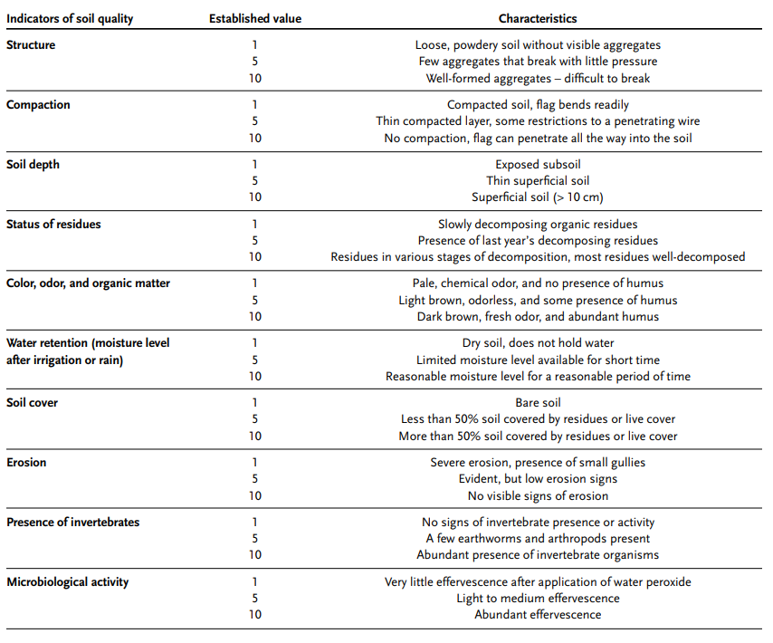  When the scoring of the indicators is complete, the values assigned to the indicators are added and divided by the number of measured indicators to obtain a mean value between 1-10.
Guidance on data entry and reporting | Record the score from 1 to 10. Be sure to take a GPS point and keep a record of the geographic coordinates where soil samples were taken to allow follow-up surveys in the same locations.
References | - Nicholls et al. (2004)¹²  - FAO (2019)¹

Nutrient use efficiency
Indicator | Nutrient use efficiency
Theme | Nutrient management
Purpose of indicator | Nutrient use efficiency (NUE) is important indicator in nutrient management as it provides information on the efficiency of inputs use, which has important implications for crop productivity, economic viability, and environmental sustainability. By monitoring NUE, farmers and agronomists can determine if the current inputs are meeting the nutrient needs of the crop and if adjustments are needed to optimize inputs use and reduce nutrient losses to the environment. This indicator is also related to a number of Sustainable Development Goals (SDG) e.g SDG 2 on zero hunger and SDG 15 life on land.
Data source | Field measurements, farm surveys (interviews and questionnaires), extension and agricultural officers
Measurement | Nutrient use efficiency (uptake and losses) in the production system
Measurement units | Harvested produce (kg) per unit N input (kg) per year, disaggregated by organic or chemical inputs. Can be presented as a ratio or as a percentage (%) of output removal over inputs.
Guidance on measurement | Nutrient use efficiency as an indicator can be determined at the three levels i.e. plot level (the level of individual crops), farm level (the level of a whole farm and its cropping system), and landscape level (a larger area e.g. region or watershed).  Data can be collected on growth parameters considering key stages of crop cycle as different stages have varied needs of nutrients uptake and utilization. Growth rate, change in biomass (root and above ground biomass). Nutrient uptake can be estimated by multiplying the N concentration of the plant by its biomass.  - Nutrient input- amount of nutrient (such as nitrogen (N), phosphorus (P), or potassium (K)) that is added to the farm system, either through fertilization or other means.  - Nutrient uptake- amount of nutrient that is taken up by the crops and other plants growing in the farm system.  - Boundary definition: extent of the system being studied, and includes the inputs and outputs that are considered in the NUE calculatio.  - Crop yield: total biomass produced by the crops in the farm system. Crop yield can be used to estimate nutrient uptake, as nutrient uptake is proportional to crop yield.  Plant tissue analysis: analysis of plant tissue samples, such as leaves or stems, to determine the nutrient concentration and biomass of the plants growing in the farm system.  At plot level it is important that regular measurements of the plant growth and nutrient uptake are done using standardized methods. e.g. Kjeldahl digestion for N content or the calorimetric methods.  At farm level, a standardized data collection and analysis method across multiple plots is required. With accurate recordings of crop rotations, soil management and nutrient inputs.  Farm definitions and specialization of system being studied e,g arable farms, horticultural farms, mixed crop-livestock. The spatial and temporal limits may include study the whole farm or during a growing season or over number years. Most recommended should be in yearly basis (kg ha⁻¹ yr⁻¹).  NUE at landscape level will include a standardized method of data collection and analysis from multiple farms, proper delineation of boundaries of different farm practices (e.g arable, horticultural, mixed crop-livestock) including environmental and socio-economic factors to account for farm heterogeneity.  The method to determine NUE at all scales is NUE = N output / N input.  At all scales, it is good to consider all possible sources of inputs into the system to avoid under or overestimation of the NUE.  Specific survey questions should address the following:  - What is the amount of nutrient input, such as nitrogen (N), phosphorus (P), or potassium (K), added to the farm system through fertilization or other means? In kg ha-1  - How many crop cycles or seasons do you have in a year and different crops in specific plots considering rotations  - Yield obtained in the farm (tha⁻¹) edible portion +stover yield categorized for each product grown in the farm /plot  - For farm surveys we need specific concentration/content of nutrients in the harvested products – secondary co-efficient can be obtained from literature or specific analysis can be done on sampled products.
Guidance on data entry and reporting | Uniform data entry and all conversion of inputs and output to be reported in kg ha⁻¹ yr⁻¹. Define the unit of measurement (e.g. kg N uptake per kg N applied, % N, etc) and make sure all data is reported consistently using the same unit.
References | - Dobermann, (2007)²¹  - European Union Nitrogen Use Efficiency (NUE) (2016)²²

Nutrient balance
Indicator | Nutrient balance
Theme | Nutrient management
Purpose of indicator | Nutrient balance is the difference between the nutrient inputs entering a farming system (mainly livestock manure and fertilisers) and the nutrient outputs leaving the system (the uptake of nutrients for crop and pasture production). A nutrient deficit indicates declining soil fertility. A nutrient surplus indicates a risk of polluting soil, water, and air. Nutrient balances are important indicators of land degradation and water pollution, relevant to SDG 6, 15, and the UNCDD.
Data source | Field measurements, farm surveys (interviews and questionnaires), extension and agricultural officers
Measurement | Mass balance of inputs and outputs in the systems (including all sources of inputs and all sources of output in a defined system
Measurement units | Kg of N per ha
Guidance on measurement | The OECD system calculates nutrient loadings for nitrogen and phosphorus to agricultural soils. It is a fairly complex system based on wide range of data sources. Nutrient inputs and offtakes are estimated by applying coefficients to physical data. The physical data covers livestock numbers, crop areas, crop yields and fertiliser use. The relevant coefficients have been developed by empirical research by experts (e.g. ADAS) within a large programme of research projects.  Input indicators:  - Mineral fertiliser consumption  - Cropping/livestock patterns (active pasture land, area of potentially fertilized land)  - Farm management practices (seed and planting materials, crop residues, manure production and use)  Output indicators:  - Ammonia emissions  - Emissions of methane and nitrous oxide  - Nitrates/pesticides in water  - Share of agriculture in nitrate contamination  Issues to be aware of:  - Estimates for offtake from pasture are based on average pasture yields and an assumed rate of grazing. Pasture represents a very significant part of the overall offtake and improvements in these estimates would greatly improve the overall accuracy of the balance sheets.  - Estimates of fertiliser use at below national level are based on a national average application rate for each crop type. Due to regional variation in practice, estimates would be improved if regional level application rates for each crop type could be estimated.  - The land to be used in the scope of the balance sheets must be correctly defined. If unfertilised land is included, the balance sheets will underestimate the total nutrient loadings. Reflecting this, the UK excluded land identified as “rough grazing” from the balance sheets.  - Manure is assumed to be applied to the same parcel of land on which the livestock are grazed/reared. This assumption is robust at aggregated levels but may not be valid at finer spatial scales, particularly at a holding level.  Questions to guide data collection in surveys  - What crops are grown on the farm and in what rotation?  - What is the typical cropping period for each crop?  - What type of fertilizers/inputs are used on the farm?  - How are the fertilizers /inputs applied (e.g., broadcast, banded)?  - How often are fertilizers /inputs applied and in what amounts?  - What is the source of nitrogen inputs to the farm (e.g., fertilizer, organic matter)?  - What is the amount of nutrient input per hectare and per year?  - How is the nitrogen input managed (e.g., application rate, timing, method)?  - What is the amount of nitrogen taken up by crops per hectare and per year-this can be determined by knowing the yield (stover/grain- tha⁻¹)?
Guidance on data entry and reporting | Data recorded on input and output as kg ha⁻¹ yr⁻¹
References | OECD/Eurostat Methodology and Handbook (2014)⁴³

Greenhouse gas emissions
Indicator | Greenhouse gas emissions
Theme | Climate mitigation
Purpose of indicator | Relevant for global climate mitigation goals (Paris Agreement) and nationally determined contributions (NDCs).
Data source | Farmer survey, literature review, and/or field measurements
Measurement | Emissions of nitrous oxide, methane and CO₂ (the main greenhouse gases, GHGs) minus carbon storage and sequestration by above-ground biomass
Measurement units | t C ha⁻¹ yr⁻¹
Guidance on measurement | Measuring GHG emissions  We discuss two options for measurement, i) using emission factors, ii) direct measurement.  Using emission factors  lan  This method is based on guidelines provided by the Intergovernmental Panel on Climate Change (IPCC 2006). GHGs are estimated by multiplying the activity data for the activity of interest with emission factors.  To apply this approach in estimating GHGs, the activity data for the area of interest needs to be well documented. This can be done as part of the household survey and supplemented with information from literature. For example, to estimate direct N₂0 emissions from agricultural soils in a certain region, one would require information on the use of fertilizers and manure, amount of N fixed by crops, amount of crop residues returned to soils, N-fixing crops, area of the cultivated crop and two emission factors, i.e. one for N inputs into soil and one for cultivation of organic soils. Detailed guidelines, examples, and training materials on how to apply the emission factors methodology to estimate GHGs can be found in the Non-Annex I training package ( https://unfccc.int/resource/cd_roms/na1/ghg_inventories/index.htm).  For livestock, much of the information required to calculate GHG emissions will be collected as part of the Animal health and welfare survey.  Step-by-step procedure:  - Within the area of study (e.g. the ALL), identify the major land uses, crops and livestock species.  - For each crop and livestock species selected, gather spatially-explicit management information (plot level information for crops and individual animal level information for livestock) together with associated soil and climatic information. Include as many plots/livestock number as possible to make the data representative for the area of interest.  - Gather total crop area and livestock number (segregated by type, breed, sex, age etc) within the smallest geographical unit (e.g. district)  - By using the management information collected in step 2, use the IPCC tier 1 emission factors co-efficients to estimate the emissions.  Direct measurement  For direct measurement of greenhouse gas emissions at farm level, use the “Static chamber method” and procedures as described in Rosenstock et al. (2016)⁴⁴.  Briefly, the chambers, made of plastic and of known dimensions are inserted into the soil to certain depths (forming bases), approximately one week before planting. About 3-5 chamber bases are inserted per plot per replicate. Base height dimensions are taken, the bases are then covered with special lids (vented, fitted with thermometers, fans, batteries and gas sampling ports) and are tightly clamped. Gas samples are collected following certain considerations (i.,e, timing, intervals, storage, etc) and taken to the laboratory for gas chromatography (GC) analysis to detect the three GHG (nitrous oxide, methane and CO₂).  Sampling requires some level of skills/expertise, i.e., drawing the gas from the chambers using the syringes should not be rushed but also not be done too slowly. When transferring the gases to the vials (evacuated) from the syringes, part of the gas (about 30 mls) should be used to push out the pre-existing gases in those vials and the remaining 30 ml retained in the tightly sealed vial (this is the one taken to the lab for GC). Training will be needed for these procedures, which will need just one day.
Guidance on data entry and reporting | Direct measurement at plot level  For direct plot measurements, proper frequency of gas sampling should be observed; guided by the prevailing environmental conditions. Under normal conditions, sampling should be done once per week. However, the frequency of sampling can be increased to 2 times per week under periods of expected high emissions in the field e.g., after rainfall, fertilization or soil disturbances like weeding. Sampling should be done between 9am to noon. In each sampling activity from the plot level, the following data should be entered:  Name of recorder, Date of sampling; Land use type; Name of site/experiment; Plot number; Air temperature and Air pressure. 3-4 chambers can be used per plot. In each of the 3 or 4 chambers bases installed , record the chamber heights (h1, h2, h3 and h4). When sampling begins, for each chamber base, record the start temperature (T1) and the stop temperature (T4) for every chamber. In each chamber, gas withdrawal (sampling) intervals can be timed at either 10 or 15 minutes, or what is feasible. Gas samples should be taken at 4 time intervals, starting from T0. At every time interval ( I.e, T0, T15, T30 or T45 mins), record the start time, stop time and properly label the gas vial after transferring the gas sample. Other additional parameters to record would be the soil moisture and soil temperature per plot in every sampling activity.  The measurement unit is t C ha⁻¹ yr⁻¹.
References | Rosenstock et al. (2016)⁴⁴  IPCC 2006, 2006 IPCC Guidelines for National Greenhouse Gas Inventories, Prepared by the National Greenhouse Gas Inventories Programme, Eggleston H.S., Buendia L., Miwa K., Ngara T. and Tanabe K. (eds). Published: IGES, Japan.  https://unfccc.int/resource/cd_roms/na1/ghg_inventories/index.htm  https://www.ipcc-nggip.iges.or.jp/public/2019rf/vol4.html  https://www.ipcc-nggip.iges.or.jp/public/2019rf/index.html

Enteric methane emission intensity
Indicator | Enteric methane emission intensity (emission per unit of product and emission per unit of fodder dry matter intake)
Theme | Climate mitigation
Purpose of indicator | In Sub Saharan Africa, a large diversity of diets (forage + staple food crop residues or other agricultural byproducts) is used by ruminants herders in different production systems. It is reported that feeding strategies could help to reduce enteric methane (eCH₄) in ruminants by up to 55%. We aimed to measure in vivo eCH₄ emission in ruminants during each season of the year in order to test different feeding strategies and to and to assess their potential to mitigate eCH₄ emission.
Data source | Herders survey on feeding strategies and feeding practices, literature review, Data from ongoing projects, and field measurements
Measurement | Daily fodder intake, fodder digestibility, fodder quality, enteric methane emission (eCH₄)
Measurement units | (gDMI/LW, g/kgDMI, eCH₄/TLU/year)
Guidance on measurement | Direct measurement  For direct measurement of enteric methane emission at animal level, use the GreenFeed system as described in (Hristov et al., 2015). In SSA, GF is actually in experiment in Burkina Faso ( Ouermi et al., 2022; Gbénou et al., 2022a, 2022b).  GreenFeed (GF) system is a device that can be used at pasture to measure eCH₄ of cattle individually (K. J. Hammond et al., 2016; Mombach et al., 2018; Zhao et al., 2020). It is equipped with an automatic baiting system which drop attracted pelleted feed in a tray. Animals are free in their movement and eating behavior to feed on pasture and in the GF. Emission is measured when animals visit to the system to consume bait. The system sucks air through the animal’s nose and mouth into a duct with airflow measured (Huhtanen et al., 2015). Most methane is eructated at 40–120s intervals. Animals can visit the unit at any time according to timing of feed availability and distribution of eCH4 measurements across various times of the day programing by investigators (Hristov et al., 2015). Pellet is generally dropped each 30s or 1min. Programming of eCH₄ measurements must take account of eating behavior (feeding, rumination, walk, drinking, calm) and will allows to implicate all daily activities on pasture. To be sure to not modify food intake by cattle on pasture and have best or good data, bait may contain forage that animals are grazing. Few times between 3-7 min by visit are significant to have a good measurement (Hristov et al., 2015). A significant correlation (R² = 0.92) between the eCH₄ measurements with GF and RC was revealed (Huhtanen et al., 2019). On pasture, animals don’t graze at night. GF can be moved to animals parking at night do complete measure. GF can be used to describe diurnal eCH₄ emissions.
Guidance on data entry and reporting | Database accessible for different feeding strategies
References | - Hristov, A.N., Oh, J., Giallongo, F., Frederick, T., Weeks, H., Zimmerman, P.R., Harper, M.T., Hristova, R.A., Zimmerman, R.S., Branco, A.F., 2015. The Use of an Automated System (GreenFeed) to Monitor Enteric Methane and Carbon Dioxide Emissions from Ruminant Animals. JoVE 52904. https://doi.org/10.3791/52904⁴⁵  - Hristov, A.N., Ott, T., Tricarico, J., Rotz, A., Waghorn, G., Adesogan, A., Dijkstra, J., Montes, F., Oh, J., Kebreab, E., Oosting, S.J., Gerber, P.J., Henderson, B., Makkar, H.P.S., Firkins, J.L., 2013. SPECIAL TOPICS — Mitigation of methane and nitrous oxide emissions from animal operations: III. A review of animal management mitigation options1. Journal of Animal Science 91, 5095–5113. https://doi.org/10.2527/jas.2013-6585⁴⁶  - Gbenou, G. X., Assouma, M. H., Zampaligre, N., Bois, B., Kiendrebeogo, T., Martin, C., ... & Dossa, L. H. (2022, December). Emission of enteric methane in cold dry season in sudanians peulh zebus in west africa. In 26. Rencontres autour des Recherches sur les Ruminants.⁴⁷

Calculating indicator scores from survey responses

Agroecology indicators
HOLPA users can convert all responses in the Agroecology module to a score from 1 to 5, using Table 6. For each of the 13 principles, users can calculate the median score, excluding missing data. This represents the agroecology integration indicator score for each principle. To obtain a single score representing the level of agroecology adherence, take the median across the 13 indicators.

Table 6: Scores to assign to agroecology module responses
PRINCIPLE | # | QUESTION | ANSWER | SCORE
RECYCLING | 1 | Where do you source most of your seeds? | All seeds are self-produced, exchanged with other farmers or managed collectively. | 5
 |  |  | 25% of seeds are purchased from the market, the other 75% is self-produced or exchanged. | 4
 |  |  | 50% of seeds are purchased from the market, the other 50% is self-produced or exchanged. | 3
 |  |  | 75% of seeds are purchased from the market, the other 25% are self-produced or exchanged. | 2
 |  |  | All seeds are purchased from the market (e.g., agrovet, seed stores, farmers' cooperatives, seed suppliers, etc.). | 1
 | 2 | Where do you source most of your manure and compost? | All manure and compost are self-produced, exchanged with other farmers or managed collectively. | 5
 |  |  | 25% of the manure and compost are purchased from the market, the other 75% is self-produced or exchanged. | 4
 |  |  | 50% of the manure and compost purchased from the market, the other 50% is self-produced or exchanged. | 3
 |  |  | 75% of the manure and compost are purchased from the market, the other 25% are self-produced or exchanged. | 2
 |  |  | All manure and compost are purchased from the market. | 1
 | 3 | Where do you source most of your livestock? | All animal genetic resources are self-produced, exchanged with other farmers or managed collectively. | 5
 |  |  | 25% of animal genetic resources are purchased from the market, the other 75% is self-produced or exchanged. | 4
 |  |  | 50% of the breeding are purchased from the market, the other 50% is self-produced or exchanged with neighboring farms. | 3
 |  |  | 75% of animal genetic resources are purchased from the market, the other 25% are self-produced or exchanged. | 2
 |  |  | All animal genetic resources (e.g., chicks, young animals, semen) are purchased from the market. | 1
 | 4 | Where do you source most of your spawn, fry or fingerling species and varieties? | All fish genetic resources are self-produced, exchanged with other farmers or managed collectively. | 5
 |  |  | 25% of fish genetic resources are purchased from the market, the other 75% is self-produced or exchanged. | 4
 |  |  | 50% of fish genetic resources are purchased from the market, the other 50% is self-produced or exchanged with neighboring farms. | 3
 |  |  | 75% of fish genetic resources are purchased from the market, the other 25% are self-produced or exchanged. | 2
 |  |  | All fish genetic resources (e.g., spawn, fry, fingerling species and varieties) are purchased from the market. | 1
 | 5 | Where do you source most of your energy? | All energy is self-produced, exchanged with other farmers or managed collectively. | 5
 |  |  | 25% of energy is purchased from the market, the other 75% is self-produced or exchanged. | 4
 |  |  | 50% of energy is purchased from the market, the other 50% produced on farm/within the agroecosystem or exchanged with other members of the community. | 3
 |  |  | 75% of energy is purchased from the market, the other 25% is produced on farm/within the agroecosystem or exchanged with other members of the community. | 2
 |  |  | All energy is purchased from the market. | 1
INPUT REDUCTION | 1 | Over the past 12 months, what did you do to improve soil fertility of cropland? | No ecological practices, chemical or organic fertilizer were applied. | 5
 |  |  | Only ecological practices are applied | 5
 |  |  | Combination of ecological practices and organic fertilizers or manure are applied. Or only organic fertilizers or manure are applied. | 4
 |  |  | Combination of ecological practices and organic fertilizers or manure and/or chemical fertilizers is applied | 3
 |  |  | Combination of chemical fertilizers and organic fertilizers or manure are applied | 2
 |  |  | Only chemical fertilizers applied | 1
 | 2 | Over the past 12 months, what did you do to manage pests in cropland? | Only ecological practices are applied | 5
 |  |  | Combination of ecological practices and non-chemical pesticides. Or only non-chemical pesticides | 4
 |  |  | Combination of chemical and non-chemical pesticides and/or ecological practices | 3
 |  |  | Combination of chemical and non-chemical pesticides | 2
 |  |  | Only chemical pesticides are applied | 1
 | 3 | Are livestock fed with dry feed (e.g., grains, hay)? | Never | 5
 |  |  | Rarely | 4
 |  |  | Sometimes | 3
 |  |  | Often | 2
 |  |  | All the time | 1
 | 4 | What types of fish feed did you primarily use in the last 12 months? | Only natural feeds used | 5
 |  |  | Combination of natural and prepared organic feed used. Or only organic feed used. | 4
 |  |  | Combination of natural, preprepared organic feeds and prepared chemical feeds used | 3
 |  |  | Combination of prepared organic and chemical feeds used | 2
 |  |  | Only chemical feeds used | 1
 | 5 | Over the past 12 months, how did you manage livestock diseases. | No action taken. | 5
 |  |  | Only ecological practices/treatments (e.g., quarantine measures, genetic selection for disease resistance). | 5
 |  |  | Combination of ecological practices/treatments and organic inputs OR only organic inputs (e.g., herbal remedies or traditional medicine, organic treatments, ). | 4
 |  |  | Combination of ecological practices/treatments, and chemical and organic inputs. | 3
 |  |  | Combination of chemical and organic inputs. . | 2
 |  |  | Only chemical inputs (e.g., antibiotics, vaccination). | 1
 | 6 | Over the past 12 months, how did you manage fish diseases | No action taken. | 5
 |  |  | Only ecological practices/treatments. | 5
 |  |  | Combination of ecological practices/treatments and organic inputs. Or only organic inputs | 4
 |  |  | Combination of ecological practices/treatments, and chemical and organic inputs. | 3
 |  |  | Combination of chemical and organic inputs. | 2
 |  |  | Only chemical inputs. | 1
SOIL HEALTH | 1 | Which ecological practices do you use on cropland to improve soil quality and health? | Implementing 4 or more practices. | 5
 |  |  | Implementing 3 practices. | 4
 |  |  | Implementing 2 practices. | 3
 |  |  | Implementing 1 practice. | 2
 |  |  | Not implementing any practice. | 1
ANIMAL HEALTH | 1 | Are the animals on your farm healthy and happy? | Animals do not suffer from stress, hunger, thirst, pain, or diseases, and are slaughtered in a way to avoid unnecessary pain. | 5
 |  |  | Animals do not suffer from hunger, thirst or diseases but can experience stress, especially at slaughter. | 4
 |  |  | Animals do not suffer from hunger or thirst, but suffer from stress, may be prone to diseases and can suffer from pain at slaughter. | 3
 |  |  | Animals suffer periodically/seasonally from hunger and thirst, stress or diseases, and are slaughtered without avoiding unnecessary pain. | 2
 |  |  | Animals suffer from hunger and thirst, stress and diseases all year long, and are slaughtered without avoiding unnecessary pain. | 1
 | 2 | What do you do on the farm to keep animals healthy and happy? | Implementing 4 or more practices. | 5
 |  |  | Implementing 3 practices. | 4
 |  |  | Implementing 2 practices. | 3
 |  |  | Implementing 1 practice. | 2
 |  |  | No action taken. | 1
 | 3 | On the fish production land, did you apply in the last 12 months any of the following practices? | Implementing 4 or more practices. | 5
 |  |  | Implementing 3 practices. | 4
 |  |  | Implementing 2 practices. | 3
 |  |  | Implementing 1 practice. | 2
 |  |  | No action taken. | 1
BIODIVERSITY | 1 | In the last 12 months, how many different crops species (including perennial crops) were produced on your farm? | Between the 76th and 100th percentile of crop species per farm, across the ALL | 5
 |  |  | Between the 51st and 75th percentile | 3.67
 |  |  | Between the 26th and 50th percentile | 2.34
 |  |  | Between the 1st and 25th percentile | 1
 | 2 | In the last 12 months, which different livestock species did you keep? | Between the 76th and 100th percentile of livestock species per farm, across the ALL | 5
 |  |  | Between the 51st and 75th percentile | 3.67
 |  |  | Between the 26th and 50th percentile | 2.34
 |  |  | Between the 1st and 25th percentile | 1
 | 3 | Over the past 12 months, how many different fish species did you produce? | Between the 76th and 100th percentile of fish species per farm, across the ALL | 5
 |  |  | Between the 51st and 75th percentile | 3.67
 |  |  | Between the 26th and 50th percentile | 2.34
 |  |  | Between the 1st and 25th percentile | 1
 | 4 | How would you describe the diversity of trees (or perennial woody plants) on your farm? | High: five or more species with different heights, woodiness, or flowering seasons. | 5
 |  |  | Medium: two to four species. | 3.67
 |  |  | Low: only one species. | 2.34
 |  |  | No trees or other woody perennials. | 1
 | 5 | How would you describe the plant diversity (i.e., number of plant species) in natural and semi-natural vegetation [on land owned, rented or used by the household]? Include any natural or semi-natural vegetation (bushland, fallow land, hedgerows, natural grassland, ponds, lakes, forest patches etc.) | High: five or more species with different heights, woodiness, or flowering seasons. | 5
 |  |  | Medium: two to four species. | 3.67
 |  |  | Low: only one species. | 2.34
 |  |  | No natural or semi-natural vegetation on-farm | 1
SYNERGY | 1 | Count of all agroecological practices implemented, based on the following questions:  - In the past, did you use any of these practices on your cropland?  - Which practices do you use on cropland to improve soil quality and health?  - What practices did you apply in the last 12 months on the farm to manage crop pests?  - On the grazing land (owned, leased or shared), did you apply in the last 12 months any of the following practices?  - On the fish production land, did you apply in the last 12 months any of the following practices?  - In addition to actions, you mentioned previously, is there anything else you do on your farm to make sure there are positive relationships between animals, crops, trees, soil and water? | Implementing four or more agroecological practices including:  Agroforestry  Cover crops  Crop rotation  Fallow (leave land unproductive)  Hedgerows/Live fences  Homegarden  Intercropping  Mulching  Natural strips/vegetation  Pollinator/Flower strips  Pull-push  Other (please specify)  (Exclude:  Monoculture with annual crops  Monoculture with perennial crops  Burning crop residues  Land clearing for agriculture  Overgrazing) | 5
 |  |  | Implementing three agroecological practices | 4
 |  |  | Implementing two agroecological practices | 3
 |  |  | Implementing one agroecological practice | 2
 |  |  | No agroecological practices | 1
ECONOMIC DIVERSIFICATION | 1 | Please select all the income sources your household has | Five or more methods of income generation. | 5
 |  |  | Four methods of income generation. | 4
 |  |  | Three methods of income generation. | 3
 |  |  | Two methods of income generation. | 2
 |  |  | One method of income generation. | 1
CO-CREATION OF KNOWLEDGE | 1 | In the last 12 months, how many times has your household exchanged information with the following food system stakeholders to create new or improved solutions to your or others' farming problems? (Agricultural advisory services, consumers, food traders, government, NGOs, other farmers, researchers.) | 5 or more times per year. | 5
 |  |  | 4 times per year. | 4
 |  |  | 2 to 3 times per year. | 3
 |  |  | 1 time per year. | 2
 |  |  | Never. | 1
 | 2 | In the last 12 months, how many times has your household exchanged information with the following food system stakeholders to create new or improved solutions to your or others' farming problems? | 5 or more times per year. | 5
 |  |  | 4 times per year. | 4
 |  |  | 2 to 3 times per year. | 3
 |  |  | 1 time per year. | 2
 |  |  | Never. | 1
 | 3 | In the last 12 months, how many times has your household exchanged information with the following food system stakeholders to create new or improved solutions to your or others' farming problems? | 5 or more times per year. | 5
 |  |  | 4 times per year. | 4
 |  |  | 2 to 3 times per year. | 3
 |  |  | 1 time per year. | 2
 |  |  | Never. | 1
 | 4 | In the last 12 months, how many times has your household exchanged information with the following food system stakeholders to create new or improved solutions to your or others' farming problems? | 5 or more times per year. | 5
 |  |  | 4 times per year. | 4
 |  |  | 2 to 3 times per year. | 3
 |  |  | 1 time per year. | 2
 |  |  | Never. | 1
 | 5 | In the last 12 months, how many times has your household exchanged information with the following food system stakeholders to create new or improved solutions to your or others' farming problems? | 5 or more times per year. | 5
 |  |  | 4 times per year. | 4
 |  |  | 2 to 3 times per year. | 3
 |  |  | 1 time per year. | 2
 |  |  | Never. | 1
 | 6 | In the last 12 months, how many times has your household exchanged information with the following food system stakeholders to create new or improved solutions to your or others' farming problems? | 5 or more times per year. | 5
 |  |  | 4 times per year. | 4
 |  |  | 2 to 3 times per year. | 3
 |  |  | 1 time per year. | 2
 |  |  | Never. | 1
 | 7 | In the last 12 months, how many times has your household exchanged information with the following food system stakeholders to create new or improved solutions to your or others' farming problems? | 5 or more times per year. | 5
 |  |  | 4 times per year. | 4
 |  |  | 2 to 3 times per year. | 3
 |  |  | 1 time per year. | 2
 |  |  | Never. | 1
SOCIAL VALUES AND DIETS | 1 | Do you and your family have access to enough healthy food? | Good access. | 5
 |  |  | Fairly good. | 4
 |  |  | Moderate access. | 3
 |  |  | Limited access. | 2
 |  |  | No access at all. | 1
 | 2 | Do you and your family have access to enough diversified food? | Good access. | 5
 |  |  | Fairly good. | 4
 |  |  | Moderate access. | 3
 |  |  | Limited access. | 2
 |  |  | No access at all. | 1
 | 3 | Do you and your family have access to enough seasonal foods? | Good access. | 5
 |  |  | Fairly good. | 4
 |  |  | Moderate access. | 3
 |  |  | Limited access. | 2
 |  |  | No access at all. | 1
 | 4 | Do you and your family have access to enough traditional food? | Good access. | 5
 |  |  | Fairly good. | 4
 |  |  | Moderate access. | 3
 |  |  | Limited access. | 2
 |  |  | No access at all. | 1
FAIRNESS | 1 | Do you get a fair price for your produced CROPS? | Always get a fair price. | 5
 |  |  | Usually get a fair price, depending on the product. | 4
 |  |  | Occasionally get a fair price, depending on the product. | 3
 |  |  | Rarely get a fair price. | 2
 |  |  | Never get a fair price. /I don’t know | 1
 | 2 | Do you get a fair price for your produced LIVESTOCK? | Always get a fair price. | 5
 |  |  | Usually get a fair price, depending on the product. | 4
 |  |  | Occasionally get a fair price, depending on the product. | 3
 |  |  | Rarely get a fair price. | 2
 |  |  | Never get a fair price. /I don’t know | 1
 | 3 | Do you get a fair price for your produced FISH? | Always get a fair price. | 5
 |  |  | Usually get a fair price, depending on the product. | 4
 |  |  | Occasionally get a fair price, depending on the product. | 3
 |  |  | Rarely get a fair price. | 2
 |  |  | Never get a fair price. /I don’t know | 1
 | 4 | Do you get a fair price for your produced wood, bark, rubber, etc. (from TREES)? | Always get a fair price. | 5
 |  |  | Usually get a fair price, depending on the product. | 4
 |  |  | Occasionally get a fair price, depending on the product. | 3
 |  |  | Rarely get a fair price. | 2
 |  |  | Never get a fair price. /I don’t know | 1
 | 5 | Do you get a fair price for your produced HONEY? | Always get a fair price. | 5
 |  |  | Usually get a fair price, depending on the product. | 4
 |  |  | Occasionally get a fair price, depending on the product. | 3
 |  |  | Rarely get a fair price. | 2
 |  |  | Never get a fair price. /I don’t know | 1
 | 6 | Do you get a fair price for your produced OTHER products? | Always get a fair price. | 5
 |  |  | Usually get a fair price, depending on the product. | 4
 |  |  | Occasionally get a fair price, depending on the product. | 3
 |  |  | Rarely get a fair price. | 2
 |  |  | Never get a fair price./I don’t know | 1
CONNECTIVITY | 1 | When you sell the produced CROPs, at least part of your production is sold to.. | Directly to consumers. | 5
 |  |  | To farmers organization / cooperative. | 4
 |  |  | To retailers such as supermarkets, grocery stores, or restaurants. | 3
 |  |  | To a middle man / aggregator. | 2
 |  |  | No products are sold. | 1
 | 2 | When you sell the produced LIVESTOCK, at least part of your production is sold to.. | Directly to consumers. | 5
 |  |  | To farmers organization / cooperative. | 4
 |  |  | To retailers such as supermarkets, grocery stores, or restaurants. | 3
 |  |  | To a middle man / aggregator. | 2
 |  |  | No products are sold. | 1
 | 3 | When you sell the produced FISH, at least part of your production is sold to.. | Directly to consumers. | 5
 |  |  | To farmers organization / cooperative. | 4
 |  |  | To retailers such as supermarkets, grocery stores, or restaurants. | 3
 |  |  | To a middle man / aggregator. | 2
 |  |  | No products are sold. | 1
 | 4 | When you sell the produced wood, bark, rubber, etc. (from TREES), at least part of your production is sold to.. | Directly to consumers. | 5
 |  |  | To farmers organization / cooperative. | 4
 |  |  | To retailers such as supermarkets, grocery stores, or restaurants. | 3
 |  |  | To a middle man / aggregator. | 2
 |  |  | No products are sold. | 1
 | 5 | When you sell the produced HONEY, at least part of your production is sold to.. | Directly to consumers. | 5
 |  |  | To farmers organization / cooperative. | 4
 |  |  | To retailers such as supermarkets, grocery stores, or restaurants. | 3
 |  |  | To a middle man / aggregator. | 2
 |  |  | No products are sold. | 1
 | 6 | When you sell OTHER products, at least part of your production is sold to.. | Directly to consumers. | 5
 |  |  | To farmers organization / cooperative. | 4
 |  |  | To retailers such as supermarkets, grocery stores, or restaurants. | 3
 |  |  | To a middle man / aggregator. | 2
 |  |  | No products are sold. | 1
LAND AND NATURAL RESOURCE GOVERNANCE | 1 | How often does your household participate in activities and meetings related to the management of your community's land and natural resources? | Always participates. | 5
 |  |  | Most of the times participates. | 4
 |  |  | Sometimes participates. | 3
 |  |  | Rarely participates. | 2
 |  |  | Never participates. | 1
 | 2 | How often does your household influence the decision-making that goes into the management of your community's land and natural resources? | Contribute to all the decisions. | 5
 |  |  | Contribute to almost all the decisions. | 4
 |  |  | Contribute to some decisions. | 3
 |  |  | Contribute to few decisions. | 2
 |  |  | Did not contribute to any decision. | 1
 | 3 | In your opinion, are your community's land and natural resources well-managed? | Extremely well-managed. | 5
 |  |  | Well-managed. | 4
 |  |  | Moderately managed. | 3
 |  |  | Poorly managed. | 2
 |  |  | Not at all well-managed. | 1
PARTICIPATION | 1 | In your opinion, how effective are farmer associations/organizations at supporting farmers in business? | Associations/organizations demonstrate exceptional effectiveness in supporting farmers' business ventures, offering comprehensive assistance, fostering growth, and ensuring long-term success. | 5
 |  |  | Associations/organizations play a significant role in supporting farmers' businesses, providing valuable resources, market opportunities, and essential services. | 4
 |  |  | Associations/organizations offer satisfactory support to farmers, aiding them in various aspects of their businesses (e.g., market access, information sharing, and capacity development). | 3
 |  |  | Associations/organizations provide limited support to farmers in business, with marginal impact on their overall success. | 2
 |  |  | Associations/organizations offer no support to farmers' businesses. | 1
 |  |  | I don't know. | 1

Performance indicators
HOLPA users can calculate key performance indicator scores using Table 7 for each of the 18 performance themes. Users can then use Table 8 to convert indicator scores onto a standardised scale from 0 to 100 to calculate an overall performance score.

Table 7: Method for calculating key performance indicators
Performance theme (indicator #) | ID | Question | Response with assigned scores | Indicator calculation method | Indicator | Indicator units
Crop health (1) | 1.1 | What percentage of the total crop production was lost or damaged in the last 12 months? | [%] | n/a | % crops damaged or lost | %
Crop health (2) | 1.2 | How would you describe crop health from a score of 1 (lowest) to 5 (highest), for each of the following indicators?  - Appearance  - Crop growth  - Disease incidence  - Insect pest incidence  - Natural enemy abundance and diversity  - Weed competition and pressure  - Actual or potential yield  - Vegetational diversity  - Natural surrounding vegetation  - Management system | Likert scale 1-5 for each crop health indicator | Take median | Crop health, on a score of 1 (poor) to 5 (good) | Continuous in range 1-5
Animal health | 2.1 | What was the extent of injury, illness, or death of livestock due to diseases in the last 12 months? | 5-None  3.66-Low  2.34-Medium  1-High | Take the median value | Extent of injury, illness or death | Continuous in range 1 to 5
 | 2.2 | What was the extent of injury, illness or death of fish due to diseases in the last 12 months? | 5-None  3.66-Low  2.34-Medium  1-High
Soil health (1) | 3.1 | What is the soil organic carbon content of soils on the farm? | [%, from three composite soil samples per farm] | Use established formulas to calculate the saturation of soil organic carbon (%) for each sample, and take the median | % saturation of soil organic carbon | %
 | 3.2 | What is the share of clay, sand and silt of soils on the farm? | [%, from three composite soil samples per farm]
Soil health (2) | 3.3 | How would you describe the fertility of soil on your farmland? | - Highly fertile (score 5)  - Moderately fertile (score 3.66)  - Low fertility (score 2.33)  - Infertile (score 1). | Take the median | Perception of soil erosion and fertility, from 1 (infertile and major soil erosion) to 5 (highly fertile with no soil erosion), by taking the median across the fertility and erosion responses | Continuous in range 1-5
 | 3.4 | How would you describe the level of soil erosion problems on your farmland? | - Soil erosion is a major problem on my farm (score 1)  - Soil erosion is a minor problem on my farm (score 3)  - Soil erosion is not a problem on my farm (score 5)
Nutrient use | 4.1 | Over the past 12 months, how much CHEMICAL FERTILIZER was applied to cropland? | [amount applied in kg; area it was applied to in hectares or acres] | Convert the amount applied to kg and the areas to hectares if needed. Divide to get the total kg fertilizer applied per ha | Total fertilizer applied per unit of cropland. Can be presented as a ratio of recommended fertilizer input intensity in the landscape obtained from extension services and literature | Kg/ha (or a ratio)
 | 4.2 | Over the past 12 months, how much ORGANIC FERTILIZER was applied to cropland? | [amount applied in kg; area it was applied to in hectares or acres]
Biodiversity (1) | 5.1 | How would you describe the diversity of insect pollinators on your farm? | 5-High diversity: Abundant presence with a wide variety of species.  3.66-Medium diversity: Regularly seen with several species.  2.33-Low diversity: Rarely seen or limited to a few species.  1-None: No insects observed. | Take the median value | Diversity of animal species from 1 (no animals) to 5 (high diversity of animals) | Continuous in range 1-5
 | 5.2 | How would you describe the diversity of crops and livestock pest enemies on your farm? | 5-High diversity: Abundant presence with a wide variety of species.  3.66-Medium diversity: Regularly seen with several species.  2.33-Low diversity: Rarely seen or limited to a few species.  1-None: No insects observed.
 | 5.3 | How would you describe the diversity of crops and livestock pests on your farm? | 5-High diversity: Abundant presence with a wide variety of species.  3.66-Medium diversity: Regularly seen with several species.  2.33-Low diversity: Rarely seen or limited to a few species.  1-None: No birds observed.
 | 5.4 | How would you describe the diversity of mammals on your farm? | 5-High diversity: Abundant presence with a wide variety of species.  3.66-Medium diversity: Regularly seen with several species.  2.33-Low diversity: Rarely seen or limited to a few species.  1-None: No mammals observed.
Biodiversity (2) | 5.5 | How would you describe the amount of trees (or perennial woody crops) on your farm? | 5-More than 50 trees (and/or other woody perennials) per hectare / acre.  3.66-21-50 trees (and/or other woody perennials) per hectare / acre.  2.33-1-20 trees (and/or other woody perennials) per hectare / acre.  1-No trees or other woody perennials. | Take the median | Diversity of trees from 1 (no trees) to 5 (high tree diversity) | Continuous in range 1-5
 | 5.6 | How would you describe the diversity of trees (or perennial woody plants) on your farm? | 5- High: five or more species with different heights, woodiness, or flowering seasons.  3.67- Medium: two to four species.  2.34- Low: only one species.  1- No trees or other woody perennials.
Agrobiodiversity (1) | 6.1 | In the last 12 months, how many different crops species (including perennial crops) were produced on your farm? | Calculate the richness per farm. | Divide by the maximum richness found on any farm in the ALL. | Crop species richness relative to landscape maximum | Continuous
Agrobiodiversity (2) | 6.2 | In the last 12 months, how many different livestock species were owned by the household? | Calculate the richness per household. | Divide by the maximum richness found on any farm in the ALL. | Livestock species richness relative to landscape maximum | Continuous
Agrobiodiversity (3) | 6.3 | In the last 12 months, how many different fish species were kept on the farm? | Calculate the richness per farm. | Divide by the maximum richness found on any farm in the ALL. | Fish species richness relative to landscape maximum | Continuous
Agrobiodiversity (4) | 6.4 | Do the crops you grow come from certified quality seeds or locally adapted varieties (e.g., traditional cultivars, landraces)? | 5: Only or mainly locally adapted varieties are grown.  4: Some certified seeds and some locally adapted varieties are grown (e.g., traditional cultivars, landraces).  3: Mainly certified seeds and some locally adapted varieties are grown (e.g., traditional cultivars, landraces).  2: Only or mainly certified quality seeds are grown.  1: I don't know, or seeds are neither certified or locally adapted | Take the median value | Use of local and certified crop varieties and livestock breeds from 1 (no known use) to 5 (dominant use) | Continuous from 1-5 (or Likert scale 1-5 if farm has only crops, or only livestock)
 | 6.3 | Are the livestock you keep exotic or local? | 5: Only or mainly local breeds are kept.  4: 75% are local breeds, and 25% are exotic breeds and  3: 75% are exotic breeds and 25% are local breeds.  2: Equal numbers of exotic breeds and local breeds are kept.  1: Only exotic breeds are kept.  No data- No exotic or local breeds are kept; I don't know.
Landscape complexity | 7.1 | How much land area is covered by natural and semi-natural vegetation on land owned, rented or used by the household? | 5: More than 50%  4: 21-50%  3: 11-20%  2: 1-10%  1: None (0%) | Take the median | Landscape complexity from 1 (low complexity) to 5 (high complexity) | Continuous in range 1-5
 | 7.2 | How would you describe the plant diversity (i.e., number of plant species) in natural and semi-natural vegetation [on land owned, rented or used by the household]? | 5- High- five or more species with different heights, woodiness, or flowering seasons.  3.67- Medium- two to four species.  2.34: Low- only one species.  1: None
Landscape complexity (alternative) | 7.3 | [Digitize from Google Earth imagery or calculate from <100m resolution imagery for a land cover maps, for a 1x1km square area around each field site GPS point. See the indicator protocol] | % | n/a | Share of farmland with natural or semi-natural vegetation | %
Climate mitigation | 8.1 | In the past 12 months, did you use any of these practices for crop production on your cropland? If yes, provide the average land area in hectares / acres:  - Monoculture  - Agroforestry  - Burning crop residues  - Cover crops  - Crop rotation  - Fallow (leave land unproductive)  - Hedgerows/Live fences  - Home garden  - Intercropping  - Land clearing for agriculture  - Mulching  - Other (please specify the name of the practice) | See indicator protocol for guidelines on classifying a net greenhouse gas emissions score (Likert from 1 to 5) for each practice | Calculate a weighted average of net emission scores, weighting by the share of farmland area under the practice | Score from 1 to 5, where 1 represents a farm with high emission and low sequestrating practices, and 5 a farm with low emission and high sequestration practices | Continuous in range 1-5
Climate mitigation (alternative) | 8.2 | For three field survey sites per farm, use tree and soil data to calculate carbon in above and below-ground biomass and in soil, converting to tonnes of carbon per hectare per year. Use IPCC and literature sources to calculate the carbon storage as a share of the maximum potential carbon storage on farmland. See indicator protocol. | % | Take the median | Tonnes of carbon in above and below ground biomass and in soils, per hectare per year, as a share of the maximum potential. | %
Water | 9.1 | During which months of the year do you find it difficult to access enough water for your agricultural needs (e.g., growing crops, drinking water for livestock), in a normal year? | Count of months, per year | # months with agricultural water stress per year divided by 12 | Proportion of months of agricultural water stress | %
Energy use | 10.1 | What types of energy do you use for:  - Irrigation (select all relevant)  - Tillage, sowing or harvesting (select all relevant)  - Cooking (select all relevant)  - Cleaning, processing, or transporting harvested food (select all relevant) | 5- All renewable  3- Renewable and non-renewable  1- Non-renewable | Take the median | Sustainability of energy use with scores from 1 (Non-renewable and externally produced) to 5 (Renewable and self-produced) | Continuous in range 1 to 5
 | 10.2 | Where do you source most of your energy? | 5 - All energy is self-produced, exchanged with other farmers or managed collectively.  4 - 25% of energy is purchased from the market, the other 75% is self-produced or exchanged.  3 - 50% of energy is purchased from the market, the other 50% produced on farm/within the agroecosystem or exchanged with other members of the community.  2 - 75% of energy is purchased from the market, the other 25% is produced on farm/within the agroecosystem or exchanged with other members of the community.  1 - All energy is purchased from the market.
Income (1) | 11.1 | Total household income in the last 12 months | [Value in local currency] | Calculate the ratio between the total household income and the national average household income | Total household income in the last 12 months, relative to national average | Continuous
Income (2) | 11.2 | How would you rate the stability of household income? | 5 - Income is increasing over time  4 – Income is stable over time  3 - Income varies little from year to year  2 - Income varies from year to year  1 - Income is on a decreasing trend | n/a | Income stability from 1 (income declining) to 5 (income increasing) | Likert 1-5
Income (3) | 11.3 | In the last 12 months, did the household spend more money on the farm than it earns from the farm? | 1 - Yes  0 - No  n/a - I don’t know
Income (4) | 11.4 | Does the household earn enough income from farming to support the family? | Yes, all needs are met, and savings are regular.  Yes, needs for food are covered, and surplus generates cash for essentials and sporadic savings.  Yes, needs for food are covered, but no surplus for savings.  No, only needs for food are covered, no surplus for income.  No, needs for food and other essentials are not met.
Agricultural productivity | 12.1 | Harvested produce per unit area (or per animal) for at least the three main crops (or livestock/fish), optionally disaggregated by management system | Kg/ha or Liters/ha (per crop) or kg/animal (per livestock/fish) or litres/animal or eggs/animal or hours/animal (per livestock) | For each crop, calculate the yield gap using local data on actual attainable yields. Take the mean yield gap across the three crops. | Yield gap (0% to 99%) | Continuous
Labour productivity | 13.1 | Number of person hours worked per year (optionally disaggregated by gender, age, contract type) | [Number of hours] | Divide the total number of person hours by agricultural land area | Person hours worked per hectare of agricultural land | Continuous
 | 13.2 | Total land area owned, rented or used by the household for agricultural purposes | [Area converted to hectares]
Climate resilience | 14.1 | [See indicator protocol] | Continuous in range 1-5, for each of the four resilience pillars: 1) access to basic services, 2) assets, 3) social safety networks, and 4) adaptive capacity. | Take the median | Resilience score from 1 (low resilience) to 5 (high resilience) | Continuous in range 1 to 5
Diet quality | 15.1 | 1. Foods made from grains  2. Whole grains  3. White roots, tubers, and plantains  4. Pulses  5. Vitamin A-rich orange vegetables  6. Dark green leafy vegetables  7. Other vegetables  8. Vitamin A-rich fruits  9. Citrus  10. Other fruits  11. Baked / grain-based sweets  12. Other sweets  13. Eggs  14. Cheese  15. Yogurt  16. Processed meats  17. Unprocessed red meat (ruminant)  18. Unprocessed red meat (non-ruminant)  19. Poultry  20. Fish and seafood  21. Nuts and seeds  22. Packaged ultra-processed salty snacks  23. Instant noodles  24. Deep fried foods  25. Fluid milk  26. Sweet tea / coffee / cocoa  27. Fruit juice and fruit-flavored drinks  28. Sugar-sweetened beverages (soft drinks, energy drinks, sports drinks)  29. Fast food | 1 (consumed) or 0 (not consumed) | Group the following questions, and assign a group score of 1 if any of the question responses are 1, and 0 otherwise. Sum the values.  Group1: Qs 1, 2, 3  Group2: Q4  Group3: Q21  Group4: Qs14,15,25  Group5: Qs16,17,18,19,2  Group6: Q13  Group7: Q6  Group8: Qs5,8  Group9: Q7  Group10: Qs 9,10 | Household Food Group Diversity Score (FGDS) (0-10) | Integer 0-10
Farmer agency | 16.1 | On which step of the ladder would you position the majority of women in your household today? | 5-Power and freedom to make all major life decisions.  4-Power and freedom to make many major life decisions.  3-Power and freedom to make some major life decisions.  2-Only a small amount of power and freedom.  1-Almost no power or freedom to make decisions. | Take the median value | Self-evaluated decision-making agency from 1 (almost no power and freedom) to 5 (complete power and freedom) | Likert 1-5
 | 16.2 | On which step of the ladder would you position the majority of men in your household today?
Land tenure (1) | 17.1 | Do you perceive that you could involuntarily lose ownership or use rights to any of the land you currently own or hold use rights to in the next 5 years? | 5 - Not at all  4- Slightly likely  3 - Moderately likely  2 - Very likely  1 - Extremely likely | n/a | Likelihood of losing land access from 1 (extremely likely) to 5 (extremely unlikely) | Continuous in range 1-5
Land tenure (2) | 17.2 | What is the area of agricultural land used by the household which at least one member of the household owns, defined as land for which a household member has their name on a legally recognized document OR has the right to sell OR has the right to bequeath? | [values provided in hectares or acres] | ((Land area for which individuals in agricultural households have their name on a legally recognized document OR have the right to sell OR bequeath agricultural land)/(Total land area used by the household))*100 | Proportion of land owned by household | %
Human well-being | 18.1 | Think about your own life and personal circumstances, how satisfied are you with your life as a whole? | 5- Completely satisfied  4- Somewhat satisfied.  3 - Neutral  2- Somewhat dissatisfied  1 - Completely dissatisfied  0 - I don't know | Take the median value, excluding zero scores | Self-evaluated level of life satisfaction from 1 (completely dissatisfied) to 5 (completely satisfied) | Continuous in range 1-5
 | 18.2 | How satisfied are you with your standard of living?
 | 18.3 | How satisfied are you with your health?
 | 18.4 | How satisfied are you with what you are achieving in life?
 | 18.5 | How satisfied are you with your personal relationships?
 | 18.6 | How satisfied are you with how safe you feel?
 | 18.7 | How satisfied are you with feeling part of your community?
 | 18.8 | How satisfied are you with your economic security?
 | 18.9 | How satisfied are you with your nutritional security?
 | 18.10 | How satisfied are you with the amount of time you have to do the things that you like doing?
 | 18.11 | How satisfied are you with the quality of your local environment?
 | 18.12 | How satisfied are you with your occupation?

Table 8 provides a method for transforming key performance indicator values to a unified scale, from 0 to 100.

Table 8: Method for converting key performance indicators from their original formats to a standardized 0 to 100 scale
Performance theme | Indicator | Score units | Min threshold | Max threshold | Scaling method | Scaled score format
Crop health (1) | % crops damaged or lost | % | 0 | 100 | n/a | Continuous
Crop health (2) | Crop health, on a score of 1 (poor) to 5 (good) | Continuous in range 1-5 | 1 | 5 | (x-min)/(max-min)*100 | Continuous
Animal health | % of livestock/fish population with injury, illness or death | % | 0 | 100 | n/a | Continuous
Soil health (1) | Saturation of soil organic carbon | % | 0 | 100 | n/a | Continuous
Soil health (2) | Perception of soil erosion and fertility | Continuous in range 1-5 | 1 | 5 | (x-min)/(max-min)*100 | Continuous
Nutrient use | Quantity of fertilizer applied per hectare | Kg/ha | 0 | [TBC] | (x-min)/(max-min)*100 | Continuous
Biodiversity (1) | Diversity of animal species from 1 (no animals) to 5 (high diversity of animals) | Continuous in range 1-5 | 1 | 5 | (x-min)/(max-min)*100 | Continuous
Biodiversity (2) | Diversity of trees from 1 (no trees) to 5 (high tree diversity) | Continuous in range 1-5 | 1 | 5 | (x-min)/(max-min)*100 | Continuous
Agrobiodiversity (1) | Diversity from 1 (low diversity) to 5 (high diversity) of crops, fish and/or livestock | Continuous in range 1-5 | 1 | 5 | (x-min)/(max-min)*100 | Continuous
Agrobiodiversity (2) | Diversity from 1 (low diversity) to 5 (high diversity) of crop varieties and/or livestock breeds | Continuous in range 1-5 | 1 | 5 | (x-min)/(max-min)*100 | Continuous
Landscape complexity | Landscape complexity from 1 (low complexity) to 5 (high complexity) | Continuous in range 1-5 | 1 | 5 | (x-min)/(max-min)*100 | Continuous
Climate mitigation | Climate mitigation score from 1 to 5, where 1 represents a farm with high emission and low sequestrating practices, and 5 a farm with low emission and high sequestration practices | Continuous in range 1-5 | 1 | 5 | (x-min)/(max-min)*100 | Continuous
Water | Proportion of months of agricultural water stress | % | 0 | 100 | n/a | Continuous
Energy use | Sustainability of energy use with scores from 1 (Non-renewable and externally produced) to 5 (Renewable and self-produced) | Continuous in range 1-5 | 1 | 5 | (x-min)/(max-min)*100 | Continuous
Income (1) | Total household income in the last 12 months, relative to national average | Continuous | 0 | 1.1 (10% above national average) | (x-min)/(max-min)*100 | Continuous
Income (2) | Income stability from 1 (income declining) to 5 (income increasing) | Likert 1-5 | 1 | 5 | (x-min)/(max-min)*100 | Integer (0, 25, 50, 75, 100)
Agricultural productivity | Yield gap | Continuous | 0 | 1 | (x-min)/(max-min)*100 | Continuous
Labour productivity | Number of person hours worked per year per hectare | Continuous | Dataset minimum | Dataset maximum | (x-min)/(max-min)*100 | Continuous
Climate resilience | Resilience score from 1 (low resilience) to 5 (high resilience) | Continuous in range 1-5 | 1 | 5 | (x-min)/(max-min)*100 | Continuous
Diet quality | Household Food Group Diversity Score (FGDS) (0-10) | Integer 0-10 | 0 | 10 | (x-min)/(max-min)*100 | Integer (0, 10, 20, 30, 40, 50, 60, 70, 80, 90, 100)
Farmer agency | Self-evaluated decision-making agency from 1 (almost no power and freedom) to 5 (complete power and freedom) | Likert 1-5 | 1 | 5 | (x-min)/(max-min)*100 | Integer (0, 25, 50, 75, 100)
Land tenure (1) | Likelihood of losing land access from 1 (extremely likely) to 5 (extremely unlikely) | Continuous in range 1-5 | 1 | 5 | (x-min)/(max-min)*100 | Continuous
Land tenure (2) | Proportion of land owned by household | % | 0 | 100 | n/a | Continuous
Human well-being | Self-evaluated level of life satisfaction from 1 (completely dissatisfied) to 5 (completely satisfied) | Continuous in range 1-5 | 1 | 5 | (x-min)/(max-min)*100 | Continuous

REFERENCES
1. FAO (2019). TAPE Tool for Agroecology Performance Evaluation 2019 - Process of development and guidelines for application. Test version.
2. Jones, S.K., Estrada-Carmona, N., Juventia, S.D., Dulloo, M.E., Laporte, M.-A., Villani, C., and Remans, R. (2021). Agrobiodiversity Index scores show agrobiodiversity is underutilized in national food systems. Nat. Food 2, 712–723. https://doi.org/10.1038/s43016-021-00344-3.
3. Landmann, T., Schmitt, M., Ekim, B., Villinger, J., Ashiono, F., Habel, J.C., and Tonnang, H.E.Z. (2023). Insect diversity is a good indicator of biodiversity status in Africa. Commun. Earth Environ. 4, 234. https://doi.org/10.1038/s43247-023-00896-1.
4. Navarro, L.M., Fernández, N., Guerra, C., Guralnick, R., Kissling, W.D., Londoño, M.C., Muller-Karger, F., Turak, E., Balvanera, P., Costello, M.J., et al. (2017). Monitoring biodiversity change through effective global coordination. Curr. Opin. Environ. Sustain. 29, 158–169. https://doi.org/10.1016/j.cosust.2018.02.005.
5. Garibaldi, L.A., Schulte, L.A., Oddi, F.J., Orr, M.C., Miguez, F.E., Kremen, C., Jobbágy, E.G., Bagnato, C., Goldenberg, M., Huaylla, C.A., et al. (2020). Working landscapes need at least 20 % native habitat. 1–10. https://doi.org/10.1111/conl.12773.
6. Mohamed, A., DeClerck, F., Verburg, P.H., Obura, D., Abrams, J.F., Zafra-Calvo, N., Rocha, J., Estrada-Carmona, N., Fremier, A., Jones, S.K., et al. (2024). Securing Nature’s Contributions to People requires at least 20%–25% (semi-)natural habitat in human-modified landscapes. One Earth 7, 59–71. https://doi.org/10.1016/j.oneear.2023.12.008.
7. Liu, Z., Deng, Z., Davis, S., and Ciais, P. (2023). Monitoring global carbon emissions in 2022. Nat. Rev. Earth Environ. 4, 205–206. https://doi.org/10.1038/s43017-023-00406-z.
8. Thornton, P.K., Rosenstock, T., Förch, W., Lamanna, C., Bell, P., Henderson, B., and Herrero, M. (2018). A Qualitative Evaluation of CSA Options in Mixed Crop-Livestock Systems in Developing Countries. In Climate Smart Agriculture : Building Resilience to Climate Change, L. Lipper, N. McCarthy, D. Zilberman, S. Asfaw, and G. Branca, eds. (Springer International Publishing), pp. 385–423. https://doi.org/10.1007/978-3-319-61194-5_17.
9. Bell, P., Namoi, N., Lamanna, C., Corner-Dolloff, C., Girvetz, E.H., Thierfelder, C.L., and Rosenstock, T.S. (2018). A Practical Guide to Climate-Smart Agriculture Technologies in Africa.
10. Anuga, S.W., Chirinda, N., Nukpezah, D., Ahenkan, A., Andrieu, N., and Gordon, C. (2020). Towards low carbon agriculture: Systematic-narratives of climate-smart agriculture mitigation potential in Africa. Curr. Res. Environ. Sustain. 2, 100015. https://doi.org/10.1016/j.crsust.2020.100015.
11. MacLeod, M.J., Hasan, M.R., Robb, D.H.F., and Mamun-Ur-Rashid, M. (2020). Quantifying greenhouse gas emissions from global aquaculture. Sci. Rep. 10, 11679. https://doi.org/10.1038/s41598-020-68231-8.
12. Nicholls, C.I., Altieri, M.A., Dezanet, A., Lana, M., Feistauer, D., and Ouriques, M. (2004). A rapid, farmer-friendly agroecological method to estimate soil quality and crop health in vineyard systems. Biodynamics, 33–39.
13. Nicholls, C.I., Altieri, M. a., Dezanet, A., Lana, M., Feistauer, D., and Ouriques, M. (2004). A rapid, farmer-friendly agroecological method to estimate soil quality and crop health in vineyard systems. Biodynamics, 33–40.
14. AssureWel (2018). Dairy cattle assessment protocol.
15. AssureWel (2018). Welfare Outcome Assessment Scoresheet - Dairy Cattle.
16. AssureWel (2023). Dairy Cattle Welfare Outcome Assessment - Explanation of measures.
17. Nelson, D.W., and Sommers, L.E. (1996). Total Carbon, Organic Carbon, and Organic Matter. In Methods of Soil Analysis (John Wiley & Sons, Ltd), pp. 961–1010. https://doi.org/10.2136/sssabookser5.3.c34.
18. Bahadori, M., and Tofighi, H. (2016). A Modified Walkley-Black Method Based on Spectrophotometric Procedure. Commun. Soil Sci. Plant Anal. 47, 213–220. https://doi.org/10.1080/00103624.2015.1118118.
19. Gelman, F., Binstock, R., and Halicz, L. Application of the Walkley–Black titration for the organic carbon quantification in organic rich sedimentary rocks. Fuel 96, 608–610.
20. Walkley, A., and Black, I.A. (1934). An examination of the Degtjareff method for determining soil organic matter and a proposed modification of the chromic acid titration method. Soil Sci. 37, 29–38.
21. Dobermann, A. (2007). Nutrient use efficiency - measurement and management (International Fertilizer Industry Association).
22. EU Nitrogen Expert Panel (2016). Nitrogen Use Efficiency (NUE) - Guidance document for assessing NUE at farm level (Wageningen University).
23. Global Diet Quality Project Diet Quality Questionnaire Tools. https://www.dietquality.org/.
24. FAO, World Bank, and UN-Habitat (2019). Measuring Individuals’ Rights to Land: An Integrated Approach to Data Collection for SDG Indicators 1.4.2 and 5.a.1 (Washington, DC: World Bank) https://doi.org/10.1596/32321.
25. Carletto, C. (2021). Better data, higher impact: improving agricultural data systems for societal change. Eur. Rev. Agric. Econ. 48, 719–740. https://doi.org/10.1093/erae/jbab030.
26. Petesch, P., and Bullock, R. (2018). Ladder of Power and Freedom: A qualitative data collection tool to understand local perceptions of agency and decision-making. GENNOVATE resources for scientists and research teams.
27. Tavenner, K., and Crane, T.A. (2022). Hitting the target and missing the point? On the risks of measuring women’s empowerment in agricultural development. Agric. Hum. Values 39, 849–857. https://doi.org/10.1007/s10460-021-10290-2.
28. WHO (2024). Promoting well-being. https://www.who.int/activities/promoting-well-being.
29. OECD (2013). OECD Guidelines on Measuring Subjective Well-being (Organisation for Economic Co-operation and Development).
30. International Well-being Group (2024). Personal Wellbeing Index - Adult (6th ed.).
31. Dutilly, C., Alary, V., Bonnet, P., Lesnoff, M., Fandamu, P., and de Haan, C. (2020). Multi-scale assessment of the livestock sector for policy design in Zambia. J. Policy Model. 42, 401–418. https://doi.org/10.1016/j.jpolmod.2019.07.004.
32. Alary, V., Lasseur, J., Frija, A., and Gautier, D. (2022). Assessing the sustainability of livestock socio-ecosystems in the drylands through a set of indicators. Agric. Syst. 198, 103389. https://doi.org/10.1016/j.agsy.2022.103389.
33. FAO (2010). Agri-Gender Database. A stastical toolkit for the production of sex-disaggregated agricultural data. Questionnaire components. Data Item 5: Labour and Time-use.
34. FAO (2016). Resilience Index Measurement and Analysis-II (Food and Agriculture Organization of the United Nations).
35. Ross, S.R.P.-J., O’Connell, D.P., Deichmann, J.L., Desjonquères, C., Gasc, A., Phillips, J.N., Sethi, S.S., Wood, C.M., and Burivalova, Z. (2023). Passive acoustic monitoring provides a fresh perspective on fundamental ecological questions. Funct. Ecol. 37, 959–975. https://doi.org/10.1111/1365-2435.14275.
36. Soroye, P., Newbold, T., and Kerr, J. (2020). Climate change contributes to widespread declines among bumble bees across continents. Science 367, 685–688. https://doi.org/10.1126/science.aax8591.
37. Millard, J., Outhwaite, C.L., Kinnersley, R., Freeman, R., Gregory, R.D., Adedoja, O., Gavini, S., Kioko, E., Kuhlmann, M., Ollerton, J., et al. (2021). Global effects of land-use intensity on local pollinator biodiversity. Nat. Commun. 12, 1–11. https://doi.org/10.1038/s41467-021-23228-3.
38. Smith, M.R., Singh, G.M., Mozaffarian, D., and Myers, S.S. (2015). Effects of decreases of animal pollinators on human nutrition and global health: A modelling analysis. The Lancet 386, 1964–1972. https://doi.org/10.1016/S0140-6736(15)61085-6.
39. Smith, M.R., Mueller, N.D., Springmann, M., Sulser, T.B., Garibaldi, L.A., Gerber, J., Wiebe, K., and Myers, S.S. (2022). Pollinator Deficits, Food Consumption, and Consequences for Human Health: A Modeling Study. Environ. Health Perspect. 130, 127003. https://doi.org/10.1289/EHP10947.
40. Chaplin-Kramer, R., Dombeck, E., Gerber, J., Knuth, K.A., Mueller, N.D., Mueller, M., Ziv, G., and Klein, A.-M. (2014). Global malnutrition overlaps with pollinator-dependent micronutrient production. Proc. Biol. Sci. 281, 20141799. https://doi.org/10.1098/rspb.2014.1799.
41. O’Connor, R.S., Kunin, W.E., Garratt, M.P.D., Potts, S.G., Roy, H.E., Andrews, C., Jones, C.M., Peyton, J.M., Savage, J., Harvey, M.C., et al. (2019). Monitoring insect pollinators and flower visitation: The effectiveness and feasibility of different survey methods. Methods Ecol. Evol. 10, 2129–2140. https://doi.org/10.1111/2041-210X.13292.
42. Hicks, D.M., Ouvrard, P., Baldock, K.C.R., Baude, M., Goddard, M.A., Kunin, W.E., Mitschunas, N., Memmott, J., Morse, H., Nikolitsi, M., et al. (2016). Food for Pollinators: Quantifying the Nectar and Pollen Resources of Urban Flower Meadows. PLOS ONE 11, e0158117. https://doi.org/10.1371/journal.pone.0158117.
43. OECD, and Eurostat (2014). Eurostat-OECD Methodological Guide for Developing Producer Price Indices for Services 2nd ed. (OECD Publishing).
44. Rosenstock, T.S., Mpanda, M., Pelster, D.E., Butterbach-Bahl, K., Rufino, M.C., Thiong’o, M., Mutuo, P., Abwanda, S., Rioux, J., Kimaro, A.A., et al. (2016). Greenhouse gas fluxes from agricultural soils of Kenya and Tanzania. J. Geophys. Res. Biogeosciences 121, 1568–1580. https://doi.org/10.1038/175238c0.
45. Hristov, A.N., Oh, J., Giallongo, F., Frederick, T., Weeks, H., Zimmerman, P.R., Harper, M.T., Hristova, R.A., Zimmerman, R.S., and Branco, A.F. (2015). The Use of an Automated System (GreenFeed) to Monitor Enteric Methane and Carbon Dioxide Emissions from Ruminant Animals. J. Vis. Exp. JoVE, 52904. https://doi.org/10.3791/52904.
46. Hristov, A.N., Ott, T., Tricarico, J., Rotz, A., Waghorn, G., Adesogan, A., Dijkstra, J., Montes, F., Oh, J., Kebreab, E., et al. (2013). SPECIAL TOPICS — Mitigation of methane and nitrous oxide emissions from animal operations: III. A review of animal management mitigation options1. J. Anim. Sci. 91, 5095–5113. https://doi.org/10.2527/jas.2013-6585.
47. Gbenou, G.X., Mohamed Habibou, A., Nouhoun, Z., Bois, B., Kiendrebeogo, T., Martin, C., Sanogo, S., Bastianelli, D., and Dossa, L. (2022). Emission of enteric methane in cold dry season in sudanian peulh zebus in west africa.

Appendix 1. Farm-household level HOLPA household survey

Context module

Consent
We are conducting farm-household surveys as part of the CGIAR’s Transformational Agroecology across Food, Land and Water Systems initiative. This initiative aims to develop and scale agroecological innovations with small-scale farmers and other agricultural and food system actors in seven low- and middle-income countries. Here, agroecology is an approach to achieving sustainable agri-food systems, grounded in a set of principles that emphasize the need to work with not against nature, and to achieve social justice by co-creating knowledge, increasing farmer and multi-actor participation and agency in decision-making, while better connecting producers to consumers.
One goal of the initiative is to better understand the social, economic and environmental outcomes in farm-households that are more agroecological compared to those that are less agroecological. As part of this, we are conducting farm-household survey with approximately 200 households in each of eight countries. The countries are Burkina Faso, India, Kenya, Laos, Peru, Senegal, Tunisia, and Zimbabwe.
You are invited to participate in one such survey. The survey includes an interview with you which will take approximately 1.5 hours, followed by a walk across the farm to observe vegetation, wildlife, and, with your permission, take some photographs and collect a few soil samples. The interview will involve us asking a series of questions about your household, your farm, and your opinion on agroecology, as well as questions related to the social, economic and environmental outcomes associated with your farming activities.
We realise this interview is taking place during your working day and really appreciate you taking the time to talk to us. Please feel free to pause or reschedule the interview at any point if you need to in order to minimize inconvenience to you.
The information collected during the interviews will be summarized in a project report and academic paper. We will completely anonymize interview responses before analysis so that participants cannot be individually identified. No personal or sensitive information about participants will be published.
Your participation is entirely voluntary and you can leave at any time.
      - Are you happy to continue with the interview?
Hint: If the response is "No", end the interview.
- Yes
- No
Before we start, I would like to audio record the interview. The recording will only be used by me and my colleagues to help with interpreting the responses, and will not be shared beyond the project team.
      - Is it ok with you if I now start recording?
- Yes
- No
      - Are you assessing the performance of a farm or landscape?
- Farm
- Landscape
As I mentioned, we would like to take some photos of your farm. These photos will be used to help interpret the data we collect and could be included in publications as examples of farms and households in your area.
      - Do you agree for us to take photos, including of you or other people on your farm?
- Yes
- No
      - Do you agree for us to use these photos in publications?
- Yes
- No
      - Enumerator name (first name and last name)

Household location
      - Country
      - Location (municipality, province, village)
      - Farm-household ID
Please enter unique enumerator and farm-household identifier e.g. enumerator1_location1_household001
      - Take the GPS point of the household location.
If the GPS point you just took was not at the location of the household, please specify where it was taken

Respondent characteristics
      - Respondent name (first name, last name)
Hint: Enumerator, the survey should be conducted with the main family member(s) of the HH, or someone who takes major agricultural and/or HH decisions.
      - What is your relationship with the head of household?
- I am the Head (male or female) of household.
- I am the HH head's partner (spouse, partner).
- I am the HH head's child / stepchild.
- I am the HH head's son-in-law / daughter-in-law.
- I am the HH head's grandchild.
- I am the HH head's father / mother.
- I am the HH head's father-in-law / mother-in-law.
- I am the HH head's sibling / stepbrother / stepsister.
- I am the HH head's brother-in-law / mother-in-law.
- Other relative (please specify).
- Other non-relative (please specify).
      - What is your relationship with the person responsible for making decision on farm activities?
- I am the farmer / person responsible for the farm.
- I am an employee on the farm.
- I am a family member working on the farm.
- Other (please specify).
      - For how many years have you lived in this community?
      - Year of birth
      - Gender
- Male
- Female
- Non-binary
- Prefer not to say
      - Marital status
- Married
- Partner (not-married)
- Single
- Divorced / Separated
- Widower
- Prefer not to say
- Other (please specify)
      - Ethnicity
      - Can you read and write in any language?
- Can read and write.
- Can read only.
- Can write only.
- Can't read or write.
- Prefer not to say.
      - What is the highest level of school you attended?
- None
- Primary
- Secondary
- Higher
      - What is the highest [YEAR/CLASS] you completed at that level?
      - What was your main occupation in the last 12 months?
- Agricultural and/or livestock work on your own land.
- Permanent salaried work on other people's land.
- Seasonal wage labor on other people's land.
- Public administration.
- Company (landowner).
- Salaried (non-agricultural work).
- Study/education/training.
- Homemaker.
- Can't work.
- Prefer not to say.
- Other (please specify).
      - What was your other occupation(s) in the last 12 months?
- Agricultural and/or livestock work on your own land.
- Permanent salaried work on other people's land.
- Seasonal wage labor on other people's land.
- Public administration.
- Company (landowner).
- Salaried (non-agricultural work).
- Study/education/training.
- Homemaker.
- Can't work.
- Prefer not to say.
- No additional occupation
- Other (please specify).

Household characteristics
      - Now we would like to ask the number of members of the household:
- How many Male adults of working age (≥18 and ≤65 years old) live in the household? | #
- How many Female adults of working age (≥18 and ≤65 years old) live in the household? | #
- How many Male adults not of working age (>65 years old) live in the household? | #
- How many Female adults not of working age (>65 years old) live in the household? | #
- How many Male children (<18 years old) live in the household? | #
- How many Female children (<18 years old) live in the household? | #
      - Please indicate the highest level of school attended by most MALE household members of working age (≥18 and ≤65 years old)
      - Please indicate the highest level of school attended by most FEMALE household members of working age (≥18 and ≤65 years old)
      - Are you or anyone in your household currently involved in any agricultural research or development project? If yes, please specify the name of the project.
- Yes
- No

Farm characteristics
      - What is the total area in hectares (or acres) of land (agricultural or not) that your household:
Hint: Select preferred area unit.
- Currently OWNS:
Hint: Please include the land for which your household has legal ownership documented in a recognized document OR has the right to sell, irrespective of whether the land is currently used by you or another household member.
- Currently LEASES from another person:
- Currently HOLDS USE RIGHTS, either alone or jointly with someone else:
Hint: e.g., land borrowed for free, shared or communal grazing land, shared cropland.
      - From the total hectares/acres of land that your household OWNS, please specify how much is owned by:
- A MALE member/members: | Hectares / Acres
- A FEMALE member/members: | Hectares / Acres
      - From the total hectares/acres of land that your household LEASES from another person, please specify how much is rented by:
- A MALE member/members: | Hectares / Acres
- A FEMALE member/members: | Hectares / Acres
      - From the total hectares/acres of land that your household HOLDS USE RIGHTS, either alone or jointly with someone else, please specify how much is held by:
- A MALE member/members: | Hectares / Acres
- A FEMALE member/members: | Hectares / Acres
      - How would you describe the slope of your farmland?
- Steep
- Moderately steep
- Slightly steep
- Flat
      - In the last 12 months, what did you produce on your farm?
Hint: please select all relevant.
- Crops (including perennial crops)
- Livestock
- Fish
- Trees (e.g., for wood, bark, rubber)
- Honey
- Other (please specify)
      - What does the produced CROPS (including perennial crops) get used for?
Hint: Select the share of harvested produce by used.
- Household consumption | None | 1-25% | 26-50% | 51-75% | 76-100%
- Own livestock consumption | None | 1-25% | 26-50% | 51-75% | 76-100%
- Sales | None | 1-25% | 26-50% | 51-75% | 76-100%
- Gifts | None | 1-25% | 26-50% | 51-75% | 76-100%
- Wasted/lost | None | 1-25% | 26-50% | 51-75% | 76-100%
- Other use (please specify) | None | 1-25% | 26-50% | 51-75% | 76-100%
      - What does the produced LIVESTOCK get used for?
- Household consumption | None | 1-25% | 26-50% | 51-75% | 76-100%
- On-farm use | None | 1-25% | 26-50% | 51-75% | 76-100%
- Sales | None | 1-25% | 26-50% | 51-75% | 76-100%
- Gifts | None | 1-25% | 26-50% | 51-75% | 76-100%
- Wasted/lost | None | 1-25% | 26-50% | 51-75% | 76-100%
- Other use (please specify) | None | 1-25% | 26-50% | 51-75% | 76-100%
      - What does the produced FISH get used for?
- Household consumption | None | 1-25% | 26-50% | 51-75% | 76-100%
- Own livestock consumption | None | 1-25% | 26-50% | 51-75% | 76-100%
- Sales | None | 1-25% | 26-50% | 51-75% | 76-100%
- Gifts | None | 1-25% | 26-50% | 51-75% | 76-100%
- Wasted/lost | None | 1-25% | 26-50% | 51-75% | 76-100%
- Other use (please specify) | None | 1-25% | 26-50% | 51-75% | 76-100%
      - What does the produced wood, bark, rubber, etc. (from TREES) get used for?
- Household use for cooking | None | 1-25% | 26-50% | 51-75% | 76-100%
- Household use for building | None | 1-25% | 26-50% | 51-75% | 76-100%
- Household use for heating | None | 1-25% | 26-50% | 51-75% | 76-100%
- Household other use | None | 1-25% | 26-50% | 51-75% | 76-100%
- Sales | None | 1-25% | 26-50% | 51-75% | 76-100%
- Gifts | None | 1-25% | 26-50% | 51-75% | 76-100%
- Wasted/lost | None | 1-25% | 26-50% | 51-75% | 76-100%
- Other use (please specify) | None | 1-25% | 26-50% | 51-75% | 76-100%

      - What does the produced HONEY get used for?
- Household consumption | None | 1-25% | 26-50% | 51-75% | 76-100%
- Sales | None | 1-25% | 26-50% | 51-75% | 76-100%
- Gifts | None | 1-25% | 26-50% | 51-75% | 76-100%
- Wasted/lost | None | 1-25% | 26-50% | 51-75% | 76-100%
- Other use (please specify) | None | 1-25% | 26-50% | 51-75% | 76-100%
      - What do the produced OTHER products get used for?
- Household consumption | None | 1-25% | 26-50% | 51-75% | 76-100%
- Own livestock consumption | None | 1-25% | 26-50% | 51-75% | 76-100%
- On-farm use | None | 1-25% | 26-50% | 51-75% | 76-100%
- Sales | None | 1-25% | 26-50% | 51-75% | 76-100%
- Gifts | None | 1-25% | 26-50% | 51-75% | 76-100%
- Wasted/lost | None | 1-25% | 26-50% | 51-75% | 76-100%
- Other use (please specify) | None | 1-25% | 26-50% | 51-75% | 76-100%
      - Over the past 12 months, how much CHEMICAL FUNGICIDES/PESTICIDES/HERBICIDES was applied to cropland?
- Name of the main product used:
- Amount applied:
Hint: please specify the applied unit
- Specify the surface area affected in hectares/acres:
      - Over the past 12 months, how much NON-CHEMICAL FUNGICIDES/PESTICIDES/HERBICIDES was applied to cropland?
- Name of the main product used:
- Amount applied:
Hint: please specify the applied unit
- Specify the surface area affected in hectares/acres:
      - Over the past 12 months, how did you manage livestock diseases?
- Vaccination.
- Antibiotics.
- Organic treatments.
- Quarantine measures.
- Genetic selection for disease resistance.
- Herbal remedies or traditional medicine.
- No action taken.
- Other (please specify).
      - Over the past 12 months, how did you manage fish diseases?
- Vaccination.
- Antibiotics.
- Organic treatments.
- Quarantine measures.
- Genetic selection for disease resistance.
- Herbal remedies or traditional medicine.
- No action taken.
- Other (please specify).

Climate change
      - Do you perceive that the temperature has changed over the last 30 years?
- Increased
- No change
- Decreased
- I am not sure
      - Do you perceive that the amount of rainfall has changed over the last 30 years?
- Increased
- No change
- Decreased
- I am not sure
      - Do you perceive that the timing of rainfall has changed over the last 30 years?
- Rainfall starts later
- Rainfall starts earlier
- Rainfall stops earlier
- Rainfall stops later
- Rainfall start and/or stop are no longer predictable
- No change
- I am not sure
      - In the last 12 months, have you experienced any flood conditions on your farmland?
- Yes
- No
      - In the last 12 months, have you experienced any drought conditions on your farmland?
- Yes
- No

Motivation to transition
      - Do you know what Agroecology means?
- Yes, I have a clear understanding of Agroecology.
- I have some knowledge about Agroecology, but I would like to learn more.
- No, I am not familiar with the term Agroecology.
Enumerator, please take the time to explain what Agroecology means.
Agroecology is an approach to achieving sustainable agri-food systems, grounded in a set of principles that emphasize the need to work with not against nature, and to achieve social justice by co-creating knowledge, increasing farmer and multi-actor participation and agency in decision-making, while better connecting producers to consumers.
      - Now we would like to ask a few questions about your perspective on agroecology. Please indicate how far you agree with the following statements.
- I care a lot about nature.
- 5 - Completely agree.
- 4 - Somewhat agree.
- 3 - Neutral.
- 2- Somewhat disagree.
- 1 - Completely disagree.
- 0 - I don't know.
- Being in nature benefits me.
- 5 - Completely agree.
- 4 - Somewhat agree.
- 3 - Neutral.
- 2- Somewhat disagree.
- 1 - Completely disagree.
- 0 - I don't know.
- I live in a place where most people take good care of the land and nature.
- 5 - Completely agree.
- 4 - Somewhat agree.
- 3 - Neutral.
- 2- Somewhat disagree.
- 1 - Completely disagree.
- 0 - I don't know.
- I take care of the land and nature on my farm.
- 5 - Completely agree.
- 4 - Somewhat agree.
- 3 - Neutral.
- 2- Somewhat disagree.
- 1 - Completely disagree.
- 0 - I don't know.
- I identify myself as an agroecological farmer.
- 5 - Completely agree.
- 4 - Somewhat agree.
- 3 - Neutral.
- 2- Somewhat disagree.
- 1 - Completely disagree.
- 0 - I don't know.
- I have power and freedom to change farm production practices if I want to.
- 5 - Completely agree.
- 4 - Somewhat agree.
- 3 - Neutral.
- 2- Somewhat disagree.
- 1 - Completely disagree.
- 0 - I don't know.
- If I work together with others in my community, we have power and freedom to solve problems facing farmers.
- 5 - Completely agree.
- 4 - Somewhat agree.
- 3 - Neutral.
- 2- Somewhat disagree.
- 1 - Completely disagree.
- 0 - I don't know.
- I make decisions about what food to buy based primarily on price.
- 5 - Completely agree.
- 4 - Somewhat agree.
- 3 - Neutral.
- 2- Somewhat disagree.
- 1 - Completely disagree.
- 0 - I don't know.
- I would prefer to eat food that is produced without chemical inputs.
- 5 - Completely agree.
- 4 - Somewhat agree.
- 3 - Neutral.
- 2- Somewhat disagree.
- 1 - Completely disagree.
- 0 - I don't know.
- I would prefer to eat food that is grown locally.
Hint: Food grown locally at the ALL-level.
- 5 - Completely agree.
- 4 - Somewhat agree.
- 3 - Neutral.
- 2- Somewhat disagree.
- 1 - Completely disagree.
- 0 - I don't know.
- I would prefer that the food I buy is produced and processed in ways that provide a fair wage and good conditions for workers.
- 5 - Completely agree.
- 4 - Somewhat agree.
- 3 - Neutral.
- 2- Somewhat disagree.
- 1 - Completely disagree.
- 0 - I don't know.
- I think shifting to agroecological farming is a sensible business decision.
- 5 - Completely agree.
- 4 - Somewhat agree.
- 3 - Neutral.
- 2- Somewhat disagree.
- 1 - Completely disagree.
- 0 - I don't know.
- Most farmers think current farming systems are working well and do not need changing.
- 5 - Completely agree.
- 4 - Somewhat agree.
- 3 - Neutral.
- 2- Somewhat disagree.
- 1 - Completely disagree.
- 0 - I don't know.

Agroecology module

Recycling

Seeds
      - Where do you source most of your seeds?
- 5 - All seeds are self-produced, exchanged with other farmers or managed collectively.
- 4 - 25% of seeds are purchased from the market, the other 75% is self-produced or exchanged.
- 3 - 50% of seeds are purchased from the market, the other 50% is self-produced or exchanged.
- 2 - 75% of seeds are purchased from the market, the other 25% are self-produced or exchanged.
- 1 - All seeds are purchased from the market (e.g., agrovet, seed stores, farmers' cooperatives, seed suppliers, etc.).

Nutrients
      - Where do you source most of your manure and compost?
Hint: Choose the option that best represents.
- 5 - All manure and compost are self-produced, exchanged with other farmers or managed collectively.
- 4 - 25% of the manure and compost are purchased from the market, the other 75% is self-produced or exchanged.
- 3 - 50% of the manure and compost purchased from the market, the other 50% is self-produced or exchanged.
- 2 - 75% of the manure and compost are purchased from the market, the other 25% are self-produced or exchanged.
- 1 - All manure and compost are purchased from the market.

Breeds
      - Where do you source most of your livestock?
- 5 - All animal genetic resources are self-produced, exchanged with other farmers or managed collectively.
- 4 - 25% of animal genetic resources are purchased from the market, the other 75% is self-produced or exchanged.
- 3 - 50% of the breeding are purchased from the market, the other 50% is self-produced or exchanged with neighboring farms.
- 2 - 75% of animal genetic resources are purchased from the market, the other 25% are self-produced or exchanged.
- 1 - All animal genetic resources (e.g., chicks, young animals, semen) are purchased from the market.

Fish
      - Where do you source most of your spawn, fry or fingerling species and varieties?
- 5 - All fish genetic resources are self-produced, exchanged with other farmers or managed collectively.
- 4 - 25% of fish genetic resources are purchased from the market, the other 75% is self-produced or exchanged.
- 3 - 50% of fish genetic resources are purchased from the market, the other 50% is self-produced or exchanged with neighboring farms.
- 2 - 75% of fish genetic resources are purchased from the market, the other 25% are self-produced or exchanged.
- 1 - All fish genetic resources (e.g., spawn, fry, fingerling species and varieties) are purchased from the market.
      - Where do you source your fish feed?
- Natural feed from the aquatic environment.
- Obtained from other farmers for free.
- Purchased from other farmers.
- Self-produced on the farm.
- Commercial feed suppliers.
- Other (Please specify).

Input reduction
      - Over the past 12 months, what did you do to improve soil fertility of cropland?
- Used of Ecological practices (e.g., cover crops, plant legumes, mulching, etc.).
- Application of Organic fertilisers or Manure.
- Application of Chemical fertilisers.
- No ecological practices, chemical or organic fertilizer were applied.
      - Over the past 12 months, what did you do to manage pests in cropland?
- Ecological practices (e.g., crop rotation, planting repelling plants).
- Non-chemical fungicides/pesticides/herbicides.
- Chemical fungicides/pesticides/herbicides.
- No ecological practices, chemical or non-chemical pesticides were applied.

      - Are livestock fed with dry feed (e.g., grains, hay)?
- All the time
- Often
- Sometimes
- Rarely
- Never
      - What types of fish feed did you primarily use in the last 12 months?
- Natural feed (i.e., feeds that occur naturally or introduced in the aquatic environment).
- Prepared organic feeds (i.e., feeds that are produced using natural ingredients).
- Prepared chemical feeds (i.e., feeds that contain specific chemical compounds or additives).
- Other (please specify).

Soil health
      - Which practices do you use on cropland to improve soil quality and health?
- Add inoculants (fungi, bacteria).
- Biochar.
- Leave crop residues on ground after harvesting.
- Fertilizer micro dosing.
- Mulching.
- No tillage.
- Plant cover crops.
- Plant legumes.
- Planting basins.
- Reduced tillage.
- Other (please specify).

Animal health
      - Are the animals on your farm healthy and happy?
- 5 - Animals do not suffer from stress, hunger, thirst, pain, or diseases, and are slaughtered in a way to avoid unnecessary pain.
- 4 - Animals do not suffer from hunger, thirst or diseases but can experience stress, especially at slaughter.
- 3 - Animals do not suffer from hunger or thirst, but suffer from stress, may be prone to diseases and can suffer from pain at slaughter.
- 2 - Animals suffer periodically/seasonally from hunger and thirst, stress or diseases, and are slaughtered without avoiding unnecessary pain.
- 1 - Animals suffer from hunger and thirst, stress and diseases all year long, and are slaughtered without avoiding unnecessary pain.
      - What do you do on the farm to keep animals healthy and happy?
- Provide consistent access to adequate food.
- Provide diversified diets.
- Provide consistent access to clean drinking water.
- Provide shelter.
- Conduct regular checks for injuries/diseases.
- Provide hygienic surroundings.
- Provide medical assistance when needed.
- No action taken.
- Other (please describe).

Biodiversity
      - In the last 12 months, how many different crops species (including perennial crops) were produced on your farm?
      - In the last 12 months, which different livestock species did you keep?
- Cattle
- Sheep
- Goats
- Horses
- Donkeys
- Mules
- Camels
- Chickens
- Ducks
- Beehives
- Other (please specify)
      - Over the past 12 months, how many different fish species did you produce?
      - How would you describe the diversity of trees (or perennial woody crops) on your farm?
Hint: Include trees and woody plants found in any productive fields used for crops or livestock on the farm, including tree and shrub crops or trees, shrubs and lianas grown in the field or at field edges. Exclude trees in forest patches on or adjacent to the farm.
- High: five or more species with different heights, woodiness, or flowering seasons.
- Medium: two to four species.
- Low: only one species.
- No trees or other woody perennials.
      - How would you describe the plant diversity (i.e., number of plant species) in natural and semi-natural vegetation [on land owned, rented or used by the household]? Include any natural or semi-natural vegetation (bushland, fallow land, hedgerows, natural grassland, ponds, lakes, forest patches etc.)
Hint: Choose the option that best represent for the following features
- Bushland patches
- High: five or more species with different heights, woodiness, or flowering seasons.
- Medium: two to four species.
- Low: only one species.
- None
- Fallow land which is unproductive for at least 1 year
- High: five or more species with different heights, woodiness, or flowering seasons.
- Medium: two to four species.
- Low: only one species.
- None
- Hedgerows/Live fences
- High: five or more species with different heights, woodiness, or flowering seasons.
- Medium: two to four species.
- Low: only one species.
- None
- Natural grassland
- High: five or more species with different heights, woodiness, or flowering seasons.
- Medium: two to four species.
- Low: only one species.
- None
- Remnant forest patches
- High: five or more species with different heights, woodiness, or flowering seasons.
- Medium: two to four species.
- Low: only one species.
- None
- Wetlands
- High: five or more species with different heights, woodiness, or flowering seasons.
- Medium: two to four species.
- Low: only one species.
- None
- Woodlots
- High: five or more species with different heights, woodiness, or flowering seasons.
- Medium: two to four species.
- Low: only one species.
- None
- Other landscape feature (please specify)
- High: five or more species with different heights, woodiness, or flowering seasons.
- Medium: two to four species.
- Low: only one species.
- None

Synergies

      - What practices did you apply in the last 12 months on the farm to manage crop pests?
- Cultural control (plants and fruits presenting signs of disease are removed manually).
- Plantation of natural repelling plants.
- Use of cover crops/intercropping/crop rotation to increase biological interactions.
- Favor the reproduction of beneficial organisms for biological-control.
- Favor biodiversity and spatial diversity within the agroecosystem.
- Plant improved or resistant crop varieties.
- Other (please specify).
      - On the grazing land (owned, leased, or shared), did you apply in the last 12 months any of the following practices?
Hint: Select all the practices that apply
- Fodder shrubs.
- Pasture rehabilitation.
- No manure management.
- Exclosures.
- Pasture fertilization.
- Biogas production.
- Silvo pastoralism.
- Overgrazing.
- Producing feed legumes.
- Reducing grazing pressure.
- Keeping improve breeds.
- Manure collection.
- Improve manure storage.
- Composting.
- Inclosures.
- None.
- Other (please specify).
      - On the fish production land, did you apply in the last 12 months any of the following practices?
- Agro-aquaculture: Combining fish farming with crop cultivation.
- Aquaponics: Integrating fish farming with hydroponic plant cultivation).
- Eco-friendly pond designs.
- Efficient water management.
- Improved feed formulation.
- Integrated fish-poultry farming: Fish and poultry coexist in the same system.
- Livestock-fish farming.
- Selective breeding for climate resilience.
- None.
- Other (please specify).
      - In addition to actions you mentioned previously, is there anything else you do on your farm to make sure there are positive relationships between animals, crops, trees, soil and water?
- Planting natural vegetation between fields like live fences, hedgerows, flower strips.
- Crop irrigation from harvested rainwater.
- Sowing along contour lines.
- Animals and crops in the same field (at same time, or in rotation).
- Planting or conserving trees on agricultural land (cropland or pasture).
- Avoid or limit grass fires (do not burn every year).
- None
- Other (please specify)

Economic diversification
      - Please select all the sources of income for your household:
- Crop production.
- Livestock production.
- Fish production.
- Other family business.
- Casual labour.
- Formal labour office job.
- Cash transfers.
- Leasing agricultural or non-agricultural land.
- Subsidy (please specify which subsidy.
- Other (please specify).

Co-creation of knowledge
      - In the last 12 months, how many times has your household exchanged information with the following food system stakeholders to create new or improved solutions to your or others' farming problems?
Hint: Please, provide the approximate number of visits/contacts in the last 12 months.
- Agricultural extension workers
Hint: Include any advisory services that the household has contact with (private, public, or other)
- Consumers
- Food traders
- Government
- NGOs
- Other farmers
- Researchers

Governance
      - How often does your household participate in activities and meetings related to the management of your community's land and natural resources?
- 5 - Always participates.
- 4 - Most of the time participates.
- 3 - Sometimes participates.
- 2 - Rarely participates.
- 1 - Never participates.
      - How often does your household influence the decision-making that goes into the management of your community's land and natural resources?
- 5 - Contribute to all the decisions.
- 4 - Contribute to almost all the decisions.
- 3 - Contribute to some decisions.
- 2 - Contribute to few decisions.
- 1 - Did not contribute to any decision.
      - In your opinion, are your community's land and natural resources well-managed?
- 5 - Extremely well-managed.
- 4 - Well-managed.
- 3 - Moderately managed.
- 2 - Poorly managed.
- 1 - Not at all well-managed.

Social values and diets
      - Do you and your family have access to enough healthy, diversified, seasonal and traditional foods?
- Healthy food:
- 5 - Good access.
- 4 - Fairly good.
- 3 - Moderate access.
- 2 - Limited access.
- 1 - No access at all.
- Diversified food:
- 5 - Good access.
- 4 - Fairly good.
- 3 - Moderate access.
- 2 - Limited access.
- 1 - No access at all.
- Seasonal food:
- 5 - Good access.
- 4 - Fairly good.
- 3 - Moderate access.
- 2 - Limited access.
- 1 - No access at all.
- Traditional food:
- 5 - Good access.
- 4 - Fairly good.
- 3 - Moderate access.
- 2 - Limited access.
- 1 - No access at all.

Fairness
      - Does your household earn enough income from farming to support the family?
Hint: Please, consider all types of assets, including crops, animals, perennial trees etc.
- 5 - Yes, all needs are met, and savings are regular.
- 4 - Yes, needs for food are covered, and surplus generates cash for essentials and sporadic savings.
- 3 - Yes, needs for food are covered, but no surplus for savings.
- 2 - No, only needs for food are covered, no surplus for income.
- 1 - No, the need for food and other essentials are not met.
      - Do you get a fair price for your produced CROPS?
Hint: Choose the option that best represents the farm-household. Here, a fair price usually refers to whether the cost is sufficient to recover the investment made to produce the product.
- 5 - Always get a fair price.
- 4 - Usually get a fair price, depending on the product.
- 3 - Occasionally get a fair price, depending on the product.
- 2 - Rarely get a fair price.
- 1 - Never get a fair price.
      - Do you get a fair price for your produced LIVESTOCK?
Hint: Choose the option that best represents the farm-household. Here, a fair price usually refers to whether the cost is sufficient to recover the investment made to produce the product.
- 5 - Always get a fair price.
- 4 - Usually get a fair price, depending on the product.
- 3 - Occasionally get a fair price, depending on the product.
- 2 - Rarely get a fair price.
- 1 - Never get a fair price.
      - Do you get a fair price for your produced FISH?
Hint: Choose the option that best represents the farm-household. Here, a fair price usually refers to whether the cost is sufficient to recover the investment made to produce the product.
- 5 - Always get a fair price.
- 4 - Usually get a fair price, depending on the product.
- 3 - Occasionally get a fair price, depending on the product.
- 2 - Rarely get a fair price.
- 1 - Never get a fair price.
      - Do you get a fair price for your produced wood, bark, rubber, etc. (from TREES)?
Hint: Choose the option that best represents the farm-household. Here, a fair price usually refers to whether the cost is sufficient to recover the investment made to produce the product.
- 5 - Always get a fair price.
- 4 - Usually get a fair price, depending on the product.
- 3 - Occasionally get a fair price, depending on the product.
- 2 - Rarely get a fair price.
- 1 - Never get a fair price.
      - Do you get a fair price for your produced HONEY?
Hint: Choose the option that best represents the farm-household. Here, a fair price usually refers to whether the cost is sufficient to recover the investment made to produce the product.
- 5 - Always get a fair price.
- 4 - Usually get a fair price, depending on the product.
- 3 - Occasionally get a fair price, depending on the product.
- 2 - Rarely get a fair price.
- 1 - Never get a fair price.
      - Do you get a fair price for your produced OTHER products?
Hint: Choose the option that best represents the farm-household. Here, a fair price usually refers to whether the cost is sufficient to recover the investment made to produce the product.
- 5 - Always get a fair price.
- 4 - Usually get a fair price, depending on the product.
- 3 - Occasionally get a fair price, depending on the product.
- 2 - Rarely get a fair price.
- 1 - Never get a fair price.

Connectivity
      - When you sell the produced CROPs, who do you sell to?
- Directly to consumers.
- To farmers organization / cooperative.
- To retailers such as supermarkets, grocery stores, or restaurants.
- To a middle man / aggregator.
- Other (please, specify).
      - When you sell the produced LIVESTOCK, who do you sell to?
- Directly to consumers.
- To farmers organization / cooperative.
- To retailers such as supermarkets, grocery stores, or restaurants.
- To a middle man / aggregator.
- Other (please, specify).
      - When you sell the produced FISH, who do you sell to?
- Directly to consumers.
- To farmers organization / cooperative.
- To retailers such as supermarkets, grocery stores, or restaurants.
- To a middle man / aggregator.
- Other (please, specify).
      - When you sell the produced wood, bark, rubber, etc. (from TREES), who do you sell to?
- Directly to consumers.
- To farmers organization / cooperative.
- To retailers such as supermarkets, grocery stores, or restaurants.
- To a middle man / aggregator.
- Other (please, specify).
      - When you sell the produced HONEY, who do you sell to?
- Directly to consumers.
- To farmers organization / cooperative.
- To retailers such as supermarkets, grocery stores, or restaurants.
- To a middle man / aggregator.
- Other (please, specify).
      - When you sell OTHER products, who do you sell to?
- Directly to consumers.
- To farmers organization / cooperative.
- To retailers such as supermarkets, grocery stores, or restaurants.
- To a middle man / aggregator.
- Other (please, specify).

Participation
      - Select all the associations/organizations of which you or other HH members are a part of:
- Agriculture/trade organization
- Cooperative.
- Environmental group.
- Farmer producer organization.
- Farmers' association.
- NGO.
- Women association.
- Youth association.
- Political organization.
- Village board.
- Cultural/health/school group.
- Other (please specify)
- Not a member of any organization.
- I don't know.
      - In your opinion, how effective are farmer associations/organizations at supporting farmers in business?
- 5 - Associations/organizations demonstrate exceptional effectiveness in supporting farmers' business ventures, offering comprehensive assistance, fostering growth, and ensuring long-term success.
- 4 - Associations/organizations play a significant role in supporting farmers' businesses, providing valuable resources, market opportunities, and essential services.
- 3 - Associations/organizations offer satisfactory support to farmers, aiding them in various aspects of their businesses (e.g., market access, information sharing, and capacity development).
- 2 - Associations/organizations provide limited support to farmers in business, with marginal impact on their overall success.
- 1 - Associations/organizations offer no support to farmers' businesses.
- 0 - I don't know.
- Would you like to explain why?

Performance module

Agricultural

Crop health
      - What percentage of the total crop production was lost or damaged in the last 12 months.
      - What was the main cause of crop loss or damage?

Animal health
      - What was the extent of injury, illness, or death of livestock due to diseases in the last 12 months?
- None
- Low
- Medium
- High
      - What was the extent of injury, illness or death of fish due to diseases in the last 12 months?
- None
- Low
- Medium
- High

Soil health
      - How would you describe the level of soil erosion problem on your farmland?
- Soil erosion is a major problem on my farm.
- Soil erosion is a minor problem on my farm.
- Soil erosion is not a problem on my farm.
      - How would you describe the fertility of your soil on your farmland?
- Highly fertile
- Moderately fertile
- Low fertility
- Infertile

Nutrient use
      - Over the past 12 months, how much CHEMICAL FERTILIZER was applied to cropland.
- Amount applied:
Hint: please specify the applied unit
- Specify the surface area affected in hectares/acres:
      - Over the past 12 months, how much ORGANIC FERTILIZER OR MANURE GENERATED ON-FARM was applied to cropland.
- Amount applied:
Hint: please specify the applied unit
- Specify the surface area affected in hectares/acres:
      - Over the past 12 months, how much ORGANIC FERTILIZER OR MANURE FROM OTHER SOURCES (from the market or exchange) was applied to cropland.
- Amount applied:
Please specify the applied unit
- Specify the surface area affected in hectares/acres:

Environmental

Biodiversity
      - How would you describe the diversity of insect pollinators on your farm?
Hint: Describe the diversity found in the majority of productive fields used for crops or livestock** on the farm.
- High diversity: Abundant presence with a wide variety of species.
- Medium diversity: Regularly seen with several species.
- Low diversity: Rarely seen or limited to a few species.
- None: No insects observed.
      - How would you describe the diversity of crop and livestock pests on your farm?
Hint: Describe the diversity found in the majority of productive fields used for crops or livestock** on the farm.
- High diversity: Abundant presence with a wide variety of species.
- Medium diversity: Regularly seen with several species.
- Low diversity: Rarely seen or limited to a few species.
- None: No insects observed.
      - How would you describe the diversity of natural crop and livestock pest enemies on your farm?
Hint: Describe the diversity found in the majority of productive fields used for crops or livestock** on the farm.
- High diversity: Abundant presence with a wide variety of species.
- Medium diversity: Regularly seen with several species.
- Low diversity: Rarely seen or limited to a few species.
- None: No insects observed.
      - How would you describe the diversity of mammals on your farm?
Hint: Describe the diversity found in the majority of productive fields used for crops or livestock** on the farm.
- High diversity: Abundant presence with a wide variety of species.
- Medium diversity: Regularly seen with several species.
- Low diversity: Rarely seen or limited to a few species.
- None: No mammals observed.
      - How would you describe the amount of trees (or perennial woody crops) on your farm?
Hint: Include trees and woody plants found in any productive fields used for crops or livestock on the farm, including tree and shrub crops or trees, shrubs and lianas grown in the field or at field edges. Exclude trees in forest patches on or adjacent to the farm.
- More than 50 trees (and/or other woody perennials) per hectare / acre.
- 21-50 trees (and/or other woody perennials) per hectare / acre.
- 1-20 trees (and/or other woody perennials) per hectare / acre.
- No trees or other woody perennials.
      - How would you describe the diversity of trees (or perennial woody crops) on your farm?
Hint: Include trees and woody plants found in any productive fields used for crops or livestock on the farm, including tree and shrub crops or trees, shrubs and lianas grown in the field or at field edges. Exclude trees in forest patches on or adjacent to the farm.
- High: five or more species with different heights, woodiness, or flowering seasons.
- Medium: two to four species.
- Low: only one species.
- No trees or other woody perennials.

Agrobiodiversity
      - In the last 12 months, how many different crops species (including perennial crops) were produced on your farm?
      - In the last 12 months, which different livestock species did you keep?
- Cattle
- Sheep
- Goats
- Horses
- Donkeys
- Mules
- Camels
- Chickens
- Ducks
- Beehives
- Other (please specify)
      - Over the past 12 months, how many different fish species did you produce?

Landscape complexity
      - How much land area is covered by natural and semi-natural vegetation on land owned, rented or used by the household?
- Any natural or semi-natural vegetation (bushland, fallow land, hedgerows, natural grassland, ponds, lakes, forest patches etc.)
- 51-100%
- 21-50%
- 11-20%
- 1-10%
- No presence or occurrence.
- Bushland patches
- 51-100%
- 21-50%
- 11-20%
- 1-10%
- No presence or occurrence.
- Fallow land which is unproductive for at least 1 year
- 51-100%
- 21-50%
- 11-20%
- 1-10%
- No presence or occurrence.
- Hedgerows/Live fences
- 51-100%
- 21-50%
- 11-20%
- 1-10%
- No presence or occurrence.
- Natural grassland (i.e., Natural grasslands are characterized by herbaceous vegetation that predominantly consists of gramineous species and reaches a maximum height of 150 cm. These areas cover at least 50% of the surface and may also include shrub formations, scattered trees, and mineral outcrops. They are frequently designated for nature conservation purposes.)
- 51-100%
- 21-50%
- 11-20%
- 1-10%
- No presence or occurrence.
- Ponds or lakes
- 51-100%
- 21-50%
- 11-20%
- 1-10%
- No presence or occurrence.
- Remnant forest patches
- 51-100%
- 21-50%
- 11-20%
- 1-10%
- No presence or occurrence.
- Wetlands
- 51-100%
- 21-50%
- 11-20%
- 1-10%
- No presence or occurrence.
- Woodlots (i.e., A restricted area of woodland usually privately maintained as a source of fuel, posts, and lumber.)
- 51-100%
- 21-50%
- 11-20%
- 1-10%
- No presence or occurrence.
- Other landscape feature (please specify)
- 51-100%
- 21-50%
- 11-20%
- 1-10%
- No presence or occurrence.

Climate mitigation
      - Since when has your household been farming this land?
Hint: If it was since before the respondent's lifetime but they do not know the exact year, put 5555. If the respondent doesn't know, put 9999.
      - What was the main previous land cover?
Hint: Enumerator: if the respondent doesn't know, please mark "9999"
      - In the past 12 months, did you use any of these practices for crop production on your cropland?
Hint: Please specify the following information for all the practices applied
- Practices | - Average land area
- Monoculture | Hectares / acres
- Agroforestry | Hectares / acres
- Burning crop residues: | Hectares / acres
- Cover crops: | Hectares / acres
- Crop rotation: | Hectares / acres
- Fallow (leave land unproductive): | Hectares / acres
- Hedgerows/Live fences: | Hectares / acres
- Home garden: | Hectares / acres
- Intercropping: | Hectares / acres
- Land clearing for agriculture: | Hectares / acres
- Mulching: | Hectares / acres
- Natural strips/vegetation: | Hectares / acres
- Pollinator/Flower strips: | Hectares / acres
- Pull-push: | Hectares / acres
- Other (please specify the name of the practice): | Hectares / acres

Water
      - Do you irrigate your cropland?
- Yes
- No
If the answer to the previous question is “Yes”, please answer the following questions:
      - What methods of irrigation do you use?
Hint: Select all methods of irrigation used.
- Drip.
- Flood.
- Hose-pipe.
- Ridges.
- Sprinkler.
- Watering can or bucket.
- Other (please specify).
      - Where do you source your water for irrigation?
- Hint: Select all water sources of irrigation used.
- Dam/lake.
- Groundwater.
- Piped regional water.
- Rainwater harvesting.
- Rivers.
- Wetland.
- Other (please specify).
      - What percentage of your cropland do you irrigate during each season?
- SEASON # 1
- Select the months corresponding to this season:
JAN FEB MAR ABR MAY JUN JUL AGO SEP OCT NOV DEC
- Percentage of irrigated cropland:
- SEASON # 2
…
- SEASON # 3
..
      - Where do you source your water for drinking water for livestock?
- Dam/lake.
- Groundwater.
- Piped regional water.
- Rainwater harvesting.
- Rivers.
- Wetland.
- Other (please specify).
      - Do you have any of the following rainwater harvesting systems in place?
- On-farm rainwater storage of runoff from roofs or similar
- On-farm dams or ponds designed to capture rainwater
- On-farm floodwater storage when watercourses (e.g., rivers, streams, canals) overflow
- None
- Other (please specify)
      - During which months of the year do you find it difficult to access enough water for your agricultural needs (e.g., growing crops, drinking water for livestock):
- During a normal year:
JAN FEB MAR ABR MAY JUN JUL AGO SEP OCT NOV DEC
- During a flood year:
JAN FEB MAR ABR MAY JUN JUL AGO SEP OCT NOV DEC
- During a drought year:
JAN FEB MAR ABR MAY JUN JUL AGO SEP OCT NOV DEC

Energy use
      - What types of energy do you use for:
- Irrigation (select all relevant)
- Electricity (national grid)
- Wind turbine
- Solar panel
- Burning plant materials
- Gas
- Coal
- Petrol or diesel
- Cow dung cakes
- Other (please specify)
- Tillage, sowing or harvesting (select all relevant)
- Electricity (national grid)
- Gas
- Petrol or diesel
- Animal traction
- Human power/by hand only
- Other (please specify)
- Cooking (select all relevant)
- Electricity (national grid)
- Wind turbine
- Solar panel
- Burning plant materials
- Biogas
- Gas LPG
- Coal
- Oil
- Other (please specify)
- Cleaning, processing, or transporting harvested food (select all relevant)
- Electricity (national grid)
- Wind turbine
- Solar panel
- Burning plant materials
- Biogas
- Gas LPG
- Coal
- Petrol or diesel
- Animal traction
- Other (please specify)
      - Where do you source most of your energy?
- 5 - All energy is self-produced, exchanged with other farmers or managed collectively.
- 4 - 25% of energy is purchased from the market, the other 75% is self-produced or exchanged.
- 3 - 50% of energy is purchased from the market, the other 50% produced on farm/within the agroecosystem or exchanged with other members of the community.
- 2 - 75% of energy is purchased from the market, the other 25% is produced on farm/within the agroecosystem or exchanged with other members of the community.
- 1 - All energy is purchased from the market.

Economic

Income
      - In the past 12 months, approximately how much income in [local currency] did the household make from the following sources.
- Crop production | Income
- Livestock production | Income
- Fish production | Income
- Other family business | Income
- Casual labour | Income
- Formal labour office job | Income
- Cash transfers | Income
- Leasing agricultural or non-agricultural land | Income
- Subsidy | Income
Other source of income | Income
      - How would you rate the stability of the household income?
Hint: Please choose the option that best represent
- 5 - Income is increasing over time.
- 4 – Income is stable over time.
- 3 - Income varies little from year to year.
- 2 - Income varies from year to year.
- 1 - Income is on a decreasing trend.
      - In the last 12 months, did the household spend more money on the farm than it earns from the farm?
- Yes
- No
- I don't know
      - If the answer is “Yes”, Could you please provide some insights into the reasons behind the excess expenditure and approximately how much money was spent in excess?

      - Please observe the farmer's main household and ask, what material is the roof of the house made of?
- Bamboo
- Concrete, brick, stone
- Fibrous cements
- Galvanized iron or aluminum or other metal sheets
- Thatch/leaves/grass
- Tiles
- Other (please specify)
      - Please observe the farmer's main household and ask, what material are the walls of the house made of?
- Asbestos
- Bricks
- Iron sheet
- Mud
- Plastered
- Stones
- Wood
- Other (please specify)

      - In the past 12 months, what percentage of the household's income was generated by the following sources.
- Agricultural production: | %
- Livestock production: | %
- Fishing production: | %
- Other family business: | %
- Casual labour: | %
- Formal labour office job: | %
- Cash transfers (e.g., transfers from absent family members, donations): | %
- Leasing agricultural or non-agricultural land: | %
- Subsidy (e.g., education subsidies, government social programs): | %
- Other (please specify): | %
      - In the past 7 days, what percentage of the household's income was used for buying food?
- None
- 1-25%
- 26-50%
- 51-75%
- 76-100%

Agricultural productivity
      - What is the total area of land used for growing crops in hectares / acres?
      - List the main 3 crops produced in the last 12 months, in terms of harvested area.
- CROP # 1
- Name of the crop species:
- Number of varieties produced:
- Area of land under production in hectares / acres:
- Total production (Please specify the unit of production):
- What does the production get used for
Hint: Please, allocate the amount produced for the following uses:
- Human consumption:
- Own livestock consumption:
- Sold on-farm direct to consumers:
- Sold to a cooperative:
- Sold in the marketplace:
- Sold to a trader or supermarket:
- Gifts:
- Wasted/lost:
- Other (please specify other use):
- Specify the price of the produce sold:
- On-farm direct to consumers [currency/unit of production]:
- To a cooperative [currency/unit of production]:
- In the marketplace [currency/unit of production]:
- To a trader or supermarket [currency/unit of production]:
- CROP # 2
…
- CROP # 3
…
      - Do the crops you grow come from certified quality seeds or locally adapted varieties (e.g., traditional cultivars, landraces)?
- 5- Only or mainly locally adapted varieties are grown.
- 4 - Some certified seeds and some locally adapted varieties are grown (e.g., traditional cultivars, landraces).
- 3 - Mainly certified seeds and some locally adapted varieties are grown (e.g., traditional cultivars, landraces).
- 2 - Only or mainly certified quality seeds are grown.
- 1 - I don't know, or seeds are neither certified or locally adapted.

      - What is the area of land used for livestock production in hectares / acres?
- Land you own: | Hectares / Acres
- Share grazing land: | Hectares / Acres
      - List the main 3 livestock species produced in the last 12 months, in terms of animal numbers.
- LIVESTOCK # 1
- Name of the animal species:
- Number of different breeds raised:
- Total number of animals raised in the last 12 months:
- Total production (Please specify the unit of production):
- What did the livestock get raised for?
Hint: Please, allocate the amount produced for the following purposes:
- Meat production (please specify the production unit)
- Human consumption (on-farm):
- Sold on-farm direct to consumer:
Provide the price at which was sold:
- Sold to a cooperative:
Provide the price at which was sold:
- Sold in the marketplace:
Provide the price at which was sold:
- Sold to a trader or supermarket:
Provide the price at which was sold:
- Gifts:
- Wasted/lost:
- Other (please specify):
- Dairy production (please specify the production unit)
- Human consumption:
- Sold on-farm direct to consumer:
Provide the price at which was sold:
- Sold to a cooperative:
Provide the price at which was sold:
- Sold in the marketplace:
Provide the price at which was sold:
- Sold to a trader or supermarket:
Provide the price at which was sold:
- Gifts:
- Wasted/lost:
- Other use (please specify):
- Eggs production (please specify the production unit)
- Human consumption:
- Sold on-farm direct to consumer:
Provide the price at which was sold:
- Sold to a cooperative:
Provide the price at which was sold:
- Sold in the marketplace:
Provide the price at which was sold:
- Sold to a trader or supermarket:
Provide the price at which was sold:
- Gifts:
- Wasted/lost:
- Other use (please specify):
- Fibre production (please specify the production unit)
- On-farm use:
- Sold on-farm direct to consumer:
Provide the price at which was sold:
- Sold to a cooperative:
Provide the price at which was sold:
- Sold in the marketplace:
Provide the price at which was sold:
- Sold to a trader or supermarket:
Provide the price at which was sold:
- Gifts:
- Wasted/lost:
- Other use (please specify):
- Livestock breeding production (please specify the production unit)
- On-farm use:
- Sold on-farm direct to consumer:
Provide the price at which was sold:
- Sold to a cooperative:
Provide the price at which was sold:
- Sold in the marketplace:
Provide the price at which was sold:
- Sold to a trader or supermarket:
Provide the price at which was sold:
- Gifts:
- Wasted/lost:
- Other use (please specify):
- Manure production (please specify the production unit)
- On-farm use:
- Sold on-farm direct to consumer:
Provide the price at which was sold:
- Sold to a cooperative:
Provide the price at which was sold:
- Sold in the marketplace:
Provide the price at which was sold:
- Sold to a trader or supermarket:
Provide the price at which was sold:
- Gifts:
- Wasted/lost:
- Other use (please specify):
- Transportation (please specify the production unit)
- On-farm use:
- Sold on-farm direct to consumer:
Provide the price at which was sold:
- Sold to a cooperative:
Provide the price at which was sold:
- Sold in the marketplace:
Provide the price at which was sold:
- Sold to a trader or supermarket:
Provide the price at which was sold:
- Gifts:
- Wasted/lost:
- Other use (please specify):
- Honey production (please specify the production unit)
- Human consumption:
- Sold on-farm direct to consumer:
Provide the price at which was sold:
- Sold to a cooperative:
Provide the price at which was sold:
- Sold in the marketplace:
Provide the price at which was sold:
- Sold to a trader or supermarket:
Provide the price at which was sold:
- Gifts:
- Wasted/lost:
- Other use (please specify):
- Draft power (please specify the production unit)
- On-farm use:
- Sold on-farm direct to consumer:
Provide the price at which was sold:
- Sold to a cooperative:
Provide the price at which was sold:
- Sold in the marketplace:
Provide the price at which was sold:
- Sold to a trader or supermarket:
Provide the price at which was sold:
- Gifts:
- Wasted/lost:
- Other use (please specify):
- Other produce (please specify) (please specify the production unit)
- Human consumption (on-farm):
- On-farm use:
- Sold on-farm direct to consumer:
Provide the price at which was sold:
- Sold to a cooperative:
Provide the price at which was sold:
- Sold in the marketplace:
Provide the price at which was sold:
- Sold to a trader or supermarket:
Provide the price at which was sold:
- Gifts:
- Wasted/lost:
- Other use (please specify):
- LIVESTOCK # 2
…
- LIVESTOCK # 3
…
      - Are the livestock you keep exotic or local?
- Only or mainly local breeds are kept.
- 75% are local breeds, and 25% are exotic breeds and
- 75% are exotic breeds and 25% are local breeds.
- Equal numbers of exotic breeds and local breeds are kept.
- Only exotic breeds are kept.
- No exotic or local breeds are kept.
- I don't know.
      - Have the livestock received any vaccinations in the last 12 months?
- Yes
- No
      - Have the livestock received preventative antibiotics in the last 12 months?
- Yes
- No
      - In the last 12 months, where was fish production carried out?
- Wetland
- Paddy field
- Other (please specify)
      - What is the total surface area in hectares / acres of water bodies, wetlands, paddy fields or other aquaculture systems used for producing fish?
      - List the main 3 fish species produced in the last 12 months, in terms of animal numbers.
- FISH # 1
- Name of the fish species:
- Total number kept in the last 12 months:
- What did the fish get kept for?
Hint: Please, allocate the amount produced for the following purposes:
- Meat production (please specify the production unit)
- Human consumption (on-farm):
- Own livestock consumption:
- Sold on-farm direct to consumer:
Provide the price at which was sold:
- Sold to a cooperative:
Provide the price at which was sold:
- Sold in the marketplace:
Provide the price at which was sold:
- Sold to a trader or supermarket:
Provide the price at which was sold:
- Gifts:
- Wasted/lost:
- Other (please specify):
- Breeding production (please specify the production unit)
- On-farm use
- Sold on-farm direct to consumer:
Provide the price at which was sold:
- Sold to a cooperative:
Provide the price at which was sold:
- Sold in the marketplace:
Provide the price at which was sold:
- Sold to a trader or supermarket:
Provide the price at which was sold:
- Gifts:
- Wasted/lost:
- Other use (please specify):
- Ornamental production (please specify the production unit)
- On-farm use:
- Sold on-farm direct to consumer:
Provide the price at which was sold:
- Sold to a cooperative:
Provide the price at which was sold:
- Sold in the marketplace:
Provide the price at which was sold:
- Sold to a trader or supermarket:
Provide the price at which was sold:
- Gifts:
- Wasted/lost:
- Other use (please specify):
- Other produce (please specify the production unit)
- Human consumption (on-farm):
- On-farm use:
- Own livestock consumption:
- Sold on-farm direct to consumer:
Provide the price at which was sold:
- Sold to a cooperative:
Provide the price at which was sold:
- Sold in the marketplace:
Provide the price at which was sold:
- Sold to a trader or supermarket:
Provide the price at which was sold:
- Gifts:
- Wasted/lost:
- Other use (please specify):
- FISH # 2
…
- FISH # 3
…
      - Labour productivity
      - Household members working PERMANENTLY (all year around) on your farm:
Household members | Number of workers | Average number of hours worked per day | In what production activities did these household members work? | Select the activities perform for CROP production (including perennial crops): | Select the activities perform for LIVESTOCK production: | Select the activities perform for FISH production: | Select the activities perform for TREES production (e.g., for wood, bark, rubber): | Select the activities perform for HONEY production:
- Male adults of working age (≥18 and ≤65 years old) | # | Hours | Ø Crops (including perennial crops)  Ø Livestock  Ø Fish  Ø Trees (e.g., for wood, bark, rubber)  Ø Honey  Ø Other (please specify) | Ø Land preparation.  Ø Planting.  Ø Weeding.  Ø Ridging, fertilizing, other non-harvested activities.  Ø Harvesting.  Ø Supervision.  Ø Shelling / Threshing / Peeling.  Ø Sorting.  Ø Drying.  Ø Cleaning.  Ø Processing (milling, grinding, grating, etc.).  Ø Protection from losses.  Ø Other activity (Please specify). | Ø Animal feeding  Ø Health care and veterinary services  Ø Pasture management  Ø Herd management  Ø Milking and dairy management  Ø Waste management  Ø Wool management  Ø Management of housing and shelter (e.g., cleaning, repairs)  Ø Egg collection  Ø Marketing and sales  Ø Other activity (Please specify) | Ø Site preparation (e.g., prepare ponds, tanks, or cages accordingly).  Ø Stocking.  Ø Feeding and nutrition.  Ø Water quality management.  Ø Disease prevention and health management.  Ø Harvesting.  Ø Filleting and processing.  Ø Record keeping.  Ø Marketing and sales.  Ø Other activity (Please specify). | Ø Soil preparation.  Ø Seedling production or sourcing.  Ø Planting and transplanting  Irrigation and water management.  Ø Fertilization and nutrient management.  Ø Pruning and training.  Ø Pest and disease management.  Ø Weed control.  Ø Market and sales.  Ø Other activity (Please specify). | Ø Hive management.  Ø Bee colony management.  Ø Bee health management.  Ø Honey extraction.  Ø Honey processing.  Ø Packaging and labeling.  Ø Marketing and sales.  Ø Other activity (Please specify).
- Female adults of working age (≥18 and ≤65 years old) | # | Hours | Ø Crops (including perennial crops)  Ø Livestock  Ø Fish  Ø Trees (e.g., for wood, bark, rubber)  Ø Honey  Ø Other (please specify) | Ø Land preparation.  Ø Planting.  Ø Weeding.  Ø Ridging, fertilizing, other non-harvested activities.  Ø Harvesting.  Ø Supervision.  Ø Shelling / Threshing / Peeling.  Ø Sorting.  Ø Drying.  Ø Cleaning.  Ø Processing (milling, grinding, grating, etc.).  Ø Protection from losses.  Ø Other activity (Please specify). | Ø Animal feeding  Ø Health care and veterinary services  Ø Pasture management  Ø Herd management  Ø Milking and dairy management  Ø Waste management  Ø Wool management  Ø Management of housing and shelter (e.g., cleaning, repairs)  Ø Egg collection  Ø Marketing and sales  Ø Other activity (Please specify) | Ø Site preparation (e.g., prepare ponds, tanks, or cages accordingly).  Ø Stocking.  Ø Feeding and nutrition.  Ø Water quality management.  Ø Disease prevention and health management.  Ø Harvesting.  Ø Filleting and processing.  Ø Record keeping.  Ø Marketing and sales.  Ø Other activity (Please specify). | Ø Soil preparation.  Ø Seedling production or sourcing.  Ø Planting and transplanting  Irrigation and water management.  Ø Fertilization and nutrient management.  Ø Pruning and training.  Ø Pest and disease management.  Ø Weed control.  Ø Market and sales.  Ø Other activity (Please specify). | Ø Hive management.  Ø Bee colony management.  Ø Bee health management.  Ø Honey extraction.  Ø Honey processing.  Ø Packaging and labeling.  Ø Marketing and sales.  Ø Other activity (Please specify).
- Male adults not of working age (>65 years old) | # | Hours | Ø Crops (including perennial crops)  Ø Livestock  Ø Fish  Ø Trees (e.g., for wood, bark, rubber)  Ø Honey  Ø Other (please specify) | Ø Land preparation.  Ø Planting.  Ø Weeding.  Ø Ridging, fertilizing, other non-harvested activities.  Ø Harvesting.  Ø Supervision.  Ø Shelling / Threshing / Peeling.  Ø Sorting.  Ø Drying.  Ø Cleaning.  Ø Processing (milling, grinding, grating, etc.).  Ø Protection from losses.  Ø Other activity (Please specify). | Ø Animal feeding  Ø Health care and veterinary services  Ø Pasture management  Ø Herd management  Ø Milking and dairy management  Ø Waste management  Ø Wool management  Ø Management of housing and shelter (e.g., cleaning, repairs)  Ø Egg collection  Ø Marketing and sales  Ø Other activity (Please specify) | Ø Site preparation (e.g., prepare ponds, tanks, or cages accordingly).  Ø Stocking.  Ø Feeding and nutrition.  Ø Water quality management.  Ø Disease prevention and health management.  Ø Harvesting.  Ø Filleting and processing.  Ø Record keeping.  Ø Marketing and sales.  Ø Other activity (Please specify). | Ø Soil preparation.  Ø Seedling production or sourcing.  Ø Planting and transplanting  Irrigation and water management.  Ø Fertilization and nutrient management.  Ø Pruning and training.  Ø Pest and disease management.  Ø Weed control.  Ø Market and sales.  Ø Other activity (Please specify). | Ø Hive management.  Ø Bee colony management.  Ø Bee health management.  Ø Honey extraction.  Ø Honey processing.  Ø Packaging and labeling.  Ø Marketing and sales.  Ø Other activity (Please specify).
- Female adults not of working age (>65 years old) | # | Hours | Ø Crops (including perennial crops)  Ø Livestock  Ø Fish  Ø Trees (e.g., for wood, bark, rubber)  Ø Honey  Ø Other (please specify) | Ø Land preparation.  Ø Planting.  Ø Weeding.  Ø Ridging, fertilizing, other non-harvested activities.  Ø Harvesting.  Ø Supervision.  Ø Shelling / Threshing / Peeling.  Ø Sorting.  Ø Drying.  Ø Cleaning.  Ø Processing (milling, grinding, grating, etc.).  Ø Protection from losses.  Ø Other activity (Please specify). | Ø Animal feeding  Ø Health care and veterinary services  Ø Pasture management  Ø Herd management  Ø Milking and dairy management  Ø Waste management  Ø Wool management  Ø Management of housing and shelter (e.g., cleaning, repairs)  Ø Egg collection  Ø Marketing and sales  Ø Other activity (Please specify) | Ø Site preparation (e.g., prepare ponds, tanks, or cages accordingly).  Ø Stocking.  Ø Feeding and nutrition.  Ø Water quality management.  Ø Disease prevention and health management.  Ø Harvesting.  Ø Filleting and processing.  Ø Record keeping.  Ø Marketing and sales.  Ø Other activity (Please specify). | Ø Soil preparation.  Ø Seedling production or sourcing.  Ø Planting and transplanting  Irrigation and water management.  Ø Fertilization and nutrient management.  Ø Pruning and training.  Ø Pest and disease management.  Ø Weed control.  Ø Market and sales.  Ø Other activity (Please specify). | Ø Hive management.  Ø Bee colony management.  Ø Bee health management.  Ø Honey extraction.  Ø Honey processing.  Ø Packaging and labeling.  Ø Marketing and sales.  Ø Other activity (Please specify).
- Male children (<18 years old) | # | Hours | Ø Crops (including perennial crops)  Ø Livestock  Ø Fish  Ø Trees (e.g., for wood, bark, rubber)  Ø Honey  Ø Other (please specify) | Ø Land preparation.  Ø Planting.  Ø Weeding.  Ø Ridging, fertilizing, other non-harvested activities.  Ø Harvesting.  Ø Supervision.  Ø Shelling / Threshing / Peeling.  Ø Sorting.  Ø Drying.  Ø Cleaning.  Ø Processing (milling, grinding, grating, etc.).  Ø Protection from losses.  Ø Other activity (Please specify). | Ø Animal feeding  Ø Health care and veterinary services  Ø Pasture management  Ø Herd management  Ø Milking and dairy management  Ø Waste management  Ø Wool management  Ø Management of housing and shelter (e.g., cleaning, repairs)  Ø Egg collection  Ø Marketing and sales  Ø Other activity (Please specify) | Ø Site preparation (e.g., prepare ponds, tanks, or cages accordingly).  Ø Stocking.  Ø Feeding and nutrition.  Ø Water quality management.  Ø Disease prevention and health management.  Ø Harvesting.  Ø Filleting and processing.  Ø Record keeping.  Ø Marketing and sales.  Ø Other activity (Please specify). | Ø Soil preparation.  Ø Seedling production or sourcing.  Ø Planting and transplanting  Irrigation and water management.  Ø Fertilization and nutrient management.  Ø Pruning and training.  Ø Pest and disease management.  Ø Weed control.  Ø Market and sales.  Ø Other activity (Please specify). | Ø Hive management.  Ø Bee colony management.  Ø Bee health management.  Ø Honey extraction.  Ø Honey processing.  Ø Packaging and labeling.  Ø Marketing and sales.  Ø Other activity (Please specify).
- Female children (<18 years old) | # | Hours | Ø Crops (including perennial crops)  Ø Livestock  Ø Fish  Ø Trees (e.g., for wood, bark, rubber)  Ø Honey  Ø Other (please specify) | Ø Land preparation.  Ø Planting.  Ø Weeding.  Ø Ridging, fertilizing, other non-harvested activities.  Ø Harvesting.  Ø Supervision.  Ø Shelling / Threshing / Peeling.  Ø Sorting.  Ø Drying.  Ø Cleaning.  Ø Processing (milling, grinding, grating, etc.).  Ø Protection from losses.  Ø Other activity (Please specify). | Ø Animal feeding  Ø Health care and veterinary services  Ø Pasture management  Ø Herd management  Ø Milking and dairy management  Ø Waste management  Ø Wool management  Ø Management of housing and shelter (e.g., cleaning, repairs)  Ø Egg collection  Ø Marketing and sales  Ø Other activity (Please specify) | Ø Site preparation (e.g., prepare ponds, tanks, or cages accordingly).  Ø Stocking.  Ø Feeding and nutrition.  Ø Water quality management.  Ø Disease prevention and health management.  Ø Harvesting.  Ø Filleting and processing.  Ø Record keeping.  Ø Marketing and sales.  Ø Other activity (Please specify). | Ø Soil preparation.  Ø Seedling production or sourcing.  Ø Planting and transplanting  Irrigation and water management.  Ø Fertilization and nutrient management.  Ø Pruning and training.  Ø Pest and disease management.  Ø Weed control.  Ø Market and sales.  Ø Other activity (Please specify). | Ø Hive management.  Ø Bee colony management.  Ø Bee health management.  Ø Honey extraction.  Ø Honey processing.  Ø Packaging and labeling.  Ø Marketing and sales.  Ø Other activity (Please specify).

      - Household members working SEASONALLY (only during peak periods) on your farm:
SEASON 1 | Select the months worked per year for SEASON 1: JAN FEB MAR ABR MAY JUN JUL AGO SEP OCT NOV DEC
Household members | Number of workers | Average number of hours worked per day | In what production activities did these household members work? | Select the activities perform for CROP production (including perennial crops): | Select the activities perform for LIVESTOCK production: | Select the activities perform for FISH production: | Select the activities perform for TREES production (e.g., for wood, bark, rubber): | Select the activities perform for HONEY production:
- Male adults of working age (≥18 and ≤65 years old) | # | Hours | Ø Crops (including perennial crops)  Ø Livestock  Ø Fish  Ø Trees (e.g., for wood, bark, rubber)  Ø Honey  Ø Other (please specify) | Ø Land preparation.  Ø Planting.  Ø Weeding.  Ø Ridging, fertilizing, other non-harvested activities.  Ø Harvesting.  Ø Supervision.  Ø Shelling / Threshing / Peeling.  Ø Sorting.  Ø Drying.  Ø Cleaning.  Ø Processing (milling, grinding, grating, etc.).  Ø Protection from losses.  Ø Other activity (Please specify). | Ø Animal feeding  Ø Health care and veterinary services  Ø Pasture management  Ø Herd management  Ø Milking and dairy management  Ø Waste management  Ø Wool management  Ø Management of housing and shelter (e.g., cleaning, repairs)  Ø Egg collection  Ø Marketing and sales  Ø Other activity (Please specify) | Ø Site preparation (e.g., prepare ponds, tanks, or cages accordingly).  Ø Stocking.  Ø Feeding and nutrition.  Ø Water quality management.  Ø Disease prevention and health management.  Ø Harvesting.  Ø Filleting and processing.  Ø Record keeping.  Ø Marketing and sales.  Ø Other activity (Please specify). | Ø Soil preparation.  Ø Seedling production or sourcing.  Ø Planting and transplanting  Irrigation and water management.  Ø Fertilization and nutrient management.  Ø Pruning and training.  Ø Pest and disease management.  Ø Weed control.  Ø Market and sales.  Ø Other activity (Please specify). | Ø Hive management.  Ø Bee colony management.  Ø Bee health management.  Ø Honey extraction.  Ø Honey processing.  Ø Packaging and labeling.  Ø Marketing and sales.  Ø Other activity (Please specify).
- Female adults of working age (≥18 and ≤65 years old) | # | Hours | Ø Crops (including perennial crops)  Ø Livestock  Ø Fish  Ø Trees (e.g., for wood, bark, rubber)  Ø Honey  Ø Other (please specify) | Ø Land preparation.  Ø Planting.  Ø Weeding.  Ø Ridging, fertilizing, other non-harvested activities.  Ø Harvesting.  Ø Supervision.  Ø Shelling / Threshing / Peeling.  Ø Sorting.  Ø Drying.  Ø Cleaning.  Ø Processing (milling, grinding, grating, etc.).  Ø Protection from losses.  Ø Other activity (Please specify). | Ø Animal feeding  Ø Health care and veterinary services  Ø Pasture management  Ø Herd management  Ø Milking and dairy management  Ø Waste management  Ø Wool management  Ø Management of housing and shelter (e.g., cleaning, repairs)  Ø Egg collection  Ø Marketing and sales  Ø Other activity (Please specify) | Ø Site preparation (e.g., prepare ponds, tanks, or cages accordingly).  Ø Stocking.  Ø Feeding and nutrition.  Ø Water quality management.  Ø Disease prevention and health management.  Ø Harvesting.  Ø Filleting and processing.  Ø Record keeping.  Ø Marketing and sales.  Ø Other activity (Please specify). | Ø Soil preparation.  Ø Seedling production or sourcing.  Ø Planting and transplanting  Irrigation and water management.  Ø Fertilization and nutrient management.  Ø Pruning and training.  Ø Pest and disease management.  Ø Weed control.  Ø Market and sales.  Ø Other activity (Please specify). | Ø Hive management.  Ø Bee colony management.  Ø Bee health management.  Ø Honey extraction.  Ø Honey processing.  Ø Packaging and labeling.  Ø Marketing and sales.  Ø Other activity (Please specify).
- Male adults not of working age (>65 years old) | # | Hours | Ø Crops (including perennial crops)  Ø Livestock  Ø Fish  Ø Trees (e.g., for wood, bark, rubber)  Ø Honey  Ø Other (please specify) | Ø Land preparation.  Ø Planting.  Ø Weeding.  Ø Ridging, fertilizing, other non-harvested activities.  Ø Harvesting.  Ø Supervision.  Ø Shelling / Threshing / Peeling.  Ø Sorting.  Ø Drying.  Ø Cleaning.  Ø Processing (milling, grinding, grating, etc.).  Ø Protection from losses.  Ø Other activity (Please specify). | Ø Animal feeding  Ø Health care and veterinary services  Ø Pasture management  Ø Herd management  Ø Milking and dairy management  Ø Waste management  Ø Wool management  Ø Management of housing and shelter (e.g., cleaning, repairs)  Ø Egg collection  Ø Marketing and sales  Ø Other activity (Please specify) | Ø Site preparation (e.g., prepare ponds, tanks, or cages accordingly).  Ø Stocking.  Ø Feeding and nutrition.  Ø Water quality management.  Ø Disease prevention and health management.  Ø Harvesting.  Ø Filleting and processing.  Ø Record keeping.  Ø Marketing and sales.  Ø Other activity (Please specify). | Ø Soil preparation.  Ø Seedling production or sourcing.  Ø Planting and transplanting  Irrigation and water management.  Ø Fertilization and nutrient management.  Ø Pruning and training.  Ø Pest and disease management.  Ø Weed control.  Ø Market and sales.  Ø Other activity (Please specify). | Ø Hive management.  Ø Bee colony management.  Ø Bee health management.  Ø Honey extraction.  Ø Honey processing.  Ø Packaging and labeling.  Ø Marketing and sales.  Ø Other activity (Please specify).
- Female adults not of working age (>65 years old) | # | Hours | Ø Crops (including perennial crops)  Ø Livestock  Ø Fish  Ø Trees (e.g., for wood, bark, rubber)  Ø Honey  Ø Other (please specify) | Ø Land preparation.  Ø Planting.  Ø Weeding.  Ø Ridging, fertilizing, other non-harvested activities.  Ø Harvesting.  Ø Supervision.  Ø Shelling / Threshing / Peeling.  Ø Sorting.  Ø Drying.  Ø Cleaning.  Ø Processing (milling, grinding, grating, etc.).  Ø Protection from losses.  Ø Other activity (Please specify). | Ø Animal feeding  Ø Health care and veterinary services  Ø Pasture management  Ø Herd management  Ø Milking and dairy management  Ø Waste management  Ø Wool management  Ø Management of housing and shelter (e.g., cleaning, repairs)  Ø Egg collection  Ø Marketing and sales  Ø Other activity (Please specify) | Ø Site preparation (e.g., prepare ponds, tanks, or cages accordingly).  Ø Stocking.  Ø Feeding and nutrition.  Ø Water quality management.  Ø Disease prevention and health management.  Ø Harvesting.  Ø Filleting and processing.  Ø Record keeping.  Ø Marketing and sales.  Ø Other activity (Please specify). | Ø Soil preparation.  Ø Seedling production or sourcing.  Ø Planting and transplanting  Irrigation and water management.  Ø Fertilization and nutrient management.  Ø Pruning and training.  Ø Pest and disease management.  Ø Weed control.  Ø Market and sales.  Ø Other activity (Please specify). | Ø Hive management.  Ø Bee colony management.  Ø Bee health management.  Ø Honey extraction.  Ø Honey processing.  Ø Packaging and labeling.  Ø Marketing and sales.  Ø Other activity (Please specify).
- Male children (<18 years old) | # | Hours | Ø Crops (including perennial crops)  Ø Livestock  Ø Fish  Ø Trees (e.g., for wood, bark, rubber)  Ø Honey  Ø Other (please specify) | Ø Land preparation.  Ø Planting.  Ø Weeding.  Ø Ridging, fertilizing, other non-harvested activities.  Ø Harvesting.  Ø Supervision.  Ø Shelling / Threshing / Peeling.  Ø Sorting.  Ø Drying.  Ø Cleaning.  Ø Processing (milling, grinding, grating, etc.).  Ø Protection from losses.  Ø Other activity (Please specify). | Ø Animal feeding  Ø Health care and veterinary services  Ø Pasture management  Ø Herd management  Ø Milking and dairy management  Ø Waste management  Ø Wool management  Ø Management of housing and shelter (e.g., cleaning, repairs)  Ø Egg collection  Ø Marketing and sales  Ø Other activity (Please specify) | Ø Site preparation (e.g., prepare ponds, tanks, or cages accordingly).  Ø Stocking.  Ø Feeding and nutrition.  Ø Water quality management.  Ø Disease prevention and health management.  Ø Harvesting.  Ø Filleting and processing.  Ø Record keeping.  Ø Marketing and sales.  Ø Other activity (Please specify). | Ø Soil preparation.  Ø Seedling production or sourcing.  Ø Planting and transplanting  Irrigation and water management.  Ø Fertilization and nutrient management.  Ø Pruning and training.  Ø Pest and disease management.  Ø Weed control.  Ø Market and sales.  Ø Other activity (Please specify). | Ø Hive management.  Ø Bee colony management.  Ø Bee health management.  Ø Honey extraction.  Ø Honey processing.  Ø Packaging and labeling.  Ø Marketing and sales.  Ø Other activity (Please specify).
- Female children (<18 years old) | # | Hours | Ø Crops (including perennial crops)  Ø Livestock  Ø Fish  Ø Trees (e.g., for wood, bark, rubber)  Ø Honey  Ø Other (please specify) | Ø Land preparation.  Ø Planting.  Ø Weeding.  Ø Ridging, fertilizing, other non-harvested activities.  Ø Harvesting.  Ø Supervision.  Ø Shelling / Threshing / Peeling.  Ø Sorting.  Ø Drying.  Ø Cleaning.  Ø Processing (milling, grinding, grating, etc.).  Ø Protection from losses.  Ø Other activity (Please specify). | Ø Animal feeding  Ø Health care and veterinary services  Ø Pasture management  Ø Herd management  Ø Milking and dairy management  Ø Waste management  Ø Wool management  Ø Management of housing and shelter (e.g., cleaning, repairs)  Ø Egg collection  Ø Marketing and sales  Ø Other activity (Please specify) | Ø Site preparation (e.g., prepare ponds, tanks, or cages accordingly).  Ø Stocking.  Ø Feeding and nutrition.  Ø Water quality management.  Ø Disease prevention and health management.  Ø Harvesting.  Ø Filleting and processing.  Ø Record keeping.  Ø Marketing and sales.  Ø Other activity (Please specify). | Ø Soil preparation.  Ø Seedling production or sourcing.  Ø Planting and transplanting  Irrigation and water management.  Ø Fertilization and nutrient management.  Ø Pruning and training.  Ø Pest and disease management.  Ø Weed control.  Ø Market and sales.  Ø Other activity (Please specify). | Ø Hive management.  Ø Bee colony management.  Ø Bee health management.  Ø Honey extraction.  Ø Honey processing.  Ø Packaging and labeling.  Ø Marketing and sales.  Ø Other activity (Please specify).
SEASON 2 | Select the months worked per year for SEASON 1: JAN FEB MAR ABR MAY JUN JUL AGO SEP OCT NOV DEC
Household members | Number of workers | Average number of hours worked per day | In what production activities did these household members work? | Select the activities perform for CROP production (including perennial crops): | Select the activities perform for LIVESTOCK production: | Select the activities perform for FISH production: | Select the activities perform for TREES production (e.g., for wood, bark, rubber): | Select the activities perform for HONEY production:
… | … | … | … | … | … | … | … | …
SEASON 3 | Select the months worked per year for SEASON 1: JAN FEB MAR ABR MAY JUN JUL AGO SEP OCT NOV DEC
Household members | Number of workers | Average number of hours worked per day | In what production activities did these household members work? | Select the activities perform for CROP production (including perennial crops): | Select the activities perform for LIVESTOCK production: | Select the activities perform for FISH production: | Select the activities perform for TREES production (e.g., for wood, bark, rubber): | Select the activities perform for HONEY production:
… | … | … | … | … | … | … | … | …
SEASON 4 | Select the months worked per year for SEASON 1: JAN FEB MAR ABR MAY JUN JUL AGO SEP OCT NOV DEC
Household members | Number of workers | Average number of hours worked per day | In what production activities did these household members work? | Select the activities perform for CROP production (including perennial crops): | Select the activities perform for LIVESTOCK production: | Select the activities perform for FISH production: | Select the activities perform for TREES production (e.g., for wood, bark, rubber): | Select the activities perform for HONEY production:
… | … | … | … | … | … | … | … | …

      - Hired/Free/Exchange Labourers working PERMANENTLY (all year around) on your farm:
Hired / Free / Exchange Labourers | Number of workers | Average number of hours worked per day | In what production activities did these household members work? | Select the activities perform for CROP production (including perennial crops): | Select the activities perform for LIVESTOCK production: | Select the activities perform for FISH production: | Select the activities perform for TREES production (e.g., for wood, bark, rubber): | Select the activities perform for HONEY production:
- Male adults of working age (≥18 and ≤65 years old) | # | Hours | Ø Crops (including perennial crops)  Ø Livestock  Ø Fish  Ø Trees (e.g., for wood, bark, rubber)  Ø Honey  Ø Other (please specify) | Ø Land preparation.  Ø Planting.  Ø Weeding.  Ø Ridging, fertilizing, other non-harvested activities.  Ø Harvesting.  Ø Supervision.  Ø Shelling / Threshing / Peeling.  Ø Sorting.  Ø Drying.  Ø Cleaning.  Ø Processing (milling, grinding, grating, etc.).  Ø Protection from losses.  Ø Other activity (Please specify). | Ø Animal feeding  Ø Health care and veterinary services  Ø Pasture management  Ø Herd management  Ø Milking and dairy management  Ø Waste management  Ø Wool management  Ø Management of housing and shelter (e.g., cleaning, repairs)  Ø Egg collection  Ø Marketing and sales  Ø Other activity (Please specify) | Ø Site preparation (e.g., prepare ponds, tanks, or cages accordingly).  Ø Stocking.  Ø Feeding and nutrition.  Ø Water quality management.  Ø Disease prevention and health management.  Ø Harvesting.  Ø Filleting and processing.  Ø Record keeping.  Ø Marketing and sales.  Ø Other activity (Please specify). | Ø Soil preparation.  Ø Seedling production or sourcing.  Ø Planting and transplanting  Irrigation and water management.  Ø Fertilization and nutrient management.  Ø Pruning and training.  Ø Pest and disease management.  Ø Weed control.  Ø Market and sales.  Ø Other activity (Please specify). | Ø Hive management.  Ø Bee colony management.  Ø Bee health management.  Ø Honey extraction.  Ø Honey processing.  Ø Packaging and labeling.  Ø Marketing and sales.  Ø Other activity (Please specify).
- Female adults of working age (≥18 and ≤65 years old) | # | Hours | Ø Crops (including perennial crops)  Ø Livestock  Ø Fish  Ø Trees (e.g., for wood, bark, rubber)  Ø Honey  Ø Other (please specify) | Ø Land preparation.  Ø Planting.  Ø Weeding.  Ø Ridging, fertilizing, other non-harvested activities.  Ø Harvesting.  Ø Supervision.  Ø Shelling / Threshing / Peeling.  Ø Sorting.  Ø Drying.  Ø Cleaning.  Ø Processing (milling, grinding, grating, etc.).  Ø Protection from losses.  Ø Other activity (Please specify). | Ø Animal feeding  Ø Health care and veterinary services  Ø Pasture management  Ø Herd management  Ø Milking and dairy management  Ø Waste management  Ø Wool management  Ø Management of housing and shelter (e.g., cleaning, repairs)  Ø Egg collection  Ø Marketing and sales  Ø Other activity (Please specify) | Ø Site preparation (e.g., prepare ponds, tanks, or cages accordingly).  Ø Stocking.  Ø Feeding and nutrition.  Ø Water quality management.  Ø Disease prevention and health management.  Ø Harvesting.  Ø Filleting and processing.  Ø Record keeping.  Ø Marketing and sales.  Ø Other activity (Please specify). | Ø Soil preparation.  Ø Seedling production or sourcing.  Ø Planting and transplanting  Irrigation and water management.  Ø Fertilization and nutrient management.  Ø Pruning and training.  Ø Pest and disease management.  Ø Weed control.  Ø Market and sales.  Ø Other activity (Please specify). | Ø Hive management.  Ø Bee colony management.  Ø Bee health management.  Ø Honey extraction.  Ø Honey processing.  Ø Packaging and labeling.  Ø Marketing and sales.  Ø Other activity (Please specify).
- Male adults not of working age (>65 years old) | # | Hours | Ø Crops (including perennial crops)  Ø Livestock  Ø Fish  Ø Trees (e.g., for wood, bark, rubber)  Ø Honey  Ø Other (please specify) | Ø Land preparation.  Ø Planting.  Ø Weeding.  Ø Ridging, fertilizing, other non-harvested activities.  Ø Harvesting.  Ø Supervision.  Ø Shelling / Threshing / Peeling.  Ø Sorting.  Ø Drying.  Ø Cleaning.  Ø Processing (milling, grinding, grating, etc.).  Ø Protection from losses.  Ø Other activity (Please specify). | Ø Animal feeding  Ø Health care and veterinary services  Ø Pasture management  Ø Herd management  Ø Milking and dairy management  Ø Waste management  Ø Wool management  Ø Management of housing and shelter (e.g., cleaning, repairs)  Ø Egg collection  Ø Marketing and sales  Ø Other activity (Please specify) | Ø Site preparation (e.g., prepare ponds, tanks, or cages accordingly).  Ø Stocking.  Ø Feeding and nutrition.  Ø Water quality management.  Ø Disease prevention and health management.  Ø Harvesting.  Ø Filleting and processing.  Ø Record keeping.  Ø Marketing and sales.  Ø Other activity (Please specify). | Ø Soil preparation.  Ø Seedling production or sourcing.  Ø Planting and transplanting  Irrigation and water management.  Ø Fertilization and nutrient management.  Ø Pruning and training.  Ø Pest and disease management.  Ø Weed control.  Ø Market and sales.  Ø Other activity (Please specify). | Ø Hive management.  Ø Bee colony management.  Ø Bee health management.  Ø Honey extraction.  Ø Honey processing.  Ø Packaging and labeling.  Ø Marketing and sales.  Ø Other activity (Please specify).
- Female adults not of working age (>65 years old) | # | Hours | Ø Crops (including perennial crops)  Ø Livestock  Ø Fish  Ø Trees (e.g., for wood, bark, rubber)  Ø Honey  Ø Other (please specify) | Ø Land preparation.  Ø Planting.  Ø Weeding.  Ø Ridging, fertilizing, other non-harvested activities.  Ø Harvesting.  Ø Supervision.  Ø Shelling / Threshing / Peeling.  Ø Sorting.  Ø Drying.  Ø Cleaning.  Ø Processing (milling, grinding, grating, etc.).  Ø Protection from losses.  Ø Other activity (Please specify). | Ø Animal feeding  Ø Health care and veterinary services  Ø Pasture management  Ø Herd management  Ø Milking and dairy management  Ø Waste management  Ø Wool management  Ø Management of housing and shelter (e.g., cleaning, repairs)  Ø Egg collection  Ø Marketing and sales  Ø Other activity (Please specify) | Ø Site preparation (e.g., prepare ponds, tanks, or cages accordingly).  Ø Stocking.  Ø Feeding and nutrition.  Ø Water quality management.  Ø Disease prevention and health management.  Ø Harvesting.  Ø Filleting and processing.  Ø Record keeping.  Ø Marketing and sales.  Ø Other activity (Please specify). | Ø Soil preparation.  Ø Seedling production or sourcing.  Ø Planting and transplanting  Irrigation and water management.  Ø Fertilization and nutrient management.  Ø Pruning and training.  Ø Pest and disease management.  Ø Weed control.  Ø Market and sales.  Ø Other activity (Please specify). | Ø Hive management.  Ø Bee colony management.  Ø Bee health management.  Ø Honey extraction.  Ø Honey processing.  Ø Packaging and labeling.  Ø Marketing and sales.  Ø Other activity (Please specify).
- Male children (<18 years old) | # | Hours | Ø Crops (including perennial crops)  Ø Livestock  Ø Fish  Ø Trees (e.g., for wood, bark, rubber)  Ø Honey  Ø Other (please specify) | Ø Land preparation.  Ø Planting.  Ø Weeding.  Ø Ridging, fertilizing, other non-harvested activities.  Ø Harvesting.  Ø Supervision.  Ø Shelling / Threshing / Peeling.  Ø Sorting.  Ø Drying.  Ø Cleaning.  Ø Processing (milling, grinding, grating, etc.).  Ø Protection from losses.  Ø Other activity (Please specify). | Ø Animal feeding  Ø Health care and veterinary services  Ø Pasture management  Ø Herd management  Ø Milking and dairy management  Ø Waste management  Ø Wool management  Ø Management of housing and shelter (e.g., cleaning, repairs)  Ø Egg collection  Ø Marketing and sales  Ø Other activity (Please specify) | Ø Site preparation (e.g., prepare ponds, tanks, or cages accordingly).  Ø Stocking.  Ø Feeding and nutrition.  Ø Water quality management.  Ø Disease prevention and health management.  Ø Harvesting.  Ø Filleting and processing.  Ø Record keeping.  Ø Marketing and sales.  Ø Other activity (Please specify). | Ø Soil preparation.  Ø Seedling production or sourcing.  Ø Planting and transplanting  Irrigation and water management.  Ø Fertilization and nutrient management.  Ø Pruning and training.  Ø Pest and disease management.  Ø Weed control.  Ø Market and sales.  Ø Other activity (Please specify). | Ø Hive management.  Ø Bee colony management.  Ø Bee health management.  Ø Honey extraction.  Ø Honey processing.  Ø Packaging and labeling.  Ø Marketing and sales.  Ø Other activity (Please specify).
- Female children (<18 years old) | # | Hours | Ø Crops (including perennial crops)  Ø Livestock  Ø Fish  Ø Trees (e.g., for wood, bark, rubber)  Ø Honey  Ø Other (please specify) | Ø Land preparation.  Ø Planting.  Ø Weeding.  Ø Ridging, fertilizing, other non-harvested activities.  Ø Harvesting.  Ø Supervision.  Ø Shelling / Threshing / Peeling.  Ø Sorting.  Ø Drying.  Ø Cleaning.  Ø Processing (milling, grinding, grating, etc.).  Ø Protection from losses.  Ø Other activity (Please specify). | Ø Animal feeding  Ø Health care and veterinary services  Ø Pasture management  Ø Herd management  Ø Milking and dairy management  Ø Waste management  Ø Wool management  Ø Management of housing and shelter (e.g., cleaning, repairs)  Ø Egg collection  Ø Marketing and sales  Ø Other activity (Please specify) | Ø Site preparation (e.g., prepare ponds, tanks, or cages accordingly).  Ø Stocking.  Ø Feeding and nutrition.  Ø Water quality management.  Ø Disease prevention and health management.  Ø Harvesting.  Ø Filleting and processing.  Ø Record keeping.  Ø Marketing and sales.  Ø Other activity (Please specify). | Ø Soil preparation.  Ø Seedling production or sourcing.  Ø Planting and transplanting  Irrigation and water management.  Ø Fertilization and nutrient management.  Ø Pruning and training.  Ø Pest and disease management.  Ø Weed control.  Ø Market and sales.  Ø Other activity (Please specify). | Ø Hive management.  Ø Bee colony management.  Ø Bee health management.  Ø Honey extraction.  Ø Honey processing.  Ø Packaging and labeling.  Ø Marketing and sales.  Ø Other activity (Please specify).

      - Hired / Free / Exchange Labourers working SEASONALLY (only during peak periods) on your farm:
SEASON 1 | Select the months worked per year for SEASON 1: JAN FEB MAR ABR MAY JUN JUL AGO SEP OCT NOV DEC
Hired / Free / Exchange Labourers | Number of workers | Average number of hours worked per day | In what production activities did these household members work? | Select the activities perform for CROP production (including perennial crops): | Select the activities perform for LIVESTOCK production: | Select the activities perform for FISH production: | Select the activities perform for TREES production (e.g., for wood, bark, rubber): | Select the activities perform for HONEY production:
- Male adults of working age (>14 and <65 years old) | # | Hours | Ø Crops (including perennial crops)  Ø Livestock  Ø Fish  Ø Trees (e.g., for wood, bark, rubber)  Ø Honey  Ø Other (please specify) | Ø Land preparation.  Ø Planting.  Ø Weeding.  Ø Ridging, fertilizing, other non-harvested activities.  Ø Harvesting.  Ø Supervision.  Ø Shelling / Threshing / Peeling.  Ø Sorting.  Ø Drying.  Ø Cleaning.  Ø Processing (milling, grinding, grating, etc.).  Ø Protection from losses.  Ø Other activity (Please specify). | Ø Animal feeding  Ø Health care and veterinary services  Ø Pasture management  Ø Herd management  Ø Milking and dairy management  Ø Waste management  Ø Wool management  Ø Management of housing and shelter (e.g., cleaning, repairs)  Ø Egg collection  Ø Marketing and sales  Ø Other activity (Please specify) | Ø Site preparation (e.g., prepare ponds, tanks, or cages accordingly).  Ø Stocking.  Ø Feeding and nutrition.  Ø Water quality management.  Ø Disease prevention and health management.  Ø Harvesting.  Ø Filleting and processing.  Ø Record keeping.  Ø Marketing and sales.  Ø Other activity (Please specify). | Ø Soil preparation.  Ø Seedling production or sourcing.  Ø Planting and transplanting  Irrigation and water management.  Ø Fertilization and nutrient management.  Ø Pruning and training.  Ø Pest and disease management.  Ø Weed control.  Ø Market and sales.  Ø Other activity (Please specify). | Ø Hive management.  Ø Bee colony management.  Ø Bee health management.  Ø Honey extraction.  Ø Honey processing.  Ø Packaging and labeling.  Ø Marketing and sales.  Ø Other activity (Please specify).
- Female adults of working age (>14 and <65 years old) | # | Hours | Ø Crops (including perennial crops)  Ø Livestock  Ø Fish  Ø Trees (e.g., for wood, bark, rubber)  Ø Honey  Ø Other (please specify) | Ø Land preparation.  Ø Planting.  Ø Weeding.  Ø Ridging, fertilizing, other non-harvested activities.  Ø Harvesting.  Ø Supervision.  Ø Shelling / Threshing / Peeling.  Ø Sorting.  Ø Drying.  Ø Cleaning.  Ø Processing (milling, grinding, grating, etc.).  Ø Protection from losses.  Ø Other activity (Please specify). | Ø Animal feeding  Ø Health care and veterinary services  Ø Pasture management  Ø Herd management  Ø Milking and dairy management  Ø Waste management  Ø Wool management  Ø Management of housing and shelter (e.g., cleaning, repairs)  Ø Egg collection  Ø Marketing and sales  Ø Other activity (Please specify) | Ø Site preparation (e.g., prepare ponds, tanks, or cages accordingly).  Ø Stocking.  Ø Feeding and nutrition.  Ø Water quality management.  Ø Disease prevention and health management.  Ø Harvesting.  Ø Filleting and processing.  Ø Record keeping.  Ø Marketing and sales.  Ø Other activity (Please specify). | Ø Soil preparation.  Ø Seedling production or sourcing.  Ø Planting and transplanting  Irrigation and water management.  Ø Fertilization and nutrient management.  Ø Pruning and training.  Ø Pest and disease management.  Ø Weed control.  Ø Market and sales.  Ø Other activity (Please specify). | Ø Hive management.  Ø Bee colony management.  Ø Bee health management.  Ø Honey extraction.  Ø Honey processing.  Ø Packaging and labeling.  Ø Marketing and sales.  Ø Other activity (Please specify).
- Male adults not of working age (>64 years old) | # | Hours | Ø Crops (including perennial crops)  Ø Livestock  Ø Fish  Ø Trees (e.g., for wood, bark, rubber)  Ø Honey  Ø Other (please specify) | Ø Land preparation.  Ø Planting.  Ø Weeding.  Ø Ridging, fertilizing, other non-harvested activities.  Ø Harvesting.  Ø Supervision.  Ø Shelling / Threshing / Peeling.  Ø Sorting.  Ø Drying.  Ø Cleaning.  Ø Processing (milling, grinding, grating, etc.).  Ø Protection from losses.  Ø Other activity (Please specify). | Ø Animal feeding  Ø Health care and veterinary services  Ø Pasture management  Ø Herd management  Ø Milking and dairy management  Ø Waste management  Ø Wool management  Ø Management of housing and shelter (e.g., cleaning, repairs)  Ø Egg collection  Ø Marketing and sales  Ø Other activity (Please specify) | Ø Site preparation (e.g., prepare ponds, tanks, or cages accordingly).  Ø Stocking.  Ø Feeding and nutrition.  Ø Water quality management.  Ø Disease prevention and health management.  Ø Harvesting.  Ø Filleting and processing.  Ø Record keeping.  Ø Marketing and sales.  Ø Other activity (Please specify). | Ø Soil preparation.  Ø Seedling production or sourcing.  Ø Planting and transplanting  Irrigation and water management.  Ø Fertilization and nutrient management.  Ø Pruning and training.  Ø Pest and disease management.  Ø Weed control.  Ø Market and sales.  Ø Other activity (Please specify). | Ø Hive management.  Ø Bee colony management.  Ø Bee health management.  Ø Honey extraction.  Ø Honey processing.  Ø Packaging and labeling.  Ø Marketing and sales.  Ø Other activity (Please specify).
- Female adults not of working age (>64 years old) | # | Hours | Ø Crops (including perennial crops)  Ø Livestock  Ø Fish  Ø Trees (e.g., for wood, bark, rubber)  Ø Honey  Ø Other (please specify) | Ø Land preparation.  Ø Planting.  Ø Weeding.  Ø Ridging, fertilizing, other non-harvested activities.  Ø Harvesting.  Ø Supervision.  Ø Shelling / Threshing / Peeling.  Ø Sorting.  Ø Drying.  Ø Cleaning.  Ø Processing (milling, grinding, grating, etc.).  Ø Protection from losses.  Ø Other activity (Please specify). | Ø Animal feeding  Ø Health care and veterinary services  Ø Pasture management  Ø Herd management  Ø Milking and dairy management  Ø Waste management  Ø Wool management  Ø Management of housing and shelter (e.g., cleaning, repairs)  Ø Egg collection  Ø Marketing and sales  Ø Other activity (Please specify) | Ø Site preparation (e.g., prepare ponds, tanks, or cages accordingly).  Ø Stocking.  Ø Feeding and nutrition.  Ø Water quality management.  Ø Disease prevention and health management.  Ø Harvesting.  Ø Filleting and processing.  Ø Record keeping.  Ø Marketing and sales.  Ø Other activity (Please specify). | Ø Soil preparation.  Ø Seedling production or sourcing.  Ø Planting and transplanting  Irrigation and water management.  Ø Fertilization and nutrient management.  Ø Pruning and training.  Ø Pest and disease management.  Ø Weed control.  Ø Market and sales.  Ø Other activity (Please specify). | Ø Hive management.  Ø Bee colony management.  Ø Bee health management.  Ø Honey extraction.  Ø Honey processing.  Ø Packaging and labeling.  Ø Marketing and sales.  Ø Other activity (Please specify).
- Male children (<15 years old) | # | Hours | Ø Crops (including perennial crops)  Ø Livestock  Ø Fish  Ø Trees (e.g., for wood, bark, rubber)  Ø Honey  Ø Other (please specify) | Ø Land preparation.  Ø Planting.  Ø Weeding.  Ø Ridging, fertilizing, other non-harvested activities.  Ø Harvesting.  Ø Supervision.  Ø Shelling / Threshing / Peeling.  Ø Sorting.  Ø Drying.  Ø Cleaning.  Ø Processing (milling, grinding, grating, etc.).  Ø Protection from losses.  Ø Other activity (Please specify). | Ø Animal feeding  Ø Health care and veterinary services  Ø Pasture management  Ø Herd management  Ø Milking and dairy management  Ø Waste management  Ø Wool management  Ø Management of housing and shelter (e.g., cleaning, repairs)  Ø Egg collection  Ø Marketing and sales  Ø Other activity (Please specify) | Ø Site preparation (e.g., prepare ponds, tanks, or cages accordingly).  Ø Stocking.  Ø Feeding and nutrition.  Ø Water quality management.  Ø Disease prevention and health management.  Ø Harvesting.  Ø Filleting and processing.  Ø Record keeping.  Ø Marketing and sales.  Ø Other activity (Please specify). | Ø Soil preparation.  Ø Seedling production or sourcing.  Ø Planting and transplanting  Irrigation and water management.  Ø Fertilization and nutrient management.  Ø Pruning and training.  Ø Pest and disease management.  Ø Weed control.  Ø Market and sales.  Ø Other activity (Please specify). | Ø Hive management.  Ø Bee colony management.  Ø Bee health management.  Ø Honey extraction.  Ø Honey processing.  Ø Packaging and labeling.  Ø Marketing and sales.  Ø Other activity (Please specify).
- Female children (<15 years old) | # | Hours | Ø Crops (including perennial crops)  Ø Livestock  Ø Fish  Ø Trees (e.g., for wood, bark, rubber)  Ø Honey  Ø Other (please specify) | Ø Land preparation.  Ø Planting.  Ø Weeding.  Ø Ridging, fertilizing, other non-harvested activities.  Ø Harvesting.  Ø Supervision.  Ø Shelling / Threshing / Peeling.  Ø Sorting.  Ø Drying.  Ø Cleaning.  Ø Processing (milling, grinding, grating, etc.).  Ø Protection from losses.  Ø Other activity (Please specify). | Ø Animal feeding  Ø Health care and veterinary services  Ø Pasture management  Ø Herd management  Ø Milking and dairy management  Ø Waste management  Ø Wool management  Ø Management of housing and shelter (e.g., cleaning, repairs)  Ø Egg collection  Ø Marketing and sales  Ø Other activity (Please specify) | Ø Site preparation (e.g., prepare ponds, tanks, or cages accordingly).  Ø Stocking.  Ø Feeding and nutrition.  Ø Water quality management.  Ø Disease prevention and health management.  Ø Harvesting.  Ø Filleting and processing.  Ø Record keeping.  Ø Marketing and sales.  Ø Other activity (Please specify). | Ø Soil preparation.  Ø Seedling production or sourcing.  Ø Planting and transplanting  Irrigation and water management.  Ø Fertilization and nutrient management.  Ø Pruning and training.  Ø Pest and disease management.  Ø Weed control.  Ø Market and sales.  Ø Other activity (Please specify). | Ø Hive management.  Ø Bee colony management.  Ø Bee health management.  Ø Honey extraction.  Ø Honey processing.  Ø Packaging and labeling.  Ø Marketing and sales.  Ø Other activity (Please specify).
SEASON 2 | Select the months worked per year for SEASON 1: JAN FEB MAR ABR MAY JUN JUL AGO SEP OCT NOV DEC
Hired / Free / Exchange Labourers | Number of workers | Average number of hours worked per day | In what production activities did these household members work? | Select the activities perform for CROP production (including perennial crops): | Select the activities perform for LIVESTOCK production: | Select the activities perform for FISH production: | Select the activities perform for TREES production (e.g., for wood, bark, rubber): | Select the activities perform for HONEY production:
… | … | … | … | … | … | … | … | …
SEASON 3 | Select the months worked per year for SEASON 1: JAN FEB MAR ABR MAY JUN JUL AGO SEP OCT NOV DEC
Hired / Free / Exchange Labourers | Number of workers | Average number of hours worked per day | In what production activities did these household members work? | Select the activities perform for CROP production (including perennial crops): | Select the activities perform for LIVESTOCK production: | Select the activities perform for FISH production: | Select the activities perform for TREES production (e.g., for wood, bark, rubber): | Select the activities perform for HONEY production:
… | … | … | … | … | … | … | … | …
SEASON 4 | Select the months worked per year for SEASON 1: JAN FEB MAR ABR MAY JUN JUL AGO SEP OCT NOV DEC
Hired / Free / Exchange Labourers | Number of workers | Average number of hours worked per day | In what production activities did these household members work? | Select the activities perform for CROP production (including perennial crops): | Select the activities perform for LIVESTOCK production: | Select the activities perform for FISH production: | Select the activities perform for TREES production (e.g., for wood, bark, rubber): | Select the activities perform for HONEY production:
… | … | … | … | … | … | … | … | …

Climate resilience
      - Has any household member received training in the last 12 months in the following topics:
- Training in Innovative or best management agricultural practices | Yes | No | I don’t know
- Training in Agribusiness management and value addition | Yes | No | I don’t know
- Other training (please specify) | Yes | No | I don’t know
      - In the past 5 years, has your household needed credit to support investment in your farming business, but was unable to obtain it?
- Yes, we needed credit but could not obtain it.
- No, we did not need credit during that period.
- Yes, we needed credit and were able to obtain it.
- Don't know / Not sure.
If the answer is Yes, please reply to the following question
      - Credit for what types of investment
Hint: select all that apply.
- Investments in machinery.
- Investments to buy fertilizers or pesticides.
- Investments to build storage.
- Investments to build processing facilities.
- Investments to change to less intensive farm production system (e.g. to organic).
- Investments to plant trees on-farm.
- Investments in irrigation systems (e.g., drip irrigation).
- Investment to build livestock sheds.
- Investment to build water storage facility.
- Investment in bee keeping.
- Other (please specify)
If your household obtained the credit, please answer the following question:
      - Please indicate the source of the credit you obtained for your farming business.
- Bank
- Cooperative
- Microfinance Institutions
- Governmental agricultural loan programs
- NGOs
- Farmers' associations/organizations
- Friend loans
- Family loans
- Agricultural Insurance Companies
- Trade Credit (e.g., from buyers, processors, or retailers)
- Supplier Credit (e.g., from input suppliers, equipment dealers)
- Other (please specify)
      - Have your farm/household fully paid off the credit?
- Yes
- No
      - How do you feel about your farm/household's ability to meet credit repayments now and until the loans are fully repaid?
- We are currently able to meet our loan repayments and confident that we can meet our future repayments.
- We are currently able to meet our loan repayments, but uncertain about meeting future repayments.
- We are currently not able to meet our loan repayments, but confident about meeting future repayments.
- We are currently not able to meet our loan repayments and uncertain about meeting future repayments.
      - Do you have insurance against agricultural losses?
- Yes, fully covered.
- Yes, partially covered.
- No.
If the answer is yes, please answer the following question:
      - What is covered, e.g. losses to crops/livestock/buildings from weather events, pest outbreaks, market shocks?
      - Do you have access to subsidies for agricultural inputs?
- Yes
- No
If the answer of the last question is “Yes”, please answer the following:
      - For which inputs?
      - Do any children in the household attend school?
- Yes
- No
If the answer for the previous question is “Yes”, please answer the following question:
      - On average, how many free schools’ meals were received per week over the last 4 weeks of schools attendance?
- More than one meal per day every day.
- At least one meal per day every day.
- One meal per day on most days.
- One meal per day occasionally.
- No meals.
      - In the last 12 months, what were the most severe shocks faced by the household?
Hint: Enumerator: Shock means an unexpected or unpredictable event that is external to the specific household, causing a disturbance in the equilibrium or permanence of something, which can either harm or boost it. Please, mark all shocks mentioned.
- Extreme weather events (e.g. cyclones, dust storm, excess rainfall, insufficient rainfall, frost, high temperatures, high winds)
- Death of a household member
- Government change
- Indebtedness
- Market disruptions
- Natural disasters (e.g., foods, droughts, wildfires)
- Pest or disease outbreaks
- Policy changes
- Price fluctuations in market
- Severe illness of a household member
- None
- Other (please specify)
      - What did the household members do to cope with the shocks?
- Accessed insurance or risk management mechanisms.
- Diversified on-farm income sources of income.
- Engage in off-farm income sources.
- Migrated.
- Reduced area under cultivation.
- Reduced food consumption.
- Reduced household expenditure.
- Relied on institutional support.
- Sold assets.
- Switched from chemical to organic farming.
- Switched from organic to chemical farming.
- Taken loans.
- Other (please specify).
- Nothing
      - How would you rate the capacity of the household's income and agricultural production to recover from shocks/perturbations?
- 5 - They fully and quickly recover after shocks/perturbations.
- 4 - Income and production mostly recover after shocks/perturbations.
- 3- Income and production partially recover after shocks/perturbations.
- 2 - There is little capacity to recover after shocks/perturbations.
- 1 - There is no capacity to recover after shocks/perturbations.
      - Would any of the following individuals or organisations provide your household support in case of need. By support I mean all types of support no matter how small or big, including but not limited to emotional support, food, job opportunities, loans or credit, housing.
Hint: Answer with yes, no or I don't know.
- Banks | Yes | No | I don’t know
- Community leaders | Yes | No | I don’t know
- Individuals from a different community (family/ friends/ farmers) | Yes | No | I don’t know
- Individuals from my community (family/ friends/ fellow farmers) | Yes | No | I don’t know
- Local farmer cooperatives | Yes | No | I don’t know
- Local farmer producer organization | Yes | No | I don’t know
- Local government | Yes | No | I don’t know
- Moneylenders | Yes | No | I don’t know
- National government | Yes | No | I don’t know
- NGOs | Yes | No | I don’t know
- Other local associations (e.g. women support groups, youth groups) | Yes | No | I don’t know
- Shops/private input dealer | Yes | No | I don’t know
- Other (please specify) | Yes | No | I don’t know
      - How many of the following assets do household members own?
- Car | #
- Motorbike | #
- Bicycle | #
- Gas cooker | #
- Electric cooker | #
- Mobile phone | #
- Smartphone (with internet access) | #
- Ox-plough | #
- Tractor | #
- Plow | #
- Seed drill | #
- Crop storage facility | #
- Other asset (please specify) | #
      - Does your household have the following services:
Hint: Answer with yes or no.
- Drinking water piped to the household | Yes | No
- Toilet with piped sewer or septic tank | Yes | No
- Electrical energy | Yes | No
- Waste (rubbish) collection service | Yes | No
- Mobile phone reception | Yes | No
- Internet | Yes | No
      - How far (one way) is the household from your closest farmland in minutes / kilometers?
Hint: If the household and farmland are located in the same place, please put 0 minutes/kilometers
- Select the state mode of transport:  - Walking  - Cycling  - Motorbike  - Car  - Horse  - Donkey | Minutes/Kilometers
      - How far (one way) is the household from the closest accessible and functioning FRESHWATER SOURCE in minutes?
Hint: If the household has piped drinking water, please put 0 minutes/kilometers
- Select the state mode of transport:  - Walking  - Cycling  - Motorbike  - Car  - Horse  - Donkey | Minutes/Kilometers
      - How far (one way) is the household from the closest accessible and functioning PRIMARY SCHOOL in minutes/kilometers?
- Select the state mode of transport:  - Walking  - Cycling  - Motorbike  - Car  - Horse  - Donkey | Minutes/Kilometers
      - How far (one way) is the household from the closest accessible and functioning PUBLIC HOSPITAL OR HEALTH FACILITY in minutes/kilometers?
- Select the state mode of transport:  - Walking  - Cycling  - Motorbike  - Car  - Horse  - Donkey | Minutes/Kilometers
      - How far (one way) is the household from the closest accessible and functioning LIVESTOCK MARKET in minutes/kilometers?
- Select the state mode of transport:  - Walking  - Cycling  - Motorbike  - Car  - Horse  - Donkey | Minutes/Kilometers
      - How far (one way) is the household from the closest accessible and functioning AGRICULTURAL/CROPS MARKET in minutes/kilometers?
- Select the state mode of transport:  - Walking  - Cycling  - Motorbike  - Car  - Horse  - Donkey | Minutes/Kilometers
      - How far (one way) is the household from the closest accessible and functioning PUBLIC TRANSPORT in minutes/kilometers?
- Select the state mode of transport:  - Walking  - Cycling  - Motorbike  - Car  - Horse  - Donkey | Minutes/Kilometers
      - How far (one way) is the household from the closest accessible and functioning WELL-MAINTAINED ROAD SUITABLE FOR CARS in minutes/kilometers?
- Select the state mode of transport:  - Walking  - Cycling  - Motorbike  - Car  - Horse  - Donkey | Minutes/Kilometers

Social

Diet quality
Now I’d like to ask you some yes-or-no questions about foods and drinks that you consumed yesterday during the day or night, whether you had it at home or somewhere else. First, I would like you to think about yesterday, from the time you woke up through the night. Think to yourself about the first thing you ate or drank after you woke up in the morning. Think about where you were when you had any food or drink in the middle of the day. Think about where you were when you had any evening meal and any food or drink you may have had in the evening or late-night and any other snacks or drinks you may have had between meals throughout the day or night. I am interested in whether you had the food items I will mention even if they were combined with other foods. Please listen to the list of foods and drinks, and if you ate or drank ANY ONE OF THEM, say yes.
      - Yesterday did you eat any of the following foods?
- Foods made from grains | Yes | No
- Whole grains | Yes | No
- White roots, tubers, and plantains | Yes | No
- Pulses | Yes | No
- Vitamin A-rich orange vegetables | Yes | No
- Dark green leafy vegetables | Yes | No
- Other vegetables | Yes | No
- Vitamin A-rich fruits | Yes | No
- Citrus | Yes | No
- Other fruits | Yes | No
- Baked / grain-based sweets | Yes | No
- Other sweets | Yes | No
- Eggs | Yes | No
- Cheese | Yes | No
- Yogurt | Yes | No
- Processed meats | Yes | No
- Unprocessed red meat (ruminant) | Yes | No
- Unprocessed red meat (non-ruminant) | Yes | No
- Poultry | Yes | No
- Fish and seafood | Yes | No
- Nuts and seeds | Yes | No
- Packaged ultra-processed salty snacks | Yes | No
- Instant noodles | Yes | No
- Deep fried foods | Yes | No
- Fluid milk | Yes | No
- Sweet tea / coffee / cocoa | Yes | No
- Fruit juice and fruit-flavoured drinks | Yes | No
- Sugar-sweetened beverages (soft drinks, energy drinks, sports drinks) | Yes | No
- Fast food | Yes | No

Farmer agency
Now I would like to talk to you about how much power and freedom women and men have to make important decisions in the food system, for example about how and what kind of food is produced, where it goes, how much it costs, and how and what kind of food people consume. Please imagine a five-step ladder, where at the bottom on the first step stand individual men and women of the community with little capacity to make their own decisions about food production, trade or consumption. These individuals have little to say about types and varieties of crops, animals, trees, they produce, the way they manage their water, land, soil, animals, and wildlife, the markets available to them, and the food source and food choices available to them. On the highest step, the fifth, stand those who have great capacity to make important decisions for themselves, including what they grow, how they manage their land, soil, water, animals, and trees, who they sell the food to, and what food they buy.
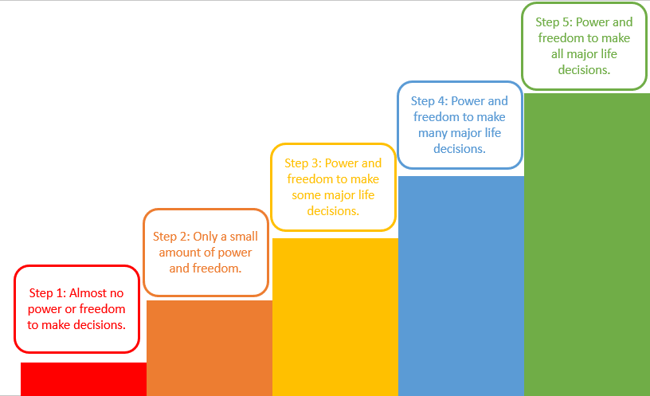
      - On which step of the ladder would you position the majority of women in your household today?
- Step 5: Power and freedom to make all major life decisions.
- Step 4: Power and freedom to make many major life decisions.
- Step 3: Power and freedom to make some major life decisions.
- Step 2: Only a small amount of power and freedom.
- Step 1: Almost no power or freedom to make decisions.
- Could you explain the main reasons for your rating?
      - On which step of the ladder would you position the majority of women in your household 10 years ago?
- Step 5: Power and freedom to make all major life decisions.
- Step 4: Power and freedom to make many major life decisions.
- Step 3: Power and freedom to make some major life decisions.
- Step 2: Only a small amount of power and freedom.
- Step 1: Almost no power or freedom to make decisions.
- Not applicable.
- Could you explain the main reasons for your rating? What has (or has not) changed for women in your household?
      - On which step of the ladder would you position the majority of men in your household today?
- Step 5: Power and freedom to make all major life decisions.
- Step 4: Power and freedom to make many major life decisions.
- Step 3: Power and freedom to make some major life decisions.
- Step 2: Only a small amount of power and freedom.
- Step 1: Almost no power or freedom to make decisions.
- Could you explain the main reasons for your rating?
      - On which step of the ladder would you position the majority of men in your household 10 years ago?
- Step 5: Power and freedom to make all major life decisions.
- Step 4: Power and freedom to make many major life decisions.
- Step 3: Power and freedom to make some major life decisions.
- Step 2: Only a small amount of power and freedom.
- Step 1: Almost no power or freedom to make decisions.
- Not applicable.
- Could you explain the main reasons for your rating? What has (or has not) changed for men in your household?
      - On which step of the ladder would you position the majority of women in your community today?
- Step 5: Power and freedom to make all major life decisions.
- Step 4: Power and freedom to make many major life decisions.
- Step 3: Power and freedom to make some major life decisions.
- Step 2: Only a small amount of power and freedom.
- Step 1: Almost no power or freedom to make decisions.
      - Would you position different types of women in different places on this ladder? Older people, younger people, poorer people, single people, etc.?
- I would place them in the same step on the ladder.
- I would place them in different steps on the ladder.
- Could you explain how the placements would be the same or not.
      - On which step of the ladder would you position the majority of men in your community today?
- Step 5: Power and freedom to make all major life decisions.
- Step 4: Power and freedom to make many major life decisions.
- Step 3: Power and freedom to make some major life decisions.
- Step 2: Only a small amount of power and freedom.
- Step 1: Almost no power or freedom to make decisions.
      - Would you position different types of men in different places on this ladder? Older people, younger people, poorer people, single people, etc.?
- I would place them in the same step on the ladder.
- I would place them in different steps on the ladder.
- Could you explain how the placements would be the same or not.
      - Are there changes you would like to see to give women or men more power and freedom in the future? What would be needed to achieve this?

Land tenure
      - Do you perceive that you could involuntarily lose ownership or use rights to any of the land you currently own or hold use rights to in the next 5 years?
- Not at all
- Slightly likely
- Moderately likely
- Very likely
- Extremely likely
      - What is the total area of your land that could be affected in hectares/acres?
Hint: Please provide the area of total land.

Human wellbeing
I am now going to ask how satisfied you feel about specific aspects of your life. Please indicate how satisfied you feel about specific aspects of your life.
- Think about your own life and personal circumstances, how satisfied are you with your life as a whole?
- 5 – Completely satisfied.
- 4 – Somewhat satisfied.
- 3 – Neutral.
- 2 – Somewhat disatisfied
- 1 - Completely dissatisfied.
- 0 – I don’t know.
- How satisfied are you with your standard of living?
- 5 - Completely satisfied.
- 4 - Somewhat satisfied.
- 3 - Neutral.
- 2 - Somewhat dissatisfied.
- 1 - Completely dissatisfied.
- 0 - I don't know.
- How satisfied are you with your health?
- 5 - Completely satisfied.
- 4 - Somewhat satisfied.
- 3 - Neutral.
- 2 - Somewhat dissatisfied.
- 1 - Completely dissatisfied.
- 0 - I don't know.
- How satisfied are you with what you are achieving in life?
- 5 - Completely satisfied.
- 4 - Somewhat satisfied.
- 3 - Neutral.
- 2 - Somewhat dissatisfied.
- 1 - Completely dissatisfied.
- 0 - I don't know.
- How satisfied are you with your personal relationships?
- 5 - Completely satisfied.
- 4 - Somewhat satisfied.
- 3 - Neutral.
- 2 - Somewhat dissatisfied.
- 1 - Completely dissatisfied.
- 0 - I don't know.
- How satisfied are you with how safe you feel?
Hint: meaning physical safety.
- 5 - Completely satisfied.
- 4 - Somewhat satisfied.
- 3 - Neutral.
- 2 - Somewhat dissatisfied.
- 1 - Completely dissatisfied.
- 0 - I don't know.
- How satisfied are you with feeling part of your community?
Hint: meaning feeling of inclusivity, or sense of belongingness.
- 5 - Completely satisfied.
- 4 - Somewhat satisfied.
- 3 - Neutral.
- 2 - Somewhat dissatisfied.
- 1 - Completely dissatisfied.
- 0 - I don't know.
- How satisfied are you with your economic security?
- 5 - Completely satisfied.
- 4 - Somewhat satisfied.
- 3 - Neutral.
- 2 - Somewhat dissatisfied.
- 1 - Completely dissatisfied.
- 0 - I don't know.
- How satisfied are you with your nutritional security?
- 5 - Completely satisfied.
- 4 - Somewhat satisfied.
- 3 - Neutral.
- 2 - Somewhat dissatisfied.
- 1 - Completely dissatisfied.
- 0 - I don't know.
- How satisfied are you with the amount of time you have to do the things that you like doing?
- 5 - Completely satisfied.
- 4 - Somewhat satisfied.
- 3 - Neutral.
- 2 - Somewhat dissatisfied.
- 1 - Completely dissatisfied.
- 0 - I don't know.
- How satisfied are you with the quality of your local environment?
Hint: e.g. is the area free from pollution including water, air, industrial, or litter pollution?
- 5 - Completely satisfied.
- 4 - Somewhat satisfied.
- 3 - Neutral.
- 2 - Somewhat dissatisfied.
- 1 - Completely dissatisfied.
- 0 - I don't know.
- How satisfied are you with your occupation?
- 5 - Completely satisfied.
- 4 - Somewhat satisfied.
- 3 - Neutral.
- 2 - Somewhat dissatisfied.
- 1 - Completely dissatisfied.
- 0 - I don't know.

Appendix 2. Farm-household level HOLPA field survey
      - What types of data will you collect?
- Collect data on soil health from SOIL SAMPLES (SOC) and on biodiversity and crop health from visual inspection (30-60 mins) - recommended response
- Collect data on soil health using PARTICIPATORY METHODS (SOCLA) and on biodiversity and crop health from visual inspection (30-60 mins)
- Collect data on soil health from soil samples AND participatory methods (SOC and SOCLA) and on biodiversity and crop health from visual inspection (60+ mins)
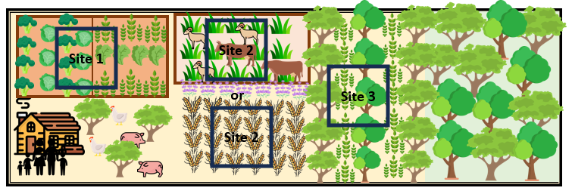

Site 1

Biodiversity
Now you will collect data on tree diversity, landscape complexity, soil and crop health, from three locations on the farm, with the first close to buildings, the second surrounded by farmland, and the third close to natural vegetation, ideally. If you have an app that can record bird sounds, you can also collect data on bird diversity.
First, walk to a single point on the farmland (land actively used for crop or livestock production) that is near to the homestead or other houses/buildings. If the farm-household plots are dispersed, walk to the edge of the closest, accessible plot. Delineate a 10 x 10 meter square area with the centre of the square corresponding to the location you are standing.
      - Take a GPS point of the location
If you have i-bird or another app for identifying birds from birdsong, activate the bird detection audio recording now
Turn in a 360 degree circle, observing all trees and natural or semi-natural vegetation that are inside an approximately 10 x 10 meter square area with the centre of the square corresponding to the location you are standing.
      - Total number of trees observed
      - Number of different tree species observed
      - Number of native tree species
      - Number of trees with a diameter at breast height greater than 10 cm
      - Number of mature trees, defined loosely as those with a height >10m or diameter at breast height >50cm
      - Spatial arrangement of the trees
- Trees are arranged in straight rows
- Trees are scattered around the plot
- Trees are clustered mainly or entirely in one part of the plot
- There are no trees
      - Select all the natural or semi-natural vegetation features that you can see inside the 10 x 10 m sample plot
- Hedgerows/Live fences
- Grass borders
- Flower strips
- Woodlots
- Remnant forest patches
- Wetlands, ponds, or lakes
- Fallow land which is unproductive for at least 1 year
- None
- Other (please specify)
      - Approximately how much of the 10 x 10 m square sample plot is covered by natural or semi-natural vegetation
- None (0%)
- 1-10%
- 11-20%
- 21-30%
- More than 30%
      - Staying at the centre of your 10 x 10 m square sample plot, look south and take a photograph
      - Staying at the centre of your 10 x 10 m square sample plot, turn 90 degrees to the right and take a photograph
      - Staying at the centre of your 10 x 10 m square sample plot, turn a further 90 degrees to the right and take a photograph
      - Staying at the centre of your 10 x 10 m square sample plot, turn a further 90 degrees to the right and take a photograph
If you have i-bird or another app for identifying birds from birdsong, please stop the audio recording now. Save the recording with a unique identifier for the farm and sampling site, such as farm12-birds-site1

Soil health
      - How diversified is the production system where you took the soil sample?
- Annual crops grown as monocultures (one crop type)
- Annual crops grown in diversified systems (more than one crop type, or crops and trees or shrubs)
- Perennial crops grown as monocultures (one crop type)
- Perennial crops grown in diversified systems (more than one crop type, or crops and trees or shrubs)
- Pasture without trees or shrubs
- Pasture with trees or shrubs
- Other (please specify)

SOC methodology
Now, in the same 10x10m square plot used to assess biodiversity, please collect soil samples at five points corresponding to the plot centre and each corner of the plot. At the first sampling point, remove any crop residues from the soil surface. Use a small trowel to dig vertically to a depth of 10cm measured with a ruler (or insert the soil probe to 10cm), and place the removed soil into an sealable plastic bag. Repeat this process at the other four sampling points. Soil from each of the five sampling points should be put into the same bag. Seal the bag and label it with a unique name that identifies the farm and sample site, such as 'Farm12-Site1'
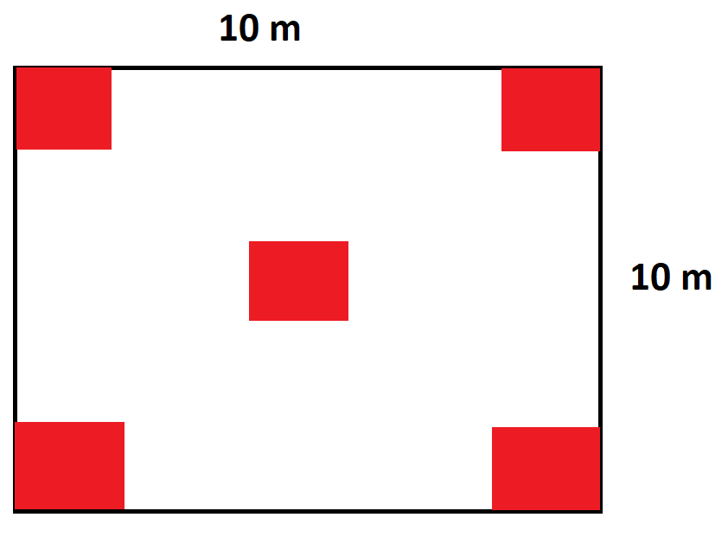
      - Label on the soil bag

SOCLA methodology
In the same 10x10m square plot used to assess biodiversity, please examine the soil around you and jointly answer the following questions with the respondent. You should dig or pick up a small amount of soil to examine it more closely.
      - In consultation with the respondent, describe the soil STRUCTURE
- Loose, powdery soil without visible aggregate
- Soil with some aggregates that break with little pressure.
- 3. Few aggregates that break with little pressure
- Soil with several well-formed aggregates that are difficult to break.
- Well-formed aggregates that are difficult to break
- I am not sure
      - In consultation with the respondent, describe the soil COMPACTION
- Compacted soil, flag bends readily when attempting to penetrate.
- Soil with a moderately compacted layer, some resistance to a penetrating wire.
- Thin compacted layer, with slight restrictions to a penetrating wire.
- Soil with minimal compaction, little resistance to a penetrating wire.
- No compaction, the flag can penetrate all the way into the soil easily.
- I am not sure
      - In consultation with the respondent, describe the soil DEPTH
- Exposed subsoil, no superficial soil present.
- Very shallow soil depth.
- Thin superficial soil, approximately 5 cm.
- Moderate soil depth, about 10 cm.
- Significant superficial soil depth, more than >10 cm.
- I am not sure
      - In consultation with the respondent, describe the soil STATUS OF RESIDUES
- Slowly decomposing organic residues.
- Some partially decomposed residues from the previous year.
- Presence of last year's decomposing residues
- Residues in various stages of decomposition, with some well-decomposed.
- Residues in various stages of decomposition, most residues well-decomposed
- I am not sure
      - In consultation with the respondent, describe the soil COLOUR, ODOUR, ORGANIC MATTER
- Pale, chemical odour, and no presence of humus.
- Light brown color, neutral or mild odor, and some presence of humus.
- Light brown, odourless, and some presence of humus.
- Dark brown color, fresh earthy odor, and a substantial amount of humus.
- Dark brown, fresh odour, and abundant humus.
- I am not sure
      - In consultation with the respondent, describe the soil MOISTURE
- Dry soil, does not hold water.
- Very low moisture level, unable to sustain plant growth.
- Limited moisture level available for short time, may not support full plant needs.
- Adequate moisture level for a moderate period of time, suitable for most plants.
- Reasonable moisture level for a reasonable period of time, providing excellent conditions for plant growth.
- I am not sure.
      - In consultation with the respondent, describe the soil COVER
- Bare soil, no residues or live cover present.
- Less than 25% soil covered by residues or live cover.
- Approximately 25% to 50% of the soil covered by residues or live cover.
- Approximately 51% to 75% of the soil covered by residues or live cover.
- More than 75% soil covered by residues or live cover
- I am not sure.
      - In consultation with the respondent, describe the soil EROSION
- Severe erosion, presence of small gullies and noticeable soil loss.
- Moderate erosion signs, with some minor gullies or soil disturbance.
- Evident, but low erosion signs, such as slight soil displacement and small rills.
- Minimal erosion signs, with only slight indications of soil disturbance.
- No visible signs of erosion, with the soil surface largely intact and undisturbed.
- I am not sure.
      - In consultation with the respondent, describe the soil INTERVEBRATE ACTIVITY
- No signs of invertebrate presence of activity observed.
- Very few earthworms and arthropods present, with minimal activity.
- A few earthworms and arthropods present, with minimal activity.
- Moderate presence of invertebrate organisms, with noticeable activity in the soil.
- Abundant presence of invertebrate organisms, indicating active and healthy soil life.
- I am not sure
      - In consultation with the respondent, describe the soil MICROBIOLOGICAL ACTIVITY
- Very little effervescence after application of water peroxide
- Low effervescence observed
- Light to medium effervescence
- Moderate effervescence noticed
- Abundant effervescence
- I am not sure

Crop and pasture health
Now, in the same 10x10m square plot used to assess biodiversity and soil, please observe the crops and/or pasture present in the plot and jointly asking the following questions with the respondent (if present).

      - In consultation with the respondent, describe the crop/pasture APPEARANCE
Hint: Use this image as reference
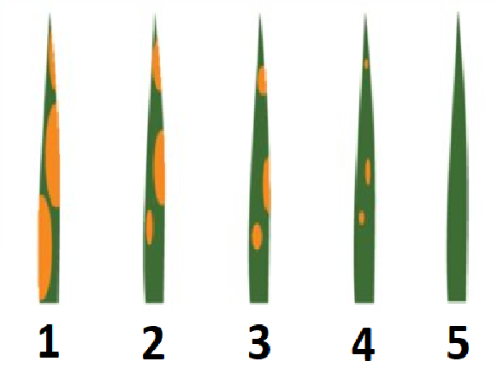
- 1. Discolored foliage with severe deficiency signs
- 2. Discolored foliage with moderate deficiency signs
- 3. Foliage with some deficiency signs
- 4. Foliage with very minor deficiency signs
- 5. Healthy foliage with no signs of deficiency
- I am not sure, or the question is not applicable
      - In consultation with the respondent, describe the crop/pasture GROWTH
- 1. Uneven plant heights with limited new growth
- 2. Uneven plant heights with some new growth
- 3. Mainly even plant heights with limited new growth
- 4. Mainly even plant heights with some new growth
- 5. Even plant heights and vigorous new growth
- I am not sure, or the question is not applicable
      - In consultation with the respondent, describe the crop/pasture DISEASE INCIDENCE
Hint: Use this image as reference\
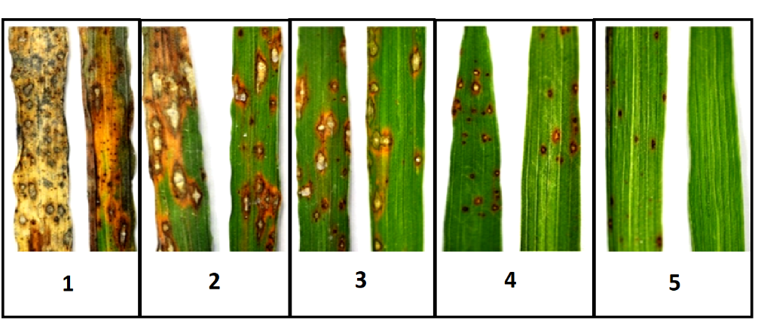
- 1. 76-100% of plants have damaged stems, leaves and/or fruits
- 2. 51-75% of plants have damaged stems, leaves and/or fruits
- 3. 26-50% of plants have damaged stems, leaves and/or fruits
- 4. 6-25% of plants have damaged stems, leaves and/or fruits
- 5. ≤5% of plants have damaged stems, leaves and/or fruits
- I am not sure, or the question is not applicable
      - In consultation with the respondent, describe the crop/pasture INSECT PEST INCIDENCE
Hint: Use this image as reference
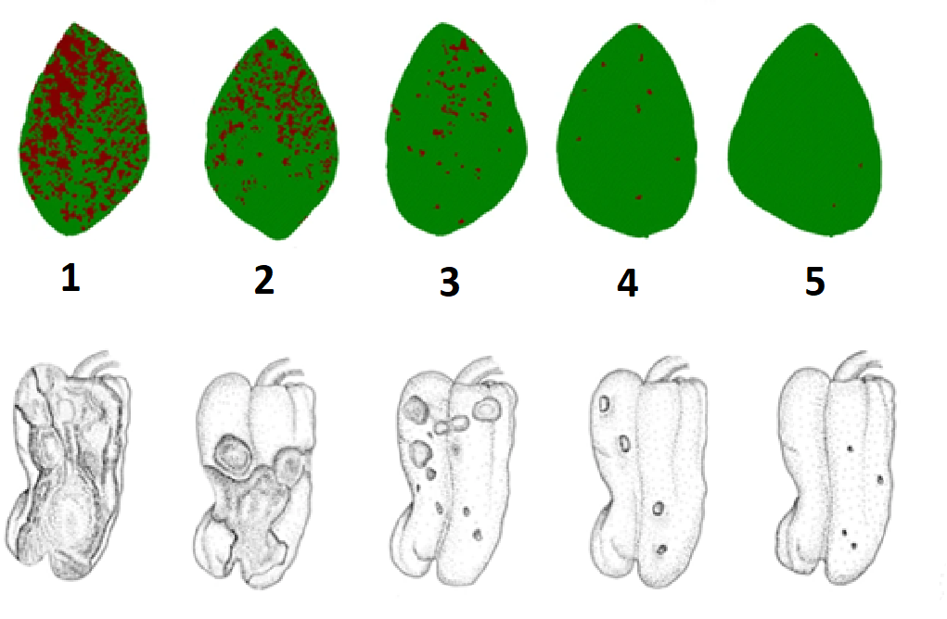
- 1. Very dense insect pest coverage on plant stems, leaves and/or fruits
- 2. Dense insect pest coverage on plant stems, leaves and/or fruits
- 3. Moderately dense insect pest coverage on plant stems, leaves and/or fruits
- 4. Sparse insect pest coverage on plant stems, leaves and/or fruits
- 5. No or very sparse signs of insect pests on plant stems, leaves and/or fruits
- I am not sure, or the question is not applicable
      - In consultation with the respondent, describe the crop/pasture NATURAL ENEMY ABUNDANCE
- No presence of pest predators on plant stems, leaves and/or fruits
- Sparse presence of pest predators on plant stems, leaves and/or fruits
- Moderate presence of pest predators on plant stems, leaves and/or fruits
- Dense presence of pest predators on plant stems, leaves and/or fruits
- Very dense presence of pest predators on plant stems, leaves and/or fruits
- I am not sure, or the question is not applicable
      - In consultation with the respondent, describe the crop/pasture WEED PRESSURE
- Crops stressed and overwhelmed by weeds
- Crops growing well but starting to be overcome by weeds
- Moderate presence of weeds with some competition
- Low presence of weeds
- Vigorous crop that overcomes weeds
- I am not sure, or the question is not applicable
      - In consultation with the respondent, describe the NATURAL SURROUNDING VEGETATION
- Surrounded by other crops or pasture with no natural vegetation nearby
- Surrounded by other crops or pasture with some natural vegetation nearby, such as inside fields or at field edge
- Adjacent to sparse or limited natural vegetation on at least one side
- Adjacent to dense or expansive natural vegetation on at least one side
- Adjacent to natural vegetation on at least two sides
- I am not sure, or the question is not applicable
      - In consultation with the respondent, describe the MANAGEMENT SYSTEM
- High chemical pesticide and/or fertilizer inputs; conventional tillage
- Moderate chemical pesticide and/or fertilizer inputs; conventional tillage
- Moderate chemical pesticide and/or fertilizer inputs; reduced or no tillage
- No or low chemical pesticide and/or fertilizer inputs; reduced or no tillage
- No chemical inputs; reduced or no tillage
- I am not sure, or the question is not applicable

Site 2

Biodiversity
Now, walk to a second point, this time at the centre of the farmland (land actively used for crop or livestock production) or as close as feasible to this, and ideally away from any houses or buildings. If the farm-household plots are dispersed, walk to the centre of the largest, accessible plot. Delineate a 10 x 10 meter square area with the centre of the square corresponding to the location you are standing.
…...

Soil health

SOC methodology
Now, in the same 10x10m square plot used to assess biodiversity, please collect soil samples at five points corresponding to the plot centre and each corner of the plot. At the first sampling point, remove any crop residues from the soil surface. Use a small trowel to dig vertically to a depth of 10cm measured with a ruler (or insert the soil probe to 10cm), and place the removed soil into a sealable plastic bag. Repeat this process at the other four sampling points. Soil from each of the five sampling points should be put into the same bag. Seal the bag and label it with a unique name that identifies the farm and sample site, such as 'Farm12-Site2'
...
4.2.2.2. SOCLA methodology
In the same 10x10m square plot used to assess biodiversity, please examine the soil around you and jointly answer the following questions with the respondent. You should dig or pick up a small amount of soil to examine it more closely.
…

Crop and pasture health
Now, in the same 10x10m square plot used to assess biodiversity, please observe the crops and/or pasture present in the plot and jointly asking the following questions with the respondent (if present).
...

Site 3

Biodiversity
Now, walk to a third point, this time at the edge of the farmland (land actively used for crop or livestock production) choosing an edge that is near to natural vegetation, if possible. If the farm-household plots are dispersed, walk to the edge of the most accessible plot that is nearest to natural vegetation and furthest from human settlements. Delineate a 10 x 10 meter square area** with the centre of the square corresponding to the location you are standing.
...

Soil health

SOC methodology
Now, in the same 10x10m square plot used to assess biodiversity, please collect soil samples at five points corresponding to the plot centre and each corner of the plot. At the first sampling point, remove any crop residues from the soil surface. Use a small trowel to dig vertically to a depth of 10cm measured with a ruler (or insert the soil probe to 10cm), and place the removed soil into a sealable plastic bag. Repeat this process at the other four sampling points. Soil from each of the five sampling points should be put into the same bag. Seal the bag and label it with a unique name that identifies the farm and sample site, such as 'Farm12-Site2'

SOCLA methodology
In the same 10x10m square plot used to assess biodiversity, please examine the soil around you and jointly answer the following questions with the respondent. You should dig or pick up a small amount of soil to examine it more closely.
...

Crop and pasture health
Now, in the same 10x10m square plot used to assess biodiversity, please observe the crops and/or pasture present in the plot and jointly asking the following questions with the respondent (if present).
...

Appendix 3. Data collection using KoboCollect
If you do not already have a KoboCollect account, go to https://www.kobotoolbox.org/ and set up a new account with your own username and password.
On an android tablet or smartphone, download the KoboCollect app (or if you already have it installed, make sure you have the latest version).
Login to the app from your tablet using your personal username and password.
Now follow the instructions below.
To download, fill in, and submit the standard HOLPA survey:
- Click on Settings (top right logo)
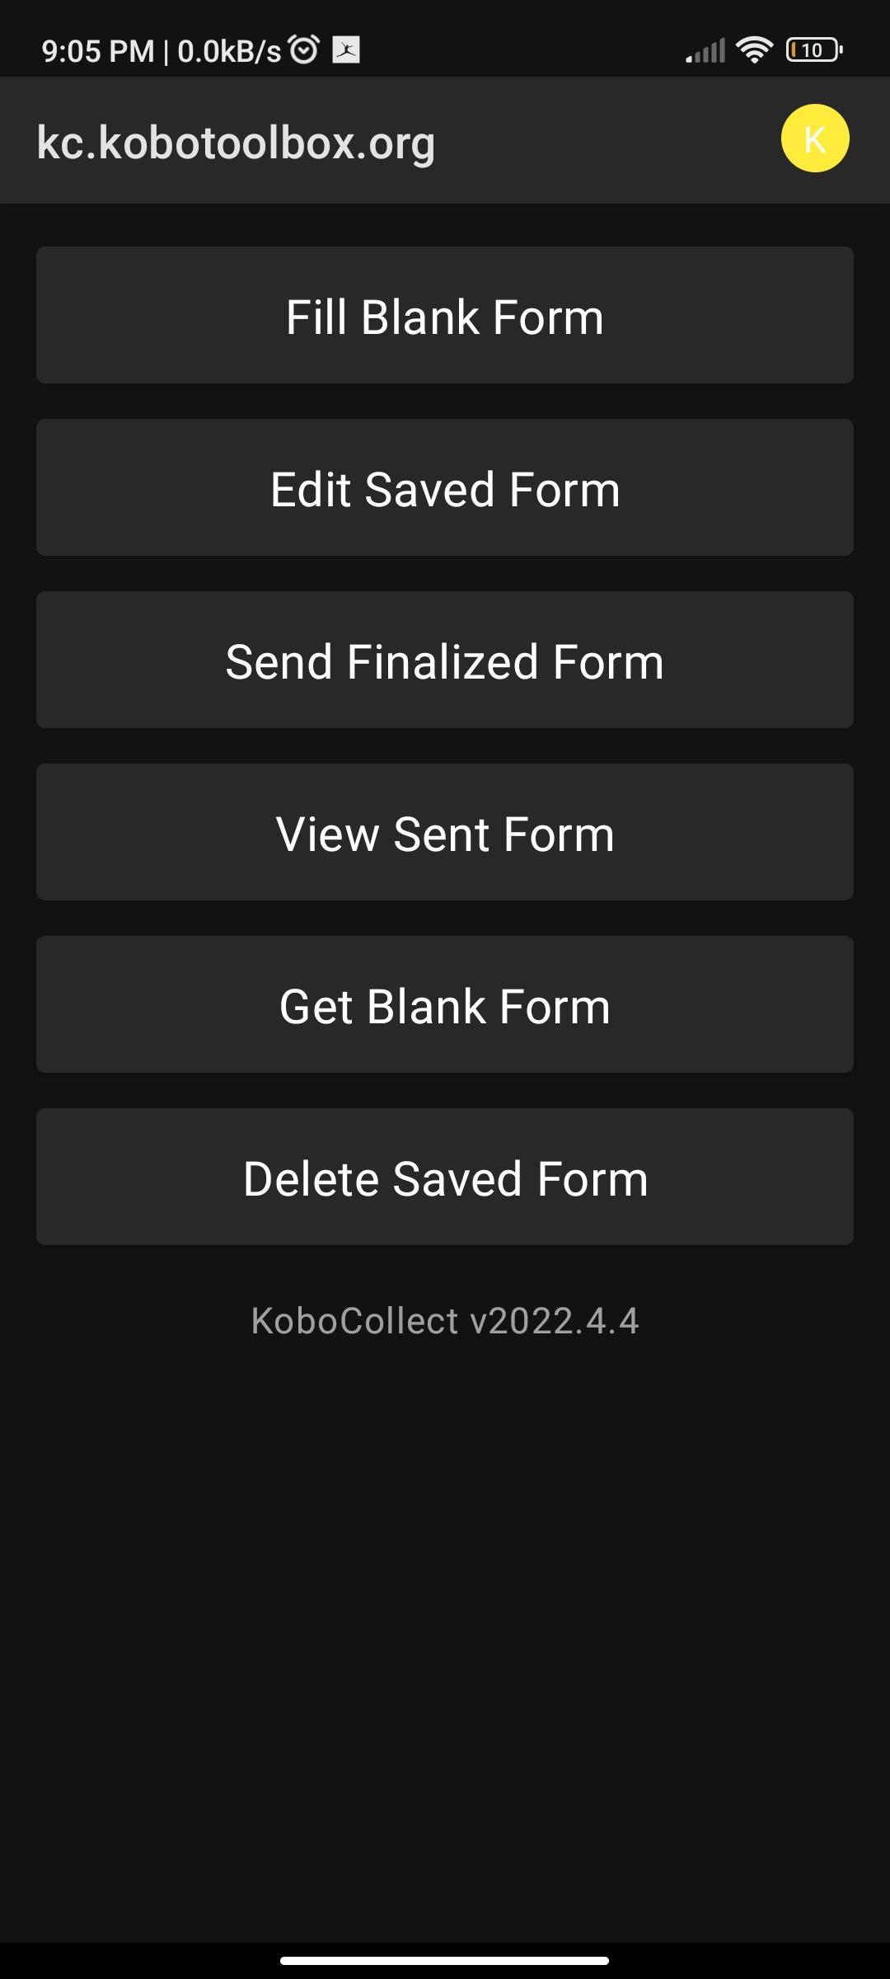

- Click on Add projects.
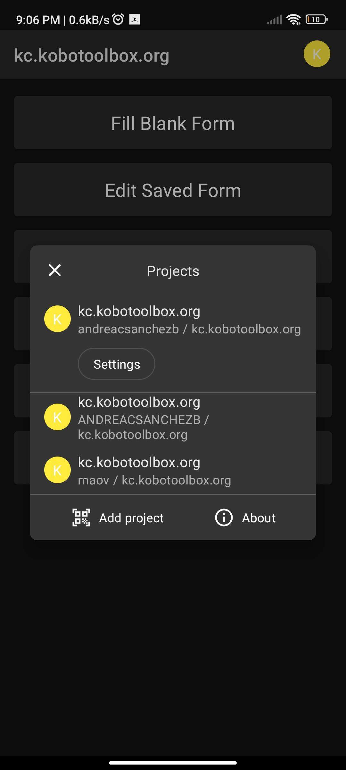
- Scan QR code
Obs: grant camera permission (if required in prompt)

The QR code should automatically import the Holpa project into your device. If this doesn’t work, you will need to add the project manually. To do this, select ‘Manually enter project details’ and enter the url.
Click ‘Add’ (bottom right).
- Click on Get blank form

- Select the latest survey version (normally the one at the bottom of the list, but if in doubt check the version number and timestamp to find the most recent). A check mark should appear on the right.
- Click on Get selected (bottom right)
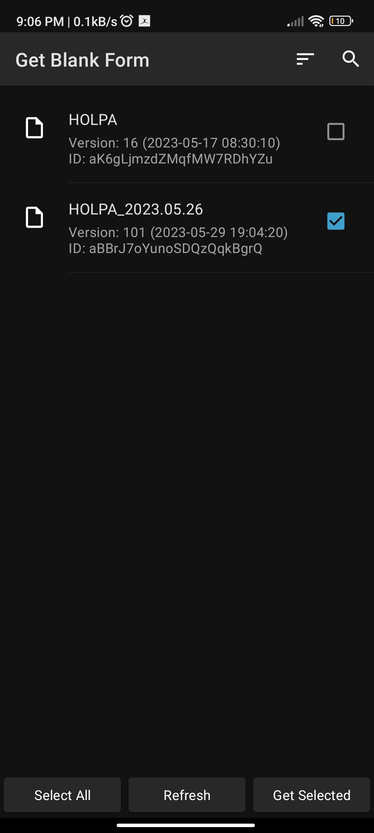

- Click Fill blank form

- Select the required form
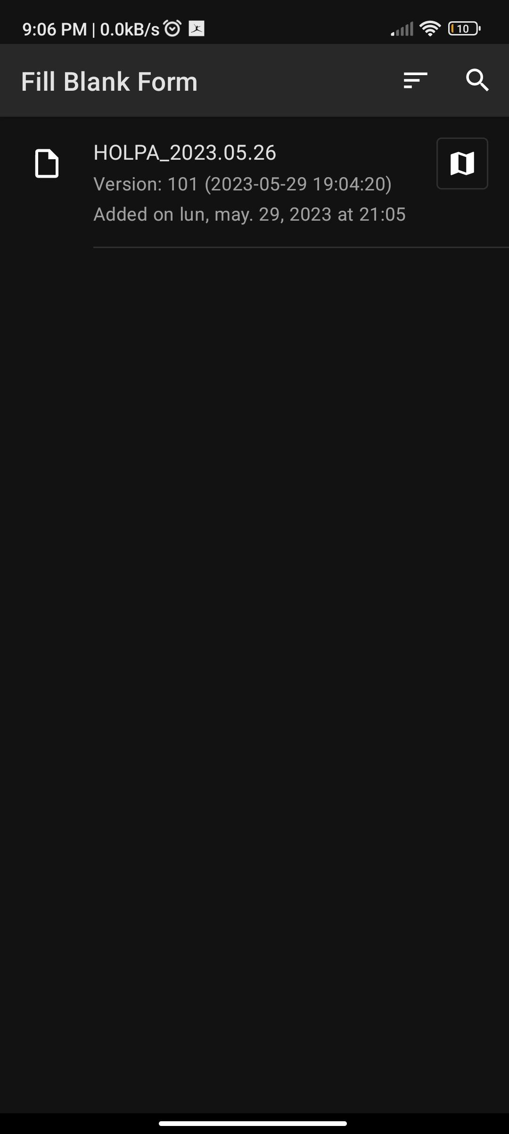

- Complete the form.
- You can save a partially finished form at any time. To edit a saved form, select ‘Edit saved form’.



- After completing the form, click ‘Send Finalized Form’.


12. Your sent forms will appear on KoboToolbox (the KoboCollect server) accessible only to users granted full access rights (i.e. you can choose whether all enumerators have access to the full dataset, or only selected members of the country team).

